NAME………………………………………………………..IDEX NO…………………………………………………………………………..
SCHOOL………………………………………………………..SIGN………………DATE…………………………………………………….
443/2

AGRICULTURE

PAPER 2

TIME: 2 HOURS

DECEMBER, 2020

MERU CENTRAL CLUSTER EXAMINATION (2020)
Kenya certificate of secondary education (k.c.s.e)

INSTRUCTIONS TO CANDIDATES

- Write your name, school and index number, in the spaces provided above.

- Sign and write the date of the examination in the spaces provided above.

- This paper consists of three sections: A, B and C.

- Answer all the questions in section A and B and any two questions from section C.

- All answers must be written in the spaces provided in this booklet

.

For Examiner’s Use Only
SECTION | QUESTIONS |  | MAXIMUM SCORE |  | CANDIDATES SCORE
A | 1−18 |  | 30
B | 18−22 |  | 20
 |  |  | 20
C
 |  |  | 20
 | Total score |  | 90

SECTION A

ANSWER ALL THE QUESTIONS IN THIS SECTION IN THE SPACES PROVIDED

- Name two dairy goat breeds found in Kenya. (1 Mk)
………………………………………………………………………………………………………………………………………………………………………………………………………………………………………………………………………………………………

- Outline four reasons for maintaining farm tools and equipment in good condition. (2 Mks)
………………………………………………………………………………………………
………………………………………………………………………………………………………………………………………………………………………………………………………………………………………………………………………………………………………………………………………………………………………………………………

- Outline two predisposing factors of foot rot. (1 Mk)
………………………………………………………………………………………………………………………………………………………………………………………………………………
- Name two rules that should be observed when milking. (1 Mks)
………………………………………………………………………………………………
………………………………………………………………………………………………………………………………………………………………………………………………………………………………………………………………………………………………………
- Outline two duties of a worker bee in a colony of bees. (1 Mks)
………………………………………………………………………………………………
………………………………………………………………………………………………………………………………………………………………………………………………………………………………………………………………………………………………………
- Study the table below fill in the blanks to show the term used to refer to parturition and young ones of the following animals. (2 Mks)
Type of animal | Act of parturition | Term to refer to the young one
Cattle | Calving | Calf
Goats | ………………………………… | …………………………………..
pig | …………………………………. | …………………………………..

- State four harmful effects of ticks. (2 Mks)
………………………………………………………………………………………………………………………………………………………………………………………………………………………………………………………………………………………………………………………………………………………………………………………………
- State four desirable factors to consider when siting a fish pond. (2 Mks)
………………………………………………………………………………………………………………………………………………………………………………………………………………………………………………………………………………………………………………………………………………………………………………………………
9. Name the most appropriate tools used in the following operations
a) Removing metal chippings in file (1mrk )
........................................................................................................................................................................................................................................................................................................................
b) Cutting wood along grains (1mrk)
........................................................................................................................................................................................................................................................................................................................
c) Branding (1mrks)
........................................................................................................................................................................................................................................................................................................................
10. State four characteristic of Boran cattle (2mrks)
................................................................................................................................................................................................................................................................................................................................................................................................................................................................................................................................................................................................................................................
11. Name three methods of out breeding in livestock production ((1 ½ marks)
........................................................................................................................................................................................................................................................................................................................
........................................................................................................................................................................................................................................................................................................................
12 .What do you understand by the following terms as used I animal production .

- Caponisation (1mrk)
....................................................................................................................................................................................................................................................................................................................
b) Bullock (1mrk)
................................................................................................................................................................................................................................................................................................................................................
c. Epistasis(1mrk)
................................................................................................................................................................................................................................................................................................................................................
13State four control measures of a liver fluke in livestock. (2 marks)

..........................................................................................................................................................................................................................................................................................................................................................................................................................................................................................................................................................................................................................................................................................................................................................................................................................................................................................................................................................

14What is “dry cow therapy” in dairy cattle management?

(1/2 mark)

....................................................................................................................................................................................................................................................................................................................

15State four causes of stress in poultry. (2 marks)

16.Distinguish between mothering ability and prolificacy as used in livestock breeding.( 1mks)

......................................................................................................................................................................................................................................................................................................................................................................................................................................................................................................................................................................................................................................

17 Name two sources of protein for livestock nutrition. (2 marks)

......................................................................................................................................................................................................................................................................................................................................................................................................................................................................................................................................................................................................................................

18State four signs of parturition shown by a in calf cow. (2 marks)
......................................................................................................................................................................................................................................................................................................................................................................................................................................................................................................................................................................................................................................

SECTION B ( 20 mks)
ANSWER ALL THE QUESTIONS IN THIS SECTION
19The diagram below shows a certain practice carried out on pig
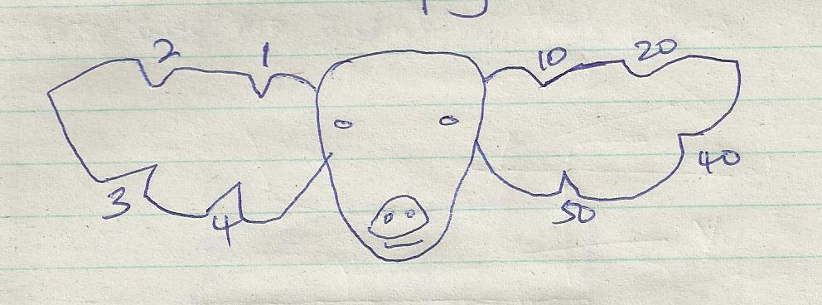
- Identify the practice illustrated above (1mrk)
........................................................................................................................................................................................................................................................................................................................
- Draw another illustration depicting pig number 37(1mrk)

- Name the tool used to carry out the practice illustrated above (1mrk)
............................................................................................................................................................................................................................................................................................
- State two other method of identifying piglet (2mrks)
i)……………………………………………………………………………………………………………………………………………..
ii)…………………………………………………………………………………………………………………………………………….

20. The diagrams below show some farm tools. study them and answer the question that follow.

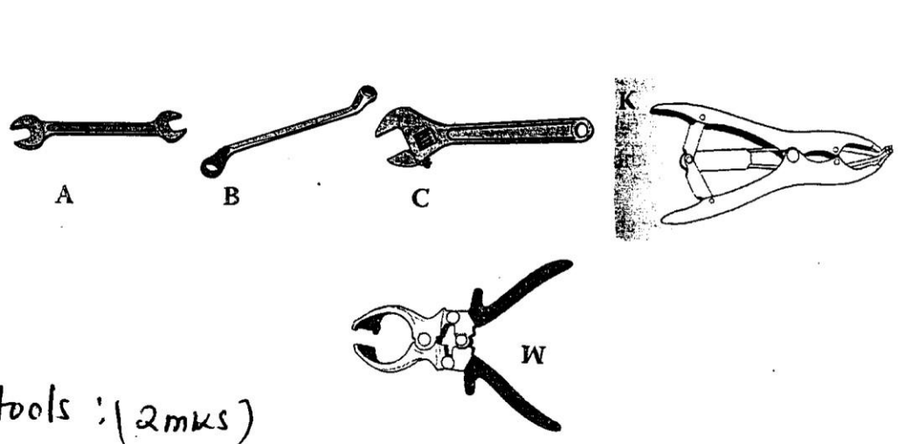

K

a) Name the tools.

(2 marks)

A

…………………………………………………………………………………………………..
B

……………………………………………………………………………………………………..
C

……………………………………………………………………………………………………..
W

……………………………………………………………………………………………………..

- State the functional differences between tools K and W. (1 mark)

………………………………………………………………………………………………………
c) What advantage does C have over A and B? (1 mark)

……………………………………………………………………………………………………………………………………………………………………………………………………………………………………………………………………………………………………………………..

- State one common maintenance practice carried out in tool C and W. (1 mark)
......................................................................................................................................................................................................................................................................................................................................................................................................................................................................................................................................................................................................................................

21a) The diagram below shows a structure of the udder of a cow. Name the part labeled W, X, Y and Z.(2 marks)
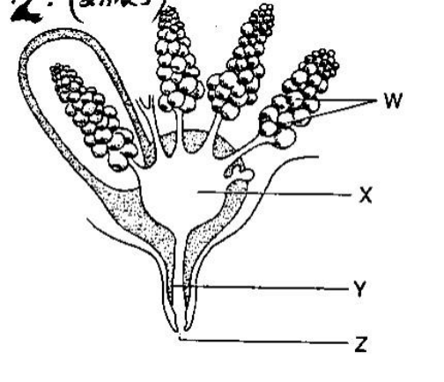

W

…………………………………………………………………………………………………

X
………………………………………………………………………………………………....

Y
……………………………………………………………………………………………………
Z

……………………………………………………………………………………………….
- What is milk let down (1 mrk)
......................................................................................................................................................................................................................................................................................................................

c) Name two hormones that control milk let down in dairy cow. (2 mrk)
......................................................................................................................................................................................................................................................................................................................................................................................................................................................................................................................................................................................................................................

22. Below is an illustration of a method of extracting honey from combs .Study the diagram and answer the question that follow .
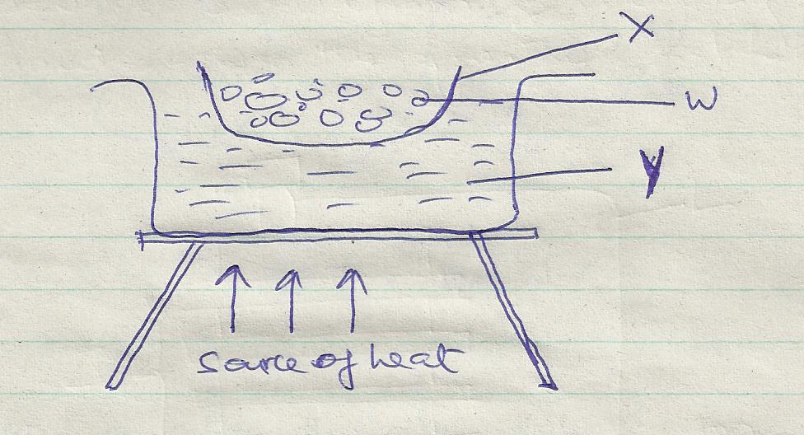
- Identify the above method of extracting honey (1mrk)
........................................................................................................................................................................................................................................................................................................................
- Give a reason why container x should not be heated directly (1mrk
........................................................................................................................................................................................................................................................................................................................

- Name the parts labeled w and y(2mrks)
W……………………………………………………………………………………………………
Y……………………………………………………………………………………………………
- Besides the above method ,State one other method of extracting honey (1mrk)
................................................................................................................................................................................................................................................................................................

SECTION C (40 MKS)
ANSWER ANY TWO QUESTIONS IN THIS SECTION

23(a) State five reasons why bees swarm. (5 marks)
......................................................................................................................................................................................................................................................................................................................................................................................................................................................................................................................................................................................................................................
......................................................................................................................................................................................................................................................................................................................................................................................................................................................................................................................................................................................................................................
......................................................................................................................................................................................................................................................................................................................................................................................................................................................................................................................................................................................................................................
......................................................................................................................................................................................................................................................................................................................................................................................................................................................................................................................................................................................................................................
......................................................................................................................................................................................................................................................................................................................................................................................................................................................................................................................................................................................................................................

b) Describe five maintenance practices carried out on a tractor battery. (5 marks)
................................................................................................................................................................................................................................................................................................................................................................................................................................................................................................................................................................................................................................................
................................................................................................................................................................................................................................................................................................................................................................................................................................................................................................................................................................................................................................................
................................................................................................................................................................................................................................................................................................................................................................................................................................................................................................................................................................................................................................................
...............................................................................................................................................................................................................................................................................................................................................................................................................................................................................................................................................................................................................................................

c) Explain five factors considered when culling livestock. (5 Mks)

................................................................................................................................................................................................................................................................................................................................................................................................................................................................................................................................................................................................................................................
................................................................................................................................................................................................................................................................................................................................................................................................................................................................................................................................................................................................................................................
................................................................................................................................................................................................................................................................................................................................................................................................................................................................................................................................................................................................................................................
...............................................................................................................................................................................................................................................................................................................................................................................................................................................................................................................................................................................................................................................
................................................................................................................................................................................................................................................................................................................................................................................................................................................................................................................................................................................................................................................

d. Explain five mechanical methods of controlling ticks.(5 mks)

...............................................................................................................................................................................................................................................................................................................................................................................................................................................................................................................................................................................................................................................
...............................................................................................................................................................................................................................................................................................................................................................................................................................................................................................................................................................................................................................................
...............................................................................................................................................................................................................................................................................................................................................................................................................................................................................................................................................................................................................................................
...................................................................................................................................................................................................................................................................................................................................................................................................................................................................................
................................................................................................................................................................................................................................................................................................................................................................................................................................................................................................................................................................................................................................................

24a) Describe the process of egg formation in chicken up to the point of laying. (10 Mks)
................................................................................................................................................................................................................................................................................................................................................................................................................................................................................................................................................................................................................................................
......................................................................................................................................................................................................................................................................................................................................................................................................................................................................................................................................................................................................................................
...............................................................................................................................................................................................................................................................................................................................................................................................................................................................................................................................................................................................................................................
...............................................................................................................................................................................................................................................................................................................................................................................................................................................................................................................................................................................................................................................
...............................................................................................................................................................................................................................................................................................................................................................................................................................................................................................................................................................................................................................................
...............................................................................................................................................................................................................................................................................................................................................................................................................................................................................................................................................................................................................................................

b) State the differences between four stroke cycle and two stroke cycle engine. (5 Mks)
....................................................................................................................................................................................................................................................................................................................................................................................................................................................................................
..............................................................................................................................................................................................................................................................................................................................................................................................................................................................................................................................................................................................................................................
...............................................................................................................................................................................................................................................................................................................................................................................................................................................................................................................................................................................................................................................
................................................................................................................................................................................................................................................................................................................................................................................................................................................................................................................................................................................................................................................
....................................................................................................................................................................................................................................................................................................................................................................................................................................................................................

c) Describe the process of digestion in rumen. (5 Mks)
...................................................................................................................................................................................................................................................................................................................................................................................................................................................................................
...............................................................................................................................................................................................................................................................................................................................................................................................................................................................................................................................................................................................................................................
................................................................................................................................................................................................................................................................................................................................................................................................................................................................................................................................................................................................................................................
...............................................................................................................................................................................................................................................................................................................................................................................................................................................................................................................................................................................................................................................
................................................................................................................................................................................................................................................................................................................................................................................................................................................................................................................................................................................................................................................
........................................................................................................................................................................................................................................................................................................................

25. a) Describe trypanosomiasis disease under the following sub-headings.
i) Causal organism (1 Mk)
........................................................................................................................................................................................................................................................................................................................

ii) Animal attacked (1 Mk)
.......................................................................................................................................................................................................................................................................................................................

iii) Five symptoms of attacked animals (5 Mks)

...................................................................................................................................................................................................................................................................................................................................................................................................................................................................................
................................................................................................................................................................................................................................................................................................................................................................................................................................................................................................................................................................................................................................................
................................................................................................................................................................................................................................................................................................................................................................................................................................................................................................................................................................................................................................................

iv) Three control measures (3 Mks)
......................................................................................................................................................................................................................................................................................................................................................................................................................................................................................................................................................................................................................................
......................................................................................................................................................................................................................................................................................................................................................................................................................................................................................................................................................................................................................................

b) Control five control measures for cannibalism (5 Mks)

..............................................................................................................................................................................................................................................................................................................................................................................................................................................................................
......................................................................................................................................................................................................................................................................................................................................................................................................................................................................................................................................................................................................................................
......................................................................................................................................................................................................................................................................................................................................................................................................................................................................................................................................................................................................................................
......................................................................................................................................................................................................................................................................................................................................................................................................................................................................................................................................................................................................................................

(c) Explain five parts of a piggery unit (10mrks)

..............................................................................................................................................................................................................................................................................................................................................................................................................................................................................
......................................................................................................................................................................................................................................................................................................................................................................................................................................................................................................................................................................................................................................
......................................................................................................................................................................................................................................................................................................................................................................................................................................................................................................................................................................................................................................
.......................................................................................................................................................................................................................................................................................................................................................................................................................................................................................................................................................................................................................................

..............................................................................................................................................................................................................................................................................................................................................................................................................................................................................
......................................................................................................................................................................................................................................................................................................................................................................................................................................................................................................................................................................................................................................
......................................................................................................................................................................................................................................................................................................................................................................................................................................................................................................................................................................................................................................
...............................................................................................................................................................................................................................................................................................................................................................................................................................................................................................................................................................................................................................................

..............................................................................................................................................................................................................................................................................................................................................................................................................................................................................
................................................................................................................................................................................................................................................................................................................................................................................................................................................................................................................................................................................................................................................
...............................................................................................................................................................................................................................................................................................................................................................................................................................................................................................................................................................................................................................................
................................................................................................................................................................................................................................................................................................................................................................................................................................................................................................................................................................................................................................................
..............................................................................................................................................................................................................................................................................................................................................................................................................................................................................
......................................................................................................................................................................................................................................................................................................................................................................................................................................................................................................................................................................................................................................
......................................................................................................................................................................................................................................................................................................................................................................................................................................................................................................................................................................................................................................
.............................................................................................................................................................................................................................................................................................................................................................................................................................................................................................................................................................................................................................................

