Name……………………………………………………… Index No………………………..
231/1
BIOLOGY Date……………………………
(Theory)
YEAR 2020 Sign……………………………
TIME: 2 hours
DECEMBER 2020
KENYA NATIONAL EXAMINATIONS COUNCIL
(Kenya Certificate of Secondary education)
Instructions
    - Write your Name and Index Number in the spaces provided above.
    - Write the date of the examination in the space provided above.
    - Answer all the questions in the spaces provided.

For Examiner’s use only

Question | Maximum Score | Candidate’s Score
1-27 | 80

This paper consists of 10 printed pages.
Candidates should check the question paper to ascertain that all the pages are printed as indicated and no questions are missing.
- The equation below shows a reaction that occurs in plants.
6CO₂+12H C₆H₁₂O₆+ 3O₂
- Identify the process. [1mk]

- In which part of the chloroplast does the process represented by the above reaction occur? [1mk]

- Write down the part of microscope that plays the following role. (2mks)
Role played | Part of microscope
Movement of stage through large distance
Attachment of objective lenses

- a. Blood group AB is a universal recipient. Explain [1mk]

- Describe the characteristics of blood group AB^{+ev}. [3mks]

4. A certain organ K was surgically removed from a rat, later drastic increase in glucose level in the blood was reported but when substance Q was injected into the animal the whole process was reversed.
Identify: a. Organ K………………………………………. [1mk]
b.Substance Q ……………………………………… [ 1mk]
5. State the two major characteristic of members of the kingdom plantae. [2mks]

6. The diagram below represents a plant cell that had been placed in a certain solution.
Study it and answer the questions that follow.
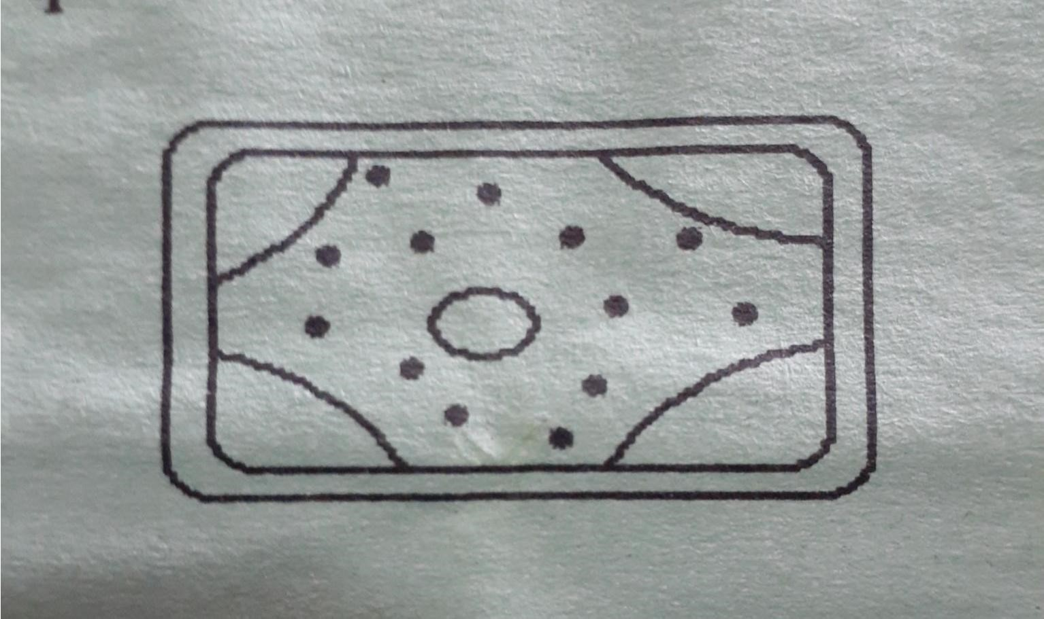

a. What term is used to describe the condition of the above cell? [1mk]

b. What term is used to describe the solution to which the cell had been placed. [1mk]

7. A variegated leaf was tested for starch.
a. Name the reagent used. [1mk]

b. State the expected results. [1mk]

c. What was the aim of the experiment? [1mk]

8. State two characteristic of anemorphilous flowers. [2mks]

9. Name two processes that are involved in the translocation of manufactured food materials. [2mks]

10. State two ways by which lactic acid formed in the muscles of an athlete is removed. [2mks]

11. Explain why sexual reproduction is important in an organism. [2mks]

12. Study the diagram below.
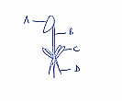

- Name the division the organism belongs. [1mk]

- Name the parts B$C. [2mks]

- State two functions of the part labelled D. [2mks]

13. In rats, black colour is dominants over white.
a. Using appropriate letter symbols make a cross of two heterozygous black rats. [4mks]

b. Indicates the genotypic and phenotypic ratios of their off springs. [2mks]

14. Explain double fertilization in flowering plants. [4mks]

15. Explain three adaptations of the root hair cell to perform its function. [3mks]

16. Distinguish between ecological niche and habitat. [2mks]

17. The diagram below shows the internal structure of a broad bean seed. Study it and answer the questions that follow.
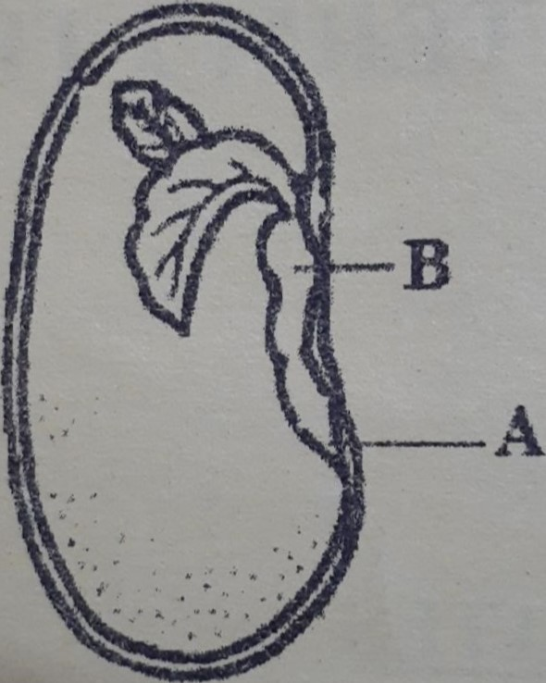

- Name the part labelled B. [1mk]

- Why is it important that the part labelled A develops first during germination? [2mks]

18. State three preventive measures of schistosomiasis in human beings. [3mks]

19. A form one student observing onion epidermal cells under the low power objective counted 5 cells on a field of view measuring 5mm
a. If the eye piece magnification used was ×10 and that of the objective lens was×10. What was the magnification of the microscope? Show your working. [2mks]

b. what is the role of centrioles in animal cells? [1mk]

c. How is support achieved in herbaceous plants? [1mk]

20. Explain why amoeba cannot burst when placed in hypertonic solution. [2mks]

21. What is the effect of contraction of diaphragm muscle breathing in mammals? [3mks]

22. a. Describe three homeostatic functions of the mammalian skin. [3mks]

b. Why do desert animals excrete nitrogenous wastes in form of uric acid? [2mks]

23. a. Give two precautions taken when collecting biological life specimen. [2mks]

b. State the function of the following biological apparatus. [2mks]
i. hand lens

ii. Pit fall tap

24. Distinguish growth from development. [2mks]

25. a. Name the hormone that stimulate milk secretion in female mammals. [1mk]

b. State the function of lytic enzyme secreted by acrosome in the sperm. [1mk]

c. Give two reasons why cross breeding is better than inbreeding. [2mks]

26. Why would burning charcoal in a poorly ventilated room cause death? [2mks]

27. State three differences between aerobic and anaerobic respiration. [3mks]

