Name: …………………………………………………… Index no ……..…......................

Candidate’s sign ……………………....... Date: ………………………

565/1
BUSINESS STUDIES
PAPER 1
DECEMBER, 2020
TIME: 2 HOURS

INSTRUCTIONS TO CANDIDATES:
- Write your name and index number in the spaces provided.
- Answer all the questions
- All answers must be written in the spaces provided in this booklet.

For Examiner’s Use Only:
QUESTION | 1 | 2 | 3 | 4 | 5 | 6 | 7 | 8 | 9 | 10 | 11 | 12 | 13 | 14
MARKS

QUESTION | 15 | 16 | 17 | 18 | 19 | 20 | 21 | 22 | 23 | 24 | 25
MARKS

TOTAL MARKS

This paper consists of 8 printed pages. Candidates should check to ascertain that all papers are printed as indicated and that no questions are missing

1. In the spaces provided, state the type of insurance policy described in each case. (4mks)

a) Premium are paid over a stated period with the sum assured payable when insured dues
b) Covers a vehicle against all losses arising from its authorized use.
c) Covers loss, damage or injury accidentally caused to other people by the insured, hrs
property, employees, pets or agents.
d) Covers goods and money lost in private and commercial premises.

(a)………………………………………………………………………………………………………………………………………………………………………………………
(b)…………………………………………………………………………………………………………………………………………………………………………………………
(c)…………………………………………………………………………………………………………………………………………………………………………………………
(d)…………………………………………………………………………………………………………………………………………………………………………………………

2. State FOUR circumstances under which a seller would require a buyer to pay cash with order C.W.O. (4mks)
(a)…………………………………………………………………………………………………………………………………………………………………………………………
(b)……………………………………………………………………………………………………………………………………………………………………………………
(c)…………………………………………………………………………………………………………………………………………………………………………………………
(d)…………………………………………………………………………………………………………………………………………………………………………………………

3. State FOUR ways in which the nature of goods would influence the choice of transport. (4mks)
(a)…………………………………………………………………………………………………………………………………………………………………………………………
(b)…………………………………………………………………………………………………………………………………………………………………………………………
(c)…………………………………………………………………………………………………………………………………………………………………………………………
(d)…………………………………………………………………………………………………………………………………………………………………………………………

4. Highlight FOUR limitations of consumer initiated methods in consumer protection. (4mks)

(a)…………………………………………………………………………………………………………………………………………………………………………………………
(b)…………………………………………………………………………………………………………………………………………………………………………………………
(c)…………………………………………………………………………………………………………………………………………………………………………………………
(d)…………………………………………………………………………………………………………………………………………………………………………………………
5. Give FOUR difficulties faced by human beings in satisfying human wants. (4mks)

(a)…………………………………………………………………………………………………………………………………………………………………………………………
(b)…………………………………………………………………………………………………………………………………………………………………………………………
(c)…………………………………………………………………………………………………………………………………………………………………………………………
(d)…………………………………………………………………………………………………………………………………………………………………………………………

6. State FOUR services offered to commercial banks by the central bank of Kenya. (4mks)

(a)…………………………………………………………………………………………………………………………………………………………………………………………
(b)…………………………………………………………………………………………………………………………………………………………………………………………
(c)…………………………………………………………………………………………………………………………………………………………………………………………
(d)…………………………………………………………………………………………………………………………………………………………………………………………
7. List FOUR sources of public finances. (4mks)

(a)…………………………………………………………………………………………………………………………………………………………………………………………
(b)…………………………………………………………………………………………………………………………………………………………………………………………
(c)…………………………………………………………………………………………………………………………………………………………………………………………
(d)…………………………………………………………………………………………………………………………………………………………………………………………
8. Give FOUR reasons why an office is necessary in any organization. (4mks)

(a)…………………………………………………………………………………………………………………………………………………………………………………………
(b)…………………………………………………………………………………………………………………………………………………………………………………………
(c)…………………………………………………………………………………………………………………………………………………………………………………………
(d)……………………………………………………………………………………………………………………………………………………………………………………

9. The diagram below shows a shift in demand for rice.
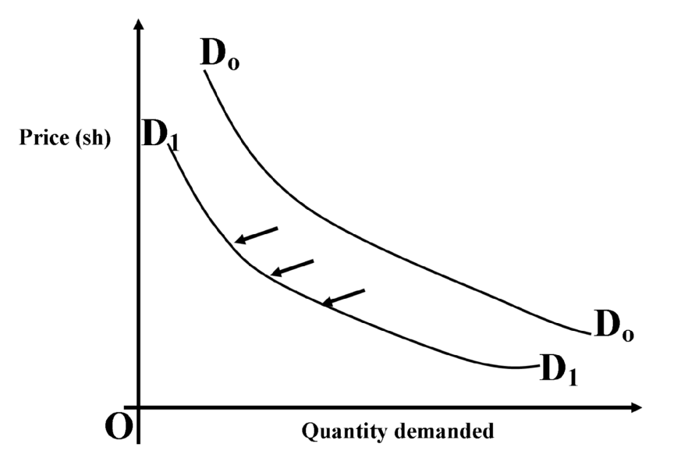

Identify FOUR factors that could have made the demand curve shift from D_{o}D_{o} to D₁D₁. (4mks)

(a)…………………………………………………………………………………………………………………………………………………………………………………………
(b)…………………………………………………………………………………………………………………………………………………………………………………………
(c)…………………………………………………………………………………………………………………………………………………………………………………………
(d)……………………………………………………………………………………………………………………………………………………………………………..

10. State FOUR ways in which the stock of a business may change. (4mks)

(a)…………………………………………………………………………………………………………………………………………………………………………………………
(b)…………………………………………………………………………………………………………………………………………………………………………………………
(c)…………………………………………………………………………………………………………………………………………………………………………………………
(d)…………………………………………………………………………………………………………………………………………………………………………………………
11. Outline FOUR benefits of business ethnics. (4mks)

(a)…………………………………………………………………………………………………………………………………………………………………………………………
(b)…………………………………………………………………………………………………………………………………………………………………………………………
(c)…………………………………………………………………………………………………………………………………………………………………………………………
(d)…………………………………………………………………………………………………………………………………………………………………………………………

12. The following information related to businesses A, B, Cand D.

BUSINESS | ASSESTS | LIABILITIES | CAPITAL
A | 250,000 | M | 150,000
B | N | 400,000 | 600,000
C | 150,000 | 60,000 | P
D | 350,000 | Q | 250,000

Determine the figures represented by M, N, P, and Q (4mks)

M…………………………………………………………………………………………………………………………………………………………………………………………

N……………………………………………………………………………………………………………………………………………………………………………………………

P……………………………………………………………………………………………………………………………………………………………………………………………

Q……………………………………………………………………………………………………………………………………………………………………………………………

13. Record the following transactions in a two column cash book of Manunga Traders and balance it off. (4mks)

2012
January 1 – Balance b/d - cash sh 10,000
- bank sh 25,000

January 2 – Bought stock in cash sh 6,000
January 7 – Cash sales shs 2,500
January 12 – With drew cash from bank for office use sh 4,000
January 1st – Paid wages in cash sh. 3,000
January 31st – Received sh 4,500 from Karanja, a debtor by cheque

Manunga Traders
Two Column Cash book for the month of Jan 2012
Dr Cr
Date | Particulars | Cash | Bank |  | Date | Particulars | Cash | Banks

14. The following account balances were obtained from the books of Mahanda Traders on 30th June 2011.
Sh
Land and buildings - 200,000
Current assets - 420,000
Furniture - 60,000
Motor car - 240,000
Capital - 480,000
Current liabilities - 440,000

Required: Prepare a trial balance for Mahanda Traders as at 30th June 2011

15. The following information was extracted from the books of Gitau Retailers for the year ended 31st December, 2010.
Sh
Cost of sales 1,200,000
Stock as at 1.1.2010 160,000
Stock as at 31.12.2010 240,000

Calculate the rate of stock turnover. (4mks)

16. The following balances were extracted from the books of Wambui Traders as at 31st December, 2009.
Sh
Capital | 620,000
Motor van | 300,000
Stock | 140,000
Furniture | 100,000
Debtors | 120,000
Creditors | 60,000
Bank | 20,000

Additional information:

On 31st December, 2009 Wambui Traders receiver cheques amounting to Sh 40,000
From debtors as part payment of their accounts

Prepare Wambui Traders balance sheet as at 31st December, 2009. (4mks)

17. Name the factor of production that each of the following resources relate to. (4mks)

Resource | Factor of production
a) Accountant

b) Motor vehicle

c) Water

d) Owner

18. State FOUR benefits that a government gets from a bonded warehouse. (4mks)

(a)…………………………………………………………………………………………………………………………………………………………………………………………
(b)…………………………………………………………………………………………………………………………………………………………………………………………
(c)…………………………………………………………………………………………………………………………………………………………………………………………
(d)…………………………………………………………………………………………………………………………………………………………………………………………

19. List FOUR features of effective communication. (4mks)

(a)…………………………………………………………………………………………………………………………………………………………………………………………
(b)…………………………………………………………………………………………………………………………………………………………………………………………
(c)…………………………………………………………………………………………………………………………………………………………………………………………
(d)…………………………………………………………………………………………………………………………………………………………………………………………

20. Give FOUR disadvantages of a long chain of distribution of goods to a buyer. (4mks)

(a)…………………………………………………………………………………………………………………………………………………………………………………………
(b)…………………………………………………………………………………………………………………………………………………………………………………………
(c)…………………………………………………………………………………………………………………………………………………………………………………………
(d)…………………………………………………………………………………………………………………………………………………………………………………………

21. Outline FOUR features of a sole proprietorship form of business organization. (4mks)

(a)…………………………………………………………………………………………………………………………………………………………………………………………
(b)…………………………………………………………………………………………………………………………………………………………………………………………
(c)…………………………………………………………………………………………………………………………………………………………………………………………
(d)…………………………………………………………………………………………………………………………………………………………………………………………

22. List FOUR causes of business failure. (4mks)

(a)…………………………………………………………………………………………………………………………………………………………………………………………
(b)…………………………………………………………………………………………………………………………………………………………………………………………
(c)…………………………………………………………………………………………………………………………………………………………………………………………
(d)…………………………………………………………………………………………………………………………………………………………………………………………
23. State FOUR reasons why a cheque may be dishonored by a bank. (4mks)

(a)…………………………………………………………………………………………………………………………………………………………………………………………
(b)…………………………………………………………………………………………………………………………………………………………………………………………
(c)…………………………………………………………………………………………………………………………………………………………………………………………
(d)…………………………………………………………………………………………………………………………………………………………………………………………

24. State FOUR circumstances under which a trader would advertise his products over the radio instead of television. (4mks)

(a)…………………………………………………………………………………………………………………………………………………………………………………………
(b)…………………………………………………………………………………………………………………………………………………………………………………………
(c)…………………………………………………………………………………………………………………………………………………………………………………………
(d)………………………………………………………………………………………………………………………………………………………………………………………
25. On 1/8/2010, Kamau bought goods on credit quoted at sh 200,000.Terms of sale were 20% trade discount and 10% cash discount if payment was made on 29/8/2010

Calculate the amount paid of payment was made on 26 /06/2010. (4 marks)
END

