MERU CENTRAL CLUSTER EXAMS
END OF TERM TWO – 2020
NAME______________________________SCHOOL_______________________ADMNO______________
451/1
COMPUTER STUDIES
Paper 1 (theory)
2 ½ hours
November 2020
FORM FOUR

INSTRUCTIONS TO CANDIDATES
This paper consists of TWO sections A and B
Answer ALL the questions in section A.
Answer questions 16 and any other THREE questions from section B

FOR OFFICIAL USE ONLY
SECTION | QUESTION | SCORE
A | 1- 15
 | 16
 | 17
 | 18
 | 19
 | 20
 | TOTAL SCORE
SECTION A (40 Marks)
Answer all the questions in this section
1. Explain disk formatting (2mks)

2. (a) Explain why the following controls should be implemented for computer based system ( 2mks)
(i) Data Back- ups
-
(ii) Password

(b) List two examples of utility software in operating systems (2mks)

3. Differentiate between source code and object code (4mks)

4. The cells P3 to P20 of a worksheet contain remarks on students ’ performance such as very good, good, fair and fail depending on the average mark. Write a formula that can be used to count ALL students who have the remark “very good”. (3 mks)

5. (a) State the purpose of registers in a computer system ( 1 mk)

6. Give Three advantages of using GUI based operating system over a command line interface (3mks)

7. (a) Name the control structure depicted by the flowchart below ( 1 mk)
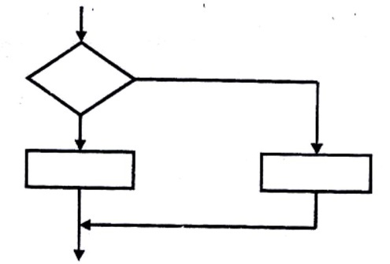

(b) Explain the following terms as used in system implementation ( 2 mks)
(i) parallel running

ii) Direct change over
.
8. (a) Name two methods of representing signed numbers in computers (2 mks)

( b) Identify the four types of storage media shown below. (2 marks)
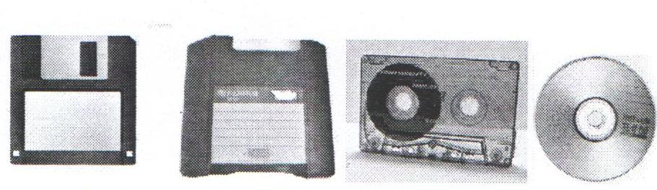
iv
iii
ii
i

c) Compare the storage device (i) and (iii) above. (1 mark)

9. Differentiate between Random and indexed-sequential file organization methods (2mks)

10. Name two types of relationships that can be applied in database design. (2mks)

11. Explain the following terms as used in word processing: (3 mks)
a) Indenting

b) Alignment

c) Word wrap

12. Outline two ways in which computers can be applied in hotels. (2mks)

13. a) Explain binary coded decimal code of data representation. (1mk)

b) Define the term firewall. (1 mark)

14. Arrange the following data units in ascending order of size.
BYTE, FILE, BIT, NIBBLE (2mks)

15. State two health issues that may result from prolonged use of computers. (2mks)
SECTION B (60 MKS)
ANSWER QUESTION 16 AND ANY OTHER THREE QUESTIONS FROM THIS SECTION
16. a) State the stage of program development in which: (4mks)
i) A flowchart would be drawn

ii) The programmer would check whether the program does as required program

iii) The user guide would be written

iv) The user guide would be written

Study the flowchart below and answer the questions that follow. 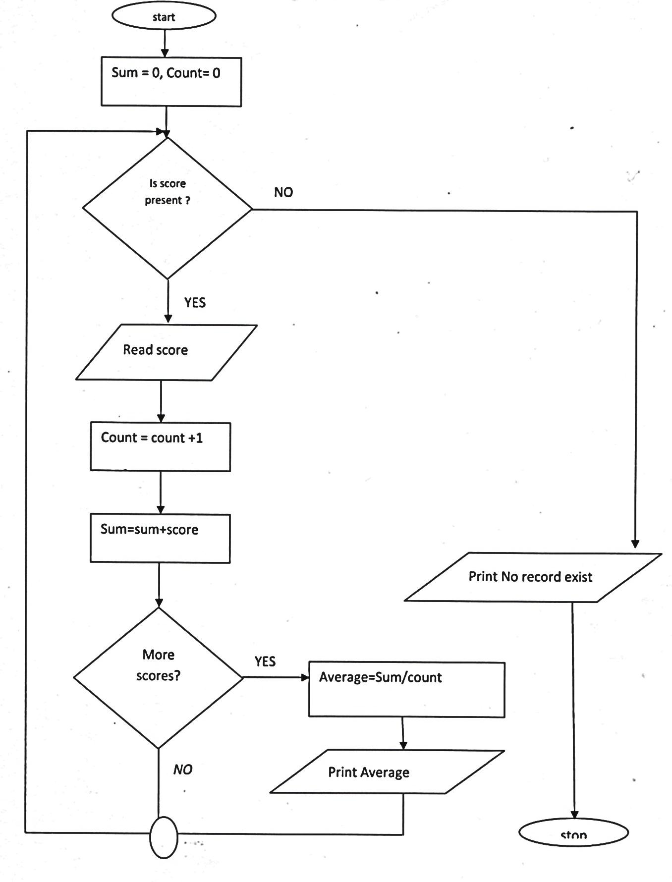
Stop

b) Translate the following flowchart into a pseudo code. (8 marks)

c) Assuming the following score are entered 0, 20 and 60 respectively what would be output from the flowchart. (3 marks)

17. a) Convert each of the following binary numbers to decimal equivalent given that the left most digit is a sign bit. (4 marks)
i) 00101101₂

ii) 11001001₂

b) Convert the decimal number 0.42 to 6 bit binary notation. (4 marks)

c) Using two’s complement, subtract 11₁₀ from 8₁₀, leaving your answer in binary notation. (3 marks)

d) Perform the following binary operation. (2 marks)
11001₂ + 1101₂ + 101₂

e) Using place value method, convert 45₁₀ to its binary equivalent. (2 marks)

18. a) What is virtual reality? (1 mark)

b) Explain the following interactive sensory equipment used in virtual reality. (2 marks)
i) Head gear

ii) Body suit

c) What is Artificial intelligence? (1 mark)

d) State and explain three components of an expert system. (6 marks)

e) Explain method of information gathering in system development. (3 marks)

f) List two application area of virtual reality. (2 marks)

19. a) The following is an extract of a select query (QBE) in Microsoft Access about hospital database.
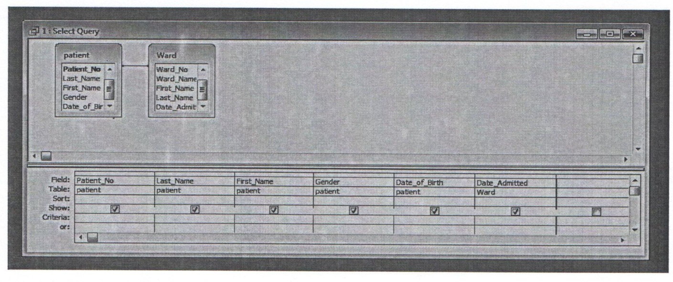
i) Other than select queries name two other queries used in databases. (2 marks)

ii) Write an expression that will return only those patients who are 20 years’ old. (3 marks)

b) Differentiate between bold and unbold controls as used in database forms. (2 marks)

c) Give two reasons why input screens are better data entry designs than entering data directly into a table. (2 marks)

d) The figure below is an extract of a worksheet containing information on household items. Use it to answer the following questions:
 | A | B | C | D | E | F
1 | Item description | No of units | Cost per unit | Total cost
2 | Maize flour | 20 | 210
3 | Tea leaves | 64 | 185
4 | Sugar | 77 | 149
5 | Salt | 28 | 25

i) Write a formula to calculate the total cost of sugar. (1 mark)

ii) The prices of all items increased by 10% and the value 10% is placed in cell B8. Using cell addresses with absolute referencing only, write a formula to calculate the new unit of the salt.
(2 marks)

iii) Write a function to display the number of cells in which the cost per unit is equal to 25. (2 marks)

iv) Write a function to display the least total cost for all items. (1 mark)

20. A school computer laboratory is scheduled to undergo major renovations.
The lab is scheduled to receive new computer whose specifications are given below:-
Pentium IV 2.8GHz processor
40GB HDD
3½ FDD
256MB RAM
56 x CD ROM
17”SVGA TFT monitor
The computers are going to be networked and will be able to browse the internet.
a) Explain what is meant by the terms:- (2 marks)
i) FDD

ii) HDD

iii) SVGA

iv) TFT

b) The computer is to be networked, name one extra device that should be fitted on every computer to enable this to happen. (1 mark)

c) The computer is to receive internet facilities through the server on a dial; up system. Name and describe the function of a special device that needs to be connected to the server to complete the connection. (1 mark)

d) i) The school has to apply star topology to link up the computer. List two advantages of this type of topology. (1 mark)

ii) Name the central device used to connect the computers in this topology. (1 mark)

e) List two other types of topologies that the school could have opted for. (1 mark)

f) List four advantages of using a network. (2 marks)

g) i) Data transmission via the internet is done using a mode known as packet switching. Describe this data transmission mode. (1 mark)

ii) Name two other modes of transmission. (1 mark)

h) i) The school’s LAN is done using UTP cable. List two advantages of using this type of cable. (1 mark)

ii) List two advantages of using fibre cable in networking. (1 mark)

i) Data flows in the school’s LAN in a duplex manner. Discuss two other types of data transmission in network giving examples. (2 marks)

