Kenya Certificate of Secondary Education
GEOGRAPHY
PAPER 2
TIME: 2½ HOURS

Section A: Answer all the questions in the section.

- Name two area studied in human and economic geography. (2mks)
- Give three reasons why it is important to study geography. (3mks)

- Name two types of human settlement. (2mks)
- Use the sketch map below to answer the question below;
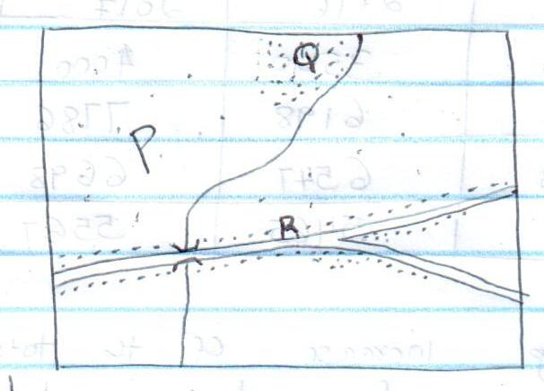
- Identify the settlement marked P,Q and R. (3mks)

- State three social factors that influence agriculture. (3mks)
- Give two types of agriculture. (2mks)

- Name two types of photographs. (2mks)

- State three importance of using photographs to study geography. (3mks
- a.Use the population pyramid below to answer the question (i) and (ii) (diagram of a pyramid of a developing country)
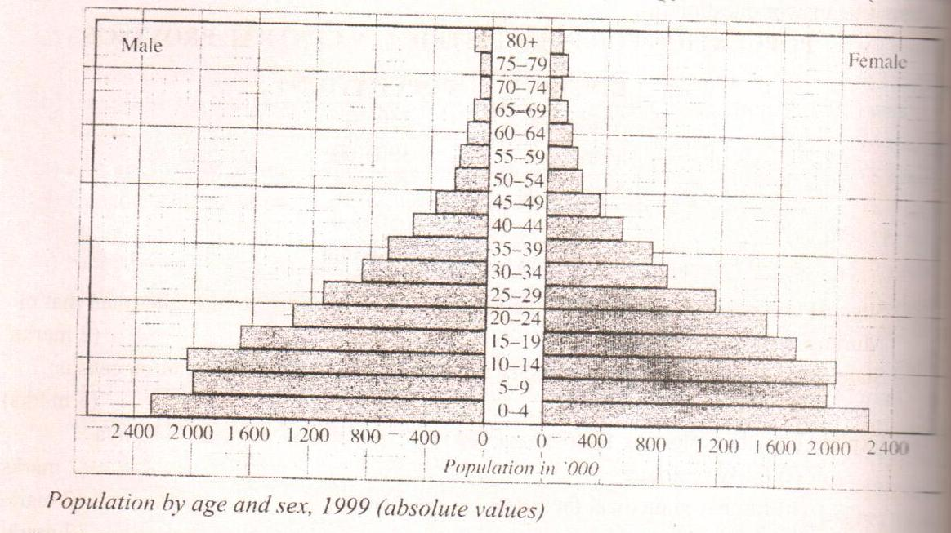

- What information can be derived from a population pyramid? (2mks)
- State two characteristics of the population shown by the pyramid. (3mks)
SECTION B
Answer question 6 and any other from this section.
- The table below shows the production of maize between 2015 and 2017 in four divisions of Baringo county.
Division | 2015 | 2016 | 2017
Bartabwa | 3005 | 3500 | 4000
Barwesa | 6087 | 6198 | 7786
Kabartonjo | 6753 | 6547 | 6698
Kipsaraman | 4078 | 5465 | 5567

- Calculate the percentage increase of the total maize production in the four divisions between 2016 and 2017. (3mks)
- What is the difference in kilograms between the highest production and the lowest in the three years? (2mks)
b. (i)Using a radius of 2.5cm draw a pre chart to represent maize production in 2017. (7mks)
(ii) Give two advantages of using a pie chart in representing information. (3mks)
c.(i)State three climatic conditions favoring maize growing. (3mks)
- Explain four problems facing small scale maize farmers in Kenya. (8mks)

- What is mining? (2mks)
- Describe how deep shaft mining is carried out. (4mks)

- Name the method used to mine trona in lake Magadi. (1mk)
- Give four uses of soda ash. (4mks)
- Explain three ways in which trona mining contributes to the economy of Kenya. (6mks)
- Explain four problems facing soda ash mining in L. Magadi. (8mks)

- Differentiate between indigenous and exotic species. (2mks)
- Give three forest reserves found along the Kenyan coast. (3mks)
c). (i)State four factors that influence the distribution of forest in Kenya. (4mks)
(ii)Explain four measures taken by the Kenyan government to conserve forest in the country. (8mks)
(d)
- Explain three factors that favor the growth of natural forest on the slopes of Mount Kenya. (6mks)
- Give the difference between softwood forest in Kenya and Canada under;
Transportation of logs. (2mks)
9.a)
- Differentiate land reclamation and land rehabilitation. (2mks)
- Name three rivers that supply water to Mwea Tebere irrigation scheme. (3mks)
b.i) Identify three methods used to control tsetse flies in Kenya. (3mks)
(ii) State three benefits that resulted from the reclamation of the Yala swamps. (3mks)
c.)Describe the stages in the reclamation of land from the sea in the Netherlands. (6mks)
d) Explain four differences between land reclamation in Kenya and Netherlands. (8mks)
10.
- Describe how the following factors influence fishing in the north west pacific fishing ground under the following sub-headings:
- Ocean currents. (2mks)
- Upwelling of ocean water. (2mks)
- Continental shelf. (2mks)

- Explain four problems that face inland fishing in Kenya. (8mks)
- Explain three methods of controlling pollution in the fishing grounds. (6mks)

- What is fish farming? (2mks)
- Give three methods of conserving fisheries in Kenya. (3mks)

