NAME……………………………………………………….. INDEX NO…………………….......

121/1 CANDIDATE’S SIGN…..…………...
MATHEMATICS ALT A
PAPER 1 DATE……….……………………….
DECEMBER, 2020
TIME: 2½ HOURS

Kenya Certificate of Secondary Education
MATHEMATICS ALT A
PAPER 1
TIME: 2½ HOURS

INSTRUCTION TO CANDIDATE’S:
(a) Write your name, index number in the spaces provided at the top of this page.
(b) Sign and write the date of examination in spaces provided above.
(c) This paper consists of TWO sections: Section I and Section II.
(d) Answer ALL the questions in Section I and any five questions from Section II.
(e) Show all the steps in your calculation, giving your answer at each stage in the
spaces provided below each question.
(f) Marks may be given for correct working even if the answer is wrong.
(g) Non-programmable silent electronic calculators and KNEC Mathematical tables
may be used, except where stated otherwise.
(h) This paper consists of 16 printed pages.
(i) Candidates should check the question paper to ascertain that all the pages are
printed as indicated and that no questions are missing.
(j) Candidates should answer the questions in English.

FOR EXAMINER’S USE ONLY:

SECTION I
1 | 2 | 3 | 4 | 5 | 6 | 7 | 8 | 9 | 10 | 11 | 12 | 13 | 14 | 15 | 16 | TOTAL

SECTION II
Grand
Total

17 | 18 | 19 | 20 | 21 | 22 | 23 | 24 | TOTAL

SECTION A (50 MARKS)
Answer all questions in this section
- Evaluate without using a calculator
¼ + ¹/₅ ÷ ½ of ¹/₃ (3mks)
½ of (⁴/₅ – ¾ + ½)

2. Simplify completely.
3a² + 5ab – 2b² (3mk)
b² – 9a²

3. An artisan has 63kg of metal of density 7000kg/m³. He intends to use it to make a rectangular pipe with external dimensions 12cm by 15cm and internal dimensions 10cm by 12 cm. Calculate the length of the pipe in metres. (3mks)

4. Given that Sin θ = 2/3 and θ is an acute angle, find without using tables or calculators
(a) tan θ, giving your answer in surd form. (2mks)

- Cos (90 - θ) (1mk)

5. Four machines give out signals at intervals of 24, 27, 30 and 50 seconds respectively. At 5.00pm all the four machines give out a signal simultaneously. Find the time this will happen again. (3mks)

6. Two pipes A and B can fill an empty tank in 3hrs and 5hrs respectively. Pipe C can empty the full tank in 4 hours. If the three pipes A, B, and C are opened at the same time, find how long it will
take for the tank to be full. (3mks)

7. A tourist arrived in Kenya with sterling pound (£) 4680 all of which he exchanged into Kenyan money. He spent Ksh. 51,790 while in Kenya and converted the rest of the money into U.S dollars. Calculate the amount he received in U.S dollars. The exchange rates were as follows.

Buying Selling.
US $ 65.20 69.10
Sterling Pound (£) 123.40 131.80 (4mks)

8. The gradient of a straight line L₁ passing through the points P (3, 4) and Q (a, b) is ⁻³/₂. A line L₂ is perpendicular to line L₁ and passes through the points Q and R (2, -1). Determine the values of a and b. (4mks)

9. Determine the quartile deviation of the set of numbers below. (2mks)
8, 2, 3, 7, 5, 11, 2, 6, 9, 4

10. Using a ruler and a pair of compasses only, construct a rhombus QRST in which angle TQR = 60⁰ and QS = 10cm. (3 mks)

11. Without using tables or calculators, find the value of t in
log ( t + 5) – log (t - 3) = ²/₃ (3mks)
8
8

12. Use the tables of cube roots, squares, and reciprocals to evaluate the following correct to 4 s.f
(3mks)
3____ 2___
^{1/}₃
(0.0136) (3.72)²

13. Three years ago John was four times as old as his son Peter. In five years time the sum of their ages will be 56. Find their present ages. (3mks)

14. Mutune bought three pens and four exercise books for a total of sh. 155 while Bonyo bought two similar pens and five similar exercise books for a total of sh. 150. Determine the cost of a pen and that of an exercise book by elimination method. (4mks)

15. The volumes of two similar solids are 800cm³ and 2700cm³. If the surface area of the larger one is 2160cm², find the surface area of the smaller figure. (3mks)

16. Find the number of sides of a regular polygon whose interior angle is five times the exterior angle. (3mks)

SECTION II (50 MARKS)
Answer any five questions in this section.
17. (a) Complete the table below for the equation y = x² + 3x – 6 given -6 ≤ x ≤ 4 (2mks)
x | -6 | -5 | -4 | -3 | -2 | -1 | 0 | 1 | 2 | 3 | 4
y

(b) Using a scale of 1cm to represent 2 units in both axes; draw the graph of y = x² + 3x – 6 (3mks)

(c) Use your graph to solve the quadratic equations.
- x² + 3x – 6 = 0 (2mks)

- x² + 3x – 2 = 0 (3mks)

18. (a) Plot a triangle ABC with coordinates A(-2,6) B(2,3) and C(-2, 3) (1mk)
(b) Reflect ΔABC in the line x = -3. Plot Δ A^{I}B^{I}C¹ the image of ΔABC under this transformation.
(2mks)

- Translate A_{I}, B_{I}, C_{I} through 10 Label the image A₂B₂C₂ and write down the
2
coordinates of the points A₂, B₂, C₂ (3mks)

(d) A₃ (6, -6), B₃ (2, -3) and C₃ (6, -3) is the image of A₂ B₂ C₂ after a transformation P plot A₃B₃C₃ and describe the transformation. (2mks)

(e) Describe fully a single transformation that would have mapped ABC to A₃B₃C₃. (2mks)

19. The figure below shows a triangle ABC inscribed in a circle. AC = 10cm, BC = 7cm and
AB = 10cm.
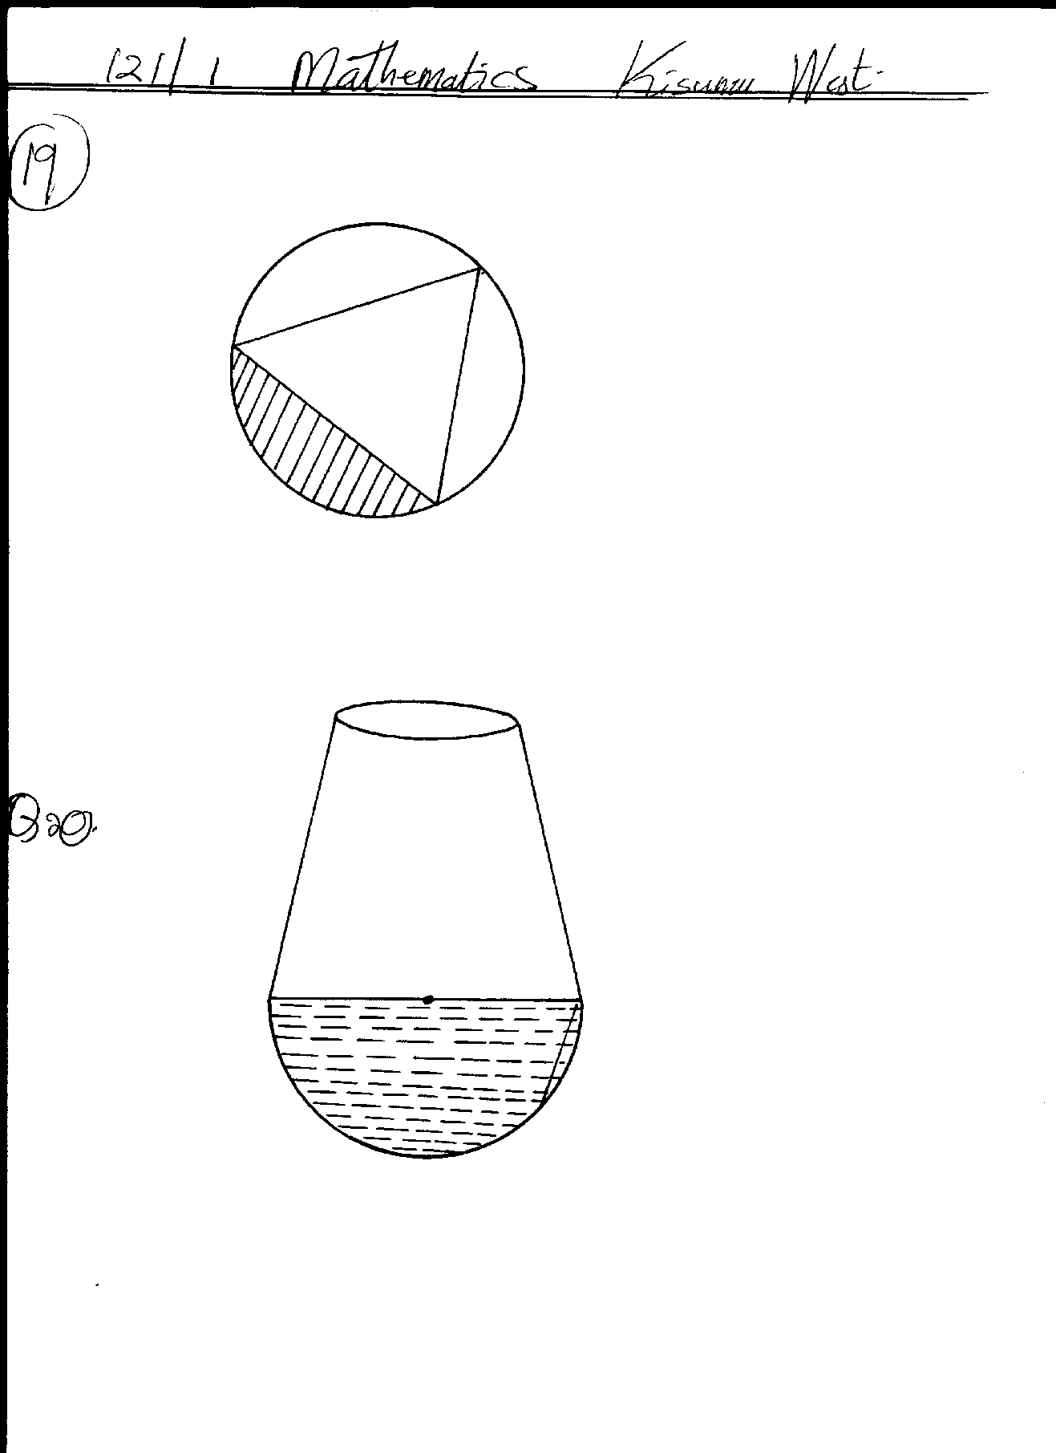
10cm
B
C
A
8cm
7cm

(a) Find the size of angle BAC. (2mks)

(b) Find the radius of the circle. (2mks)

(c) Hence calculate the area of the shaded region. (6mks)

20. The figure below shows a cross-section of a bottle. The lower part ABC is a hemisphere of radius 5.2cm and the upper part is a frustrum of a cone. The top radius of the frustrum is one third of the radius of the hemisphere. The hemispherical part is completely filled with water as shown.
5.2cm
A
C
B

When the container is inverted, the water now completely fills only the frustrum part.
- Determine the height of the frustrum. (6mks)

(b) Find the external surface area of the bottle. (4mks)

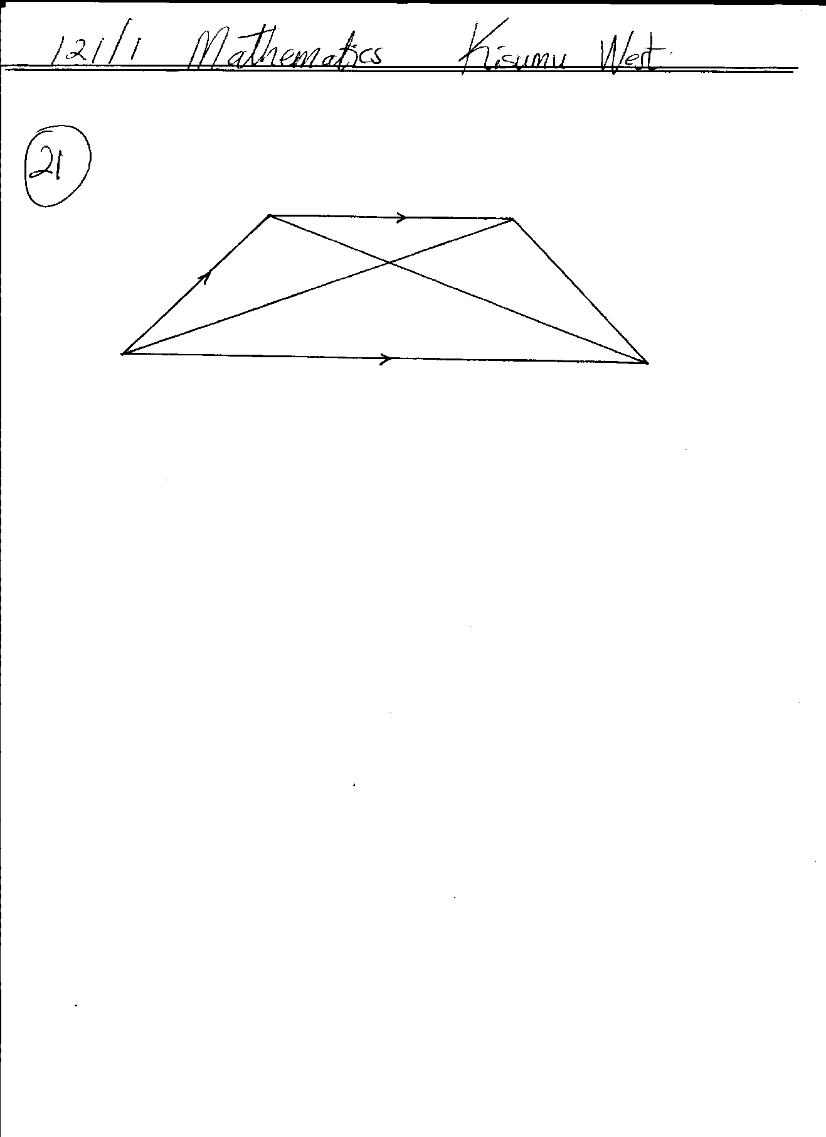
21. In the figure below, ABCD is a trapezium. AB is parallel to DC, diagonals AC and DB intersect at X and DC = 2AB, AB= a, DA = d, AX = kAC and DX = hDB, Where h and k are constants.
∼
∼
∼
∼
a
B
A
X
D
C
∼
d

∼
∼
(a) Find in terms of a and d
(i) BC. (1mk)

(ii) AX. (2mks)

(iii) DX. (1mk)

- Determine
(i) The values of h and k. (5mks)

(ii) The ratio in which X divides BD. (1mk)

22. The figure below shows two circles of radii 10.5 and 8.4cm and with centres A and B respectively. The common chord PQ = 9cm.
A
P
Q
B
8.4cm
10.5cm

(a) Calculate angle PAQ. (2 marks)

(b) Calculate angle PBQ. (2 marks)

(c) Calculate the area of the shaded part. (6 marks)

23. Four cities A, B,C, and D are such that town B is 1500km due East of town A. Town C is 1800km due North of town B. Town D is on a bearing of 330⁰ from town A and on a bearing of 300⁰ from C.
- Use a ruler and compasses only to show the position of town A, B, C, D
(Take a scale of 1cm = 300km) (5mks)

- Determine
(i) The distance AD. (2mks)

(ii) The distance CD (2mks)

(iii) The bearing of town D from town B. (1mk)

24. A car leaves town X from town Y 120km away at an average speed of 70km/h at 8.00am. At the same time a bus leaves town Y for town X at an average speed of 50km/hr. At 8.15am, a cyclist leaves town Y for town X at an average speed of 30km/hr.
(a) Calculate the time when the bus meets the car. (3mks)

(b) Calculate the distance between the car and the bus by the time the cyclist meets the car. (4mks)

- If the bus upon reaching town X rests for 10 minutes then starts its journey back to Y, calculate
how far from X the bus meets the cyclist. (3mks)

