NAME……………………………………………… ….. ……………. INDEX NO……………………

121/2 CANDIDATE’S SIGN…..…………...

MATHEMATICS ALT A

PAPER 2 DATE……….………………………..

MARCH/APRIL, 2020

TIME: 2½ HOUR

Kenya Certificate of Secondary Education

MATHEMATICS ALT A

PAPER 2

TIME: 2½ HOURS

INSTRUCTION TO CANDIDATE’S:

1. *Write your name, index number in the spaces provided at the top of this page.*
2. *Sign and write the date of examination in spaces provided above.*
3. *This paper consists of TWO sections: Section I and Section II.*
4. *Answer ALL the questions in Section I and any five questions from Section II.*
5. *Show all the steps in your calculation, giving your answer at each stage in the spaces provided below each question.*
6. *Marks may be given for correct working even if the answer is wrong.*
7. *Non-programmable silent electronic calculators and KNEC Mathematical tables may be used, except where stated otherwise.*
8. *This paper consists of 15 printed pages.*
9. *Candidates should check the question paper to ascertain that all the pages are printed as indicated and that no questions are missing.*
10. *Candidates should answer the questions in English.*

**FOR EXAMINER’S USE ONLY:**

**SECTION I**

|  |  |  |  |  |  |  |  |  |  |  |  |  |  |  |  |  |
| --- | --- | --- | --- | --- | --- | --- | --- | --- | --- | --- | --- | --- | --- | --- | --- | --- |
| **1** | **2** | **3** | **4** | **5** | **6** | **7** | **8** | **9** | **10** | **11** | **12** | **13** | **14** | **15** | **16** | **TOTAL** |
|  |  |  |  |  |  |  |  |  |  |  |  |  |  |  |  |  |

|  |  |
| --- | --- |
| **Grand** |  |
| **Total** |  |

**SECTION II**

|  |  |  |  |  |  |  |  |  |
| --- | --- | --- | --- | --- | --- | --- | --- | --- |
| **17** | **18** | **19** | **20** | **21** | **22** | **23** | **24** | **TOTAL** |
|  |  |  |  |  |  |  |  |  |

**SECTION I(50 Marks)**

***Answer all the questions in this section in the spaces provided***

1. Use logarithms to evaluate: (3 marks)



1. Given thatis a perfect square, find. (3 marks)
2. Make q the subject of the formula:

 (3 marks)

1. Given that P varies directly as V and inversely as the cube of R and that P = 12 when V = 3 and R = 2,

(i) Find an equation connecting P, V and R. (3 marks)

(ii) Find the value of V when P = 10 and R = 1.5 (1 mark)

1. (a) Find the inverse of the matrix (1 mark)



(b) Hence solve the following simultaneous equations using matrix method (3 marks)





1. A car was valued at Ksh.3000000 in January. Each year its value decreased by 12% of its

value at the beginning of the year. Find the value of the car in January 2004 giving your

answer correct to 4s.f. (3 marks)

1. Given that **a** = 3**i**  - 2**j** + 3k and

**b** = 2**i**  - 4**j**  - 3k

Find **2a** - **3b** (3mks)

1. (a) Expand  (1 marks)

(b) Use the first three terms of the expansion in (a) to find the approximate value of (0.98)4 (2 marks)

1. Kinyua bought soya and millet at sh.65 per kg and sh.40 per kg respectively. He then mixed

them and sold the mixture at sh.60 per kg making a profit of 20%. Determine the ratio of soya

to millet in mixture. (3mks)

1. Chord AB is of length 8cm and the maximum distance between chord and lower part of circle

is 2cm. Determine the radius of the circle. (3mks)

8cm

2cm

A

B

1. Find the length represented by y in the figure **below**. (3mks)

6cm

15cm

ycm

112°

1. The base and perpendicular height of a triangle measured to the nearest centimeter are 6cm and 4cm respectively. Find

(a) The absolute error in calculating the area of the triangle. (2 marks)

(b) The percentage error in the area giving the answer to 1 decimal place. (1 mark)

1. Given that  , find the ratio x:y (2 marks)
2. If  , find the value of a, b and c (3 marks)
3. Given that cos θ =  , find the value of  in its simplest form. (3 marks)

(Leave your answer in surd form)

1. Points **P**, **Q** and **R** are on the same horizontal ground such that point **P** is due south of **R** and point **Q** is due west of point **R**. **S** is a point at the top of a tower, 20m vertically above **R**. The angles of elevation of **S** from **P** and **Q** are 27° and 35° respectfully. Calculate to the nearest degree, the bearing of **Q** from **P**. (4 marks)

**SECTION II (50 MARKS)**

**Answer only FIVE questions in this section in the spaces provided.**

1. The table below shows the Kenya tax rates in a year

|  |  |
| --- | --- |
| **Income (Ksh per annum)** | **Tax rate (per £)** |
| 1 – 116,160 | 10% |
| 116,161 – 225,600 | 15% |
| 225,601 – 335,040 | 20% |
| 335,041 – 444,480 | 25% |
| Over 444,481 | 30% |

In that year, Ushuru earned a basic salary of Ksh 30000 per month. In addition, he was entitled to a medical allowance of Ksh 2,800 per month and a traveling allowance of Ksh 1800 per month. He is housed by the employer and pays a nominal rent of 2000. He also claimed a monthly family relief of Ksh 1056. Other monthly deductions were union dues Ksh 445, WCPS Ksh 490, NHIF Ksh 320, COOP shares Ksh 1000 and risk fund Ksh 100

Calculate:

1. Ushuru’s annual taxable income. (2marks)
2. The tax paid by Ushuru in that year (5marks)
3. Ushuru’s net income in that year (3marks)
4. (a)Complete the table for the function , where (2 marks)

|  |  |  |  |  |  |  |  |  |  |  |  |  |  |
| --- | --- | --- | --- | --- | --- | --- | --- | --- | --- | --- | --- | --- | --- |
|  |  |  |  |  |  |  |  |  |  |  |  |  |  |
|  |  |  |  |  |  |  |  |  |  |  |  |  |  |
|  |  |  |  |  |  |  |  |  |  |  |  |  |  |
|  |  |  |  |  |  |  |  |  |  |  |  |  |  |

(b) On the grid provided, draw the graph of the function  for using the scale 1cm for 300 on the horizontal axis and 4cm for 1 unit of y axis. (3 marks)

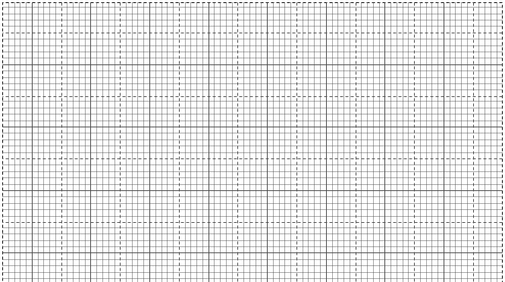

(c) Use your graph to determine the amplitude and period of the function (2 marks)

1. Use the graph to solve
2.  (1 mark)
3.  (2 marks)
4. The following are marks out of 100 scored by 40 learners in a Mathematics contest.

|  |  |  |  |  |  |  |
| --- | --- | --- | --- | --- | --- | --- |
| Marks | 40 – 49 | 50 – 59 | 60 – 69 | 70 – 79 | 80 - 89 | 90 – 99 |
| No. of learners | 4 | 6 | 8 | 12 | 8 | 2 |

(a) (i) Using an assumed mean of 64.5, calculate the standard deviation of the data. (5marks)

b. On the grid provided, draw a cumulative frequency curve. (3 marks)

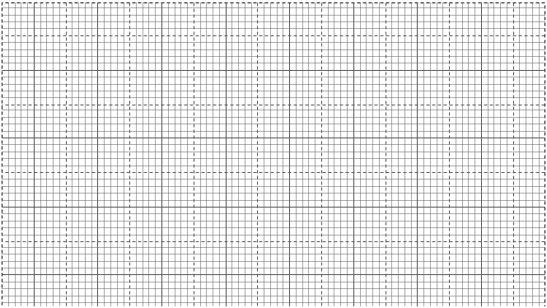

From your graph, determine;

(i) The median (1mark)

(ii) The interquartile range (1mark)

1. A triangle ABC with vertices at A (1,-1) B (3,-1) and C (1, 3) is mapped onto triangle A1B1C1 by a transformation whose matrix is

Triangle A1B1C1 is then mapped onto A11B11C11 with vertices at A11 (2, 2) B11 (6, 2) and C11 (2,-6) by a second transformation.

(i) Find the coordinates of A1B1C1 (3 marks)

(ii) Find the matrix which maps A1B1C1 onto A11B11C11. (2 marks)

(iii) Determine the ratio of the area of triangle A1B1C1 to triangle A11B11C11. (3 marks)

(iv) Find the transformation matrix which maps A11B11C11 onto ABC (2 marks)

1. In a form 2 classare boys and the rest are girls. of the boys and of the girls are right handed; the rest are left handed. The probability that a right handed student will answer a question correctly is and the corresponding probability for a left handed student is irrespective of the sex.

By use of tree diagram; Determine

1. The probability that a student chosen at random from the class is left handed. (5 marks)
2. Given that getting a boy or a girl at any stage in a family of three children is equally likely;
3. Use the letters B and G to show the possibility space for all families with three children (1mark)
4. Using the possibility space calculate the probability that a family of three children has at least one girl. (2marks)
5. The oldest and the youngest are of the same sex. (2marks)
6. The 2nd and 5th terms of an arithmetic progression are 8 and 17 respectively. The 2nd, 10th and

42nd terms of the A.P. form the first three terms of a geometric progression. Find

(a) the 1st term and the common difference. (3mks)

(b) the first three terms of the G.P and the 10th term of the G.P. (4mks)

(c) The sum of the first 10 terms of the G.P. (3mks)

1. In the figure below AOC is a diameter of the circle centre O. AB = BC and

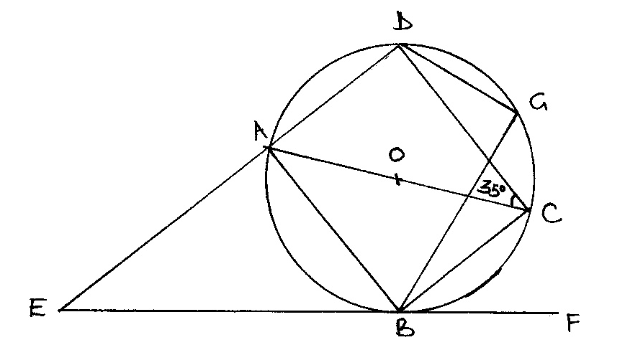∠ACD = 35°, EBF is a tangent to the circle at B. G is a point on minor arc CD.

Calculate the size of the following angles giving reasons in each case.

(a) ∠BCD. (2 marks)

(b) Obtuse angle BOD. (2 marks)

(c) ∠BAD. (2 marks)

(d) ∠CGD. (2 marks)

(e) ∠AEB. (2 marks)

24. A trader bought 8 cows and 12 goats for a total of Ksh.294,000. If he had bought 1 more cows and 3 more goats he would have spend Ksh.337,500.

(a) Form two equations to represent the above information. (2 marks)

(b) Use matrix method to determine the cost of a cow and that of a goat. (4 marks)

1. The trader sold the animals he had bought making a profit of 40% per low and 45% per goat.

(i) Calculate the total amount of money he received. (2 marks)

(ii) Determine his profit in Kenya shillings. (2 marks)