Name ............................................................................................................... Index No. ..............................

School ............................................................................................Candidate's signature ..............................

232/1
Date ........................................................

PHYSICS
Paper 1
Time 2 hours

PHYSICS
Paper - 232/1
Time: 2 hours
INSTRUCTIONS TO CANDIDATES
• Write your name and index number in the spaces provided above.
• Sign and write the date of the examination in the spaces provided above.
• This paper consist of two sections A and B.
• Answer ALL questions in section A and B in the spaces provided.
• All working must be clearly shown in the spaces provided in this booklet.
• Non-programmable, silent electronic calculators and KNEC mathematical tables may be used.

EXAMINER'S USE ONLY

SECTION | QUESTION | MAXIMUM SCORE | CANDIDATES SCORE
A | 1 - 14 | 25
B | 15 | 10
B | 16 | 11
B | 17 | 12
B | 18 | 14
B | 19 | 08
TOTAL SCORE |  | 80
This paper consists of 12 printed pages
Candidates should check the question paper to ensure that all the printed pages are printed as indicated and no questions are missing.

SECTION A (25 marks)
Answer ALL the questions in the spaces provided.

1. Figure 1 shows a section of a vernier calliper scale.

INSIDE JAWS

0 1 2 3 4 5 6

5

Fig 1

OUTSIDE JAWS

State the reading of the diameter being measured. (1 mark)

...................................................................................................................................................................

2. A man has 2m³ of concrete delivered to his home and he needed to carry it down in a wheel barrow.
If each barrow load weighs 2500N, how many trips will he have to make? (2 marks) (Density of concrete = 3000kgm-3)

 | ...................................................................................................................................................................
 | ...................................................................................................................................................................
 | ...................................................................................................................................................................
 | ...................................................................................................................................................................
3. | Figure 2 shows an instrument used to measure atmospheric pressure.

Fig 2
Vacuum

L

a) Name the instrument. (1 mark)

................................................................................................................................................................... b) Name the liquid marked L. (1 mark)
...................................................................................................................................................................

4. A motor car is uniformly retarded and brought to rest from a speed of 108 km/h in 15 sec. Find its acceleration. (2 marks)

 | ...................................................................................................................................................................
 | ...................................................................................................................................................................
 | ...................................................................................................................................................................
 | ...................................................................................................................................................................
5. | Figure 3 shows two spheres made of wax each of mass 0.10kg held in a liquid by strings A and B.
Liquid

A

Fig 3

wax Sphere

B

If the upthrust on each sphere is 1.05N, determine the tension in each string. (g = 10ms-2) (2 marks)

...................................................................................................................................................................

...................................................................................................................................................................

...................................................................................................................................................................

...................................................................................................................................................................

6. Fig 4 shows a ball being whirled in a vertical plane
Ball string
Fig 4
W
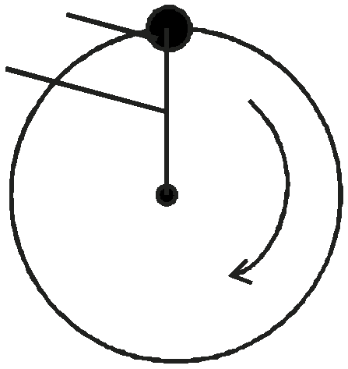

Sketch on the figure the path followed by the ball if the string cuts when the ball is in the position shown in the figure. (1 mark)

7. A girl blew air along the horizontal plane below the paper as shown in figure 5.

Fig 5
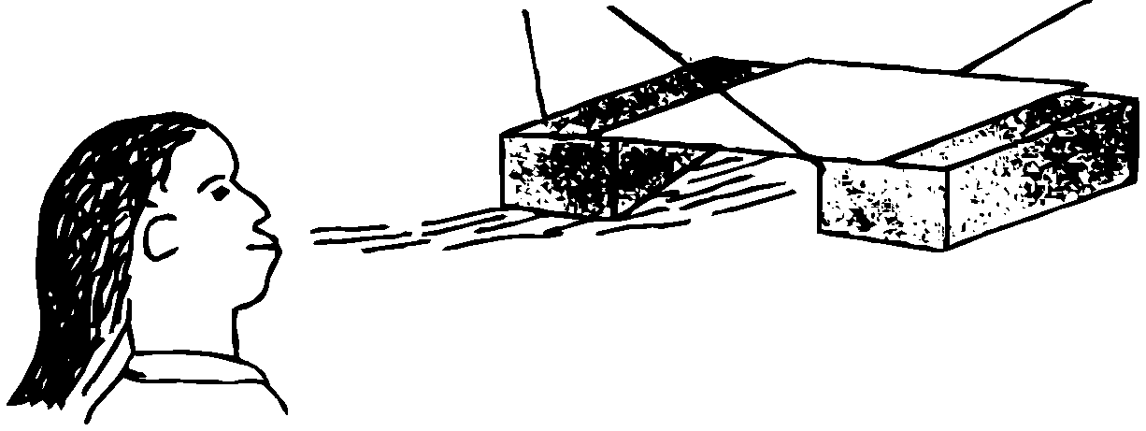

Blocks of wood Paper

State and explain what would be observed. (2 marks)

...................................................................................................................................................................

...................................................................................................................................................................

...................................................................................................................................................................

8. Fig 6 shows a uniform metre rule pivoted at the 30cm mark. It is balanced by a weight of 2N
suspended at the 5cm mark.

5cm 30cm
Fig 6

2N
Determine the weight of the metre rule. (2 marks)

...................................................................................................................................................................

...................................................................................................................................................................

...................................................................................................................................................................

...................................................................................................................................................................

9. Fig 7 shows a brick placed on a plane inclined at an angle θ to the horizontal. The weight W of the brick is shown.

Fig 7

W

θ

a) On the same diagram show with arrows the other two forces acting on the brick and name them.
(1 mark)

b) State how each of the two forces named in (a) above is affected when angle θ is reduced. (1 mark)

...................................................................................................................................................................

...................................................................................................................................................................

...................................................................................................................................................................

10. Fig 8 shows a flask filled with water. The flask is fitted with a cork through which a tube is inserted.
When the flask is cooled, the water level rises slightly, then falls steadily.

Tube

Cork

Flask

Fig 8

Water

Explain this observation. (2 marks)

...................................................................................................................................................................

...................................................................................................................................................................

11. Fig 9 shows the use of pulleys in holding a cable taut.
x
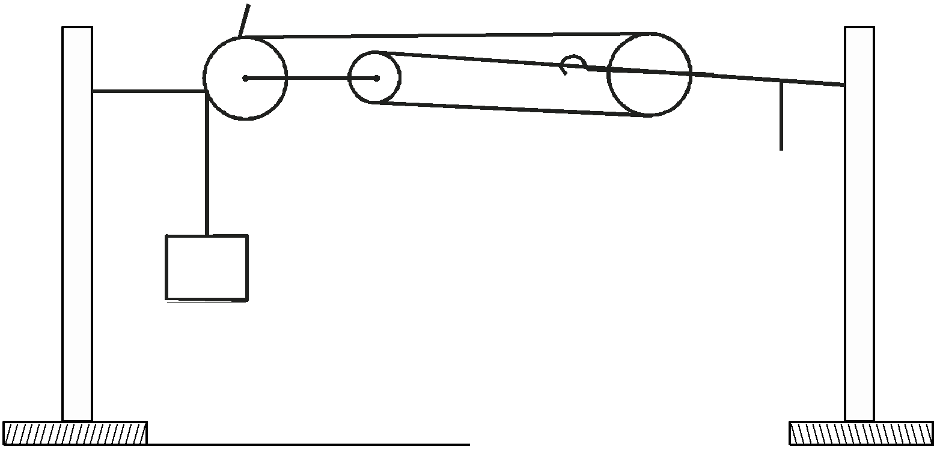

Fig 9

Cable

a) What is the purpose of pulley X? (1 mark)

...................................................................................................................................................................

................................................................................................................................................................... b) How do the pulleys used serve the purpose of the arrangement? (2 marks)
...................................................................................................................................................................

...................................................................................................................................................................

...................................................................................................................................................................
Volume

12. On the set of axes below show how the volume of an ideal gas varies with pressure. (1 mark)

Fig 10

pressure

13. The three springs shown in Fig 11 are identical and have negligible weight. The extension produced on the system of springs is 20cm

Fig 11

20N

20N

Determine the constant on each spring. (2 marks)

...................................................................................................................................................................

...................................................................................................................................................................

...................................................................................................................................................................

14. Figure 12 shows an athlete lifting weights while standing with the feet apart.

Fig 12

Explain why standing with the feet apart improves the athlete's stability. (1 mark)

...................................................................................................................................................................

...................................................................................................................................................................

SECTION B : 55 marks

15. State the law of floatation. (1 mark)

...................................................................................................................................................................

...................................................................................................................................................................
................................................................................................................................................................... b) Figure 13 shows a piece of cork held with a light thread attached to the bottom of a beaker. The
beaker is filled with water.

Fig 13
Water

Cork

String

i) Indicate and label on the diagram the forces acting on the cork. (3 marks)

ii) Write an expression showing the relationship between the forces. (1 mark)

...................................................................................................................................................................

...................................................................................................................................................................

c) A solid displaces 8.5cm³ of liquid when floating on a certain liquid and 11.5cm³ when fully submerged with liquid. The density of solid in 0.8g/cm³, determine:-

i) Upthrust on the solid when floating. (3 marks)

...................................................................................................................................................................

...................................................................................................................................................................

...................................................................................................................................................................

................................................................................................................................................................... ii) Density of the liquid. (2 marks)
...................................................................................................................................................................

...................................................................................................................................................................

...................................................................................................................................................................

16.a) Carbon dioxide is used to make fizzy drinks. It is stored in high pressure in cast iron cylinder.
Figure 14 represents the particles in a cylinder of carbon dioxide.

Fig 14 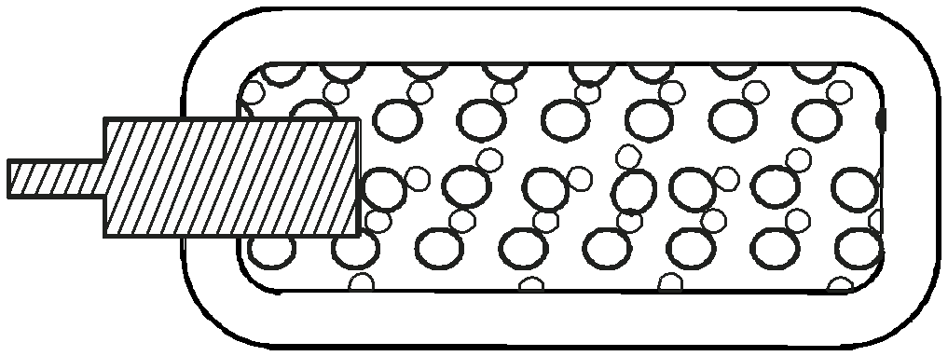

i) Describe how particles of carbon dioxide exert pressure. (3 marks)

...................................................................................................................................................................

...................................................................................................................................................................

...................................................................................................................................................................
................................................................................................................................................................... ii) The temperature of the gas in the cylinder is increased.
I. What effect does this have on the movement of the carbon dioxide particles? (1 mark)

...................................................................................................................................................................

...................................................................................................................................................................
II. Explain how this affects the pressure exerted by the g as. (1 mark)

...................................................................................................................................................................

...................................................................................................................................................................

III. The gas cylinder are painted black. Explain why gas cylinder should not be stored outside in the direct sunlight. (2 marks)

...................................................................................................................................................................

...................................................................................................................................................................

...................................................................................................................................................................

...................................................................................................................................................................

b) A weather balloon contains 100m³ of helium when atmospheric pressure is 90Kpa. If the atmosphere pressure changes to 100Kpa, calculate the new volume. (3 marks)

...................................................................................................................................................................

...................................................................................................................................................................

...................................................................................................................................................................

...................................................................................................................................................................

...................................................................................................................................................................

...................................................................................................................................................................

c) A boy wants to rescue someone who has fallen through ice pond. Would it be safe to walk or crawl across the ice towards him? Explain. (2 marks)

...................................................................................................................................................................

...................................................................................................................................................................

...................................................................................................................................................................

...................................................................................................................................................................

17. The speed of a train, hauled by a locomotive varies as shown below as it travels between two stations along a straight horizontal track.

A B

20
-1

Fig 15 15
Speed/ms

10

5
C

0 1 2 3 4 5 6 7 8 9 10
Time/Minutes

a) Use the graph to determine:

i) the maximum speed of the train. (1 mark)

...................................................................................................................................................................

................................................................................................................................................................... ii) The acceleration of the train during the first 2mins of the journey. (2 marks)
...................................................................................................................................................................

...................................................................................................................................................................

...................................................................................................................................................................

...................................................................................................................................................................
iii) The time during which the train is slowing down. (2 marks)

...................................................................................................................................................................

...................................................................................................................................................................

...................................................................................................................................................................

................................................................................................................................................................... iv) The total distance, in metres, between the two stations. (4 marks)
...................................................................................................................................................................

...................................................................................................................................................................

...................................................................................................................................................................

...................................................................................................................................................................

...................................................................................................................................................................

................................................................................................................................................................... v) The average speed in ms-1 of the train. (3 marks)
...................................................................................................................................................................

...................................................................................................................................................................

...................................................................................................................................................................

...................................................................................................................................................................

...................................................................................................................................................................

18.a) Define specific latent heat of vaporization. (1 mark)

...................................................................................................................................................................

...................................................................................................................................................................

b) In an experiment to determine the specific latent heat of vaporization of a liquid using an electrical method, the amount of heat, Q, required to vapourise a given mass, m, of a liquid were recorded as shown in table.

Q(J) × 10³ | 3.0 | 4.0 | 5.0 | 6.0 | 7.0 | 8.0
M(kg)×10-³ | 4.0 | 6.4 | 8.8 | 11.2 | 13.6 | 16.0
i) On the grid provided plot a graph of Q(y - axis) against m. (5 marks)

ii) From the graph, determine the specific latent heat of vaporization of the liquid. (3 marks)

...................................................................................................................................................................

...................................................................................................................................................................

...................................................................................................................................................................

...................................................................................................................................................................

...................................................................................................................................................................
iii) Suggest a reason why the graph does not pass through the origin. (1 mark)

...................................................................................................................................................................

...................................................................................................................................................................

................................................................................................................................................................... iv) Write a possible equation of this graph. (1 mark)
...................................................................................................................................................................

...................................................................................................................................................................

...................................................................................................................................................................

c) Calculate the amount of heat required to melt 30g of ice that 0°C. (Latent heat of fusion of ice is 3.34 × 105 jKg-1)
Give your answer correct to two decimal places. (3 marks)

...................................................................................................................................................................

...................................................................................................................................................................

...................................................................................................................................................................

...................................................................................................................................................................

...................................................................................................................................................................

19.a) Define the angular velocity. (1 mark)
...................................................................................................................................................................
................................................................................................................................................................... b) The figure 16 shows an object of mass 0.2kg whirled in a vertical circle of radius 0.5m at
uniform speed of 5m/s. A
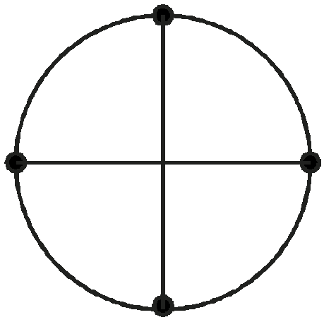

Fig 16 B D

C

Determine the tension in the string at

i) Position A. (3 marks)

...................................................................................................................................................................

...................................................................................................................................................................

...................................................................................................................................................................

...................................................................................................................................................................

...................................................................................................................................................................
ii) Position B (3 marks)

...................................................................................................................................................................

...................................................................................................................................................................

...................................................................................................................................................................

...................................................................................................................................................................

................................................................................................................................................................... iii) At what point is the string likely to cut. Explain. (2 marks)
...................................................................................................................................................................

...................................................................................................................................................................

...................................................................................................................................................................

...................................................................................................................................................................

