Name ............................................................................................................... Index No. ..............................

School ...........................................................................................Candidate's signature ..............................

232/2

PHYSICS
Paper 2
Date ........................................................

Time 2 hours
PHYSICS
Paper - 232/2
Time: 2 hours
INSTRUCTIONS TO CANDIDATES

• Write your name and index number in the spaces provided above.
• Sign and write the date of the examination in the spaces provided above.
• This paper consist of two section A and B.
• Answer ALL questions in section A and B in the spaces provided.
• All working must be clearly shown in the spaces provided in this booklet.
• Non-programmable, silent electronic calculators and KNEC mathematical tables may be used.

FOR EXAMINER'S USE ONLY

SECTION | QUESTION | MAXIMUM SCORE | CANDIDATE'S SCORE
A | 1 - 13 | 25
B | 14 | 11
B | 15 | 10
B | 16 | 08
B | 17 | 09
B | 18 | 09
B | 19 | 08
TOTAL SCORE |  | 80
This paper consists of 8 printed pages

Candidates should check the question paper to ensure that all the printed pages are printed as indicated and no questions are missing.

SECTION A (25 marks)
Answer ALL questions in this paper

1. The figure below shows two plane mirrors inclined at an angle X from each other. A viewer counts a total of seven images from looking directly from each of the object O. Determine the value of X.
(3 marks)
M1

X

M2

2. State two conditions necessary for the occurrence of an annular eclipse. (2 marks)

...................................................................................................................................................................

...................................................................................................................................................................

3. A ferromagnetic material is being magnetised by single stroking method. On the axes provided, sketch a graph to show how the strength of the magnet being created varies with number of strokes.
(1 mark)

4. The figure below shows a horse-shoed magnet whose poles are labelled and two other magnets near it. Iron nails are attracted to the lower ends of the magnets as shown.

X N S
Y

Nail

Identify poles marked X and Y. (1 mark)

...................................................................................................................................................................

...................................................................................................................................................................

5. The figure below shows a hack-saw blade clamped horizontally on a bench and the free end is made to vibrate about the rest position.

a

black saw blade
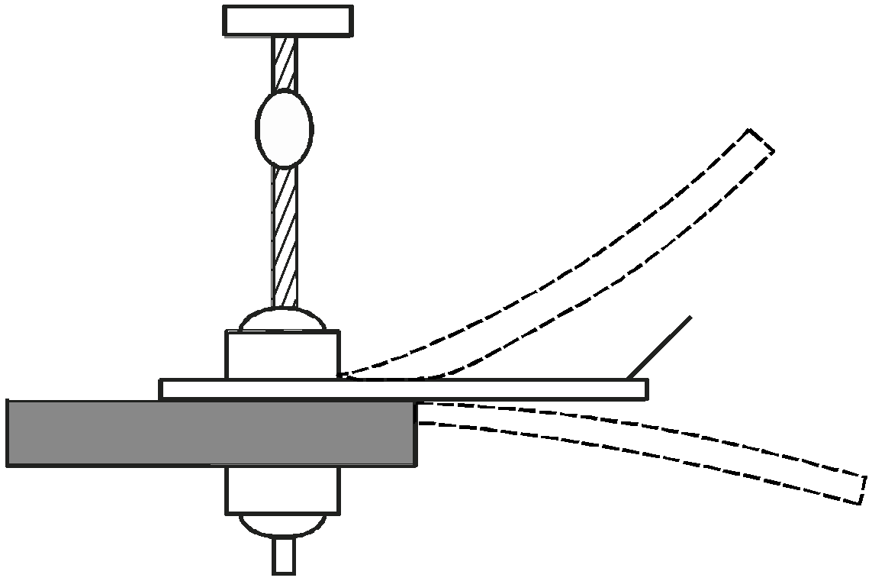

o

b

The movement o → a → o → b → o→ a → o→ b takes 0.7seconds
Determine the frequency of vibration of the blade. (3 marks)

...................................................................................................................................................................

...................................................................................................................................................................

...................................................................................................................................................................

...................................................................................................................................................................

6. How many electric iron boxes rated 1000W could be safely connected to a 240V mains circuit fitted with a 13A fuse?
(2 marks)

...................................................................................................................................................................

...................................................................................................................................................................

...................................................................................................................................................................

...................................................................................................................................................................

7. When radiations were released into a cloud chamber, short thick tracks were observed. State with reasons, the type of radiation that was detected. (2 marks)

...................................................................................................................................................................

...................................................................................................................................................................

...................................................................................................................................................................

...................................................................................................................................................................

8. a) State one advantage of an alkaline cell over a lead-acid cell. (1 mark)
................................................................................................................................................................... b) Give a reason why it is necessary to leave the caps of the cells open when charging an
accumulator. (1 mark)

...................................................................................................................................................................

...................................................................................................................................................................

9. A lady holds a large concave mirror of focal length 1.8m from her face. State two characteristics of her image in the mirror. (2 marks)

...................................................................................................................................................................

...................................................................................................................................................................

...................................................................................................................................................................
10. State why convex mirrors are used for rear view mirror in vehicles. (1 mark)

...................................................................................................................................................................

...................................................................................................................................................................

11. The figure below shows a conducting carrying current placed in the magnetic field and moves in the direction shown
X Y

Identify the polarities X and Y. (2 marks) X ............................................................................................................................................................ Y ............................................................................................................................................................
12. Sound is a longitudinal pressure wave. Explain this statement. (2 marks)

...................................................................................................................................................................

...................................................................................................................................................................

...................................................................................................................................................................

...................................................................................................................................................................

13. The figure below shows a waver profile for a wave whose frequency is 2HZ

t1 t2 t3 t4 t5 t6 Time(s)
Displacement (m)

Determine the value of t3(s) (2 marks)

...................................................................................................................................................................

...................................................................................................................................................................

...................................................................................................................................................................

SECTION B - 55 marks
14. a) When does a convex lens form a virtual image. (1 mark)

...................................................................................................................................................................
................................................................................................................................................................... b) i) The figure below shows an object 'O' in front of a lens.

O

2f f f 2f

By drawing appropriate rays, on the same figure, state the position of the image formed. (3 marks)

ii) Explain the adjustment you would make on the position of the object above in order to obtain a real magnified image. (2 marks)

...................................................................................................................................................................

...................................................................................................................................................................

...................................................................................................................................................................
................................................................................................................................................................... c) The figure below shows a pin 60mm long placed a long the principal axis of a lens of focal length
50mm. The near end of the pin is 80mm form the lens.

principal axis

600mm 800mm

Determine the length of the image. (4 marks)

...................................................................................................................................................................

...................................................................................................................................................................

...................................................................................................................................................................

................................................................................................................................................................... d) State what is meant by accommodation as applied to the human eye. (1 mark)
...................................................................................................................................................................

...................................................................................................................................................................

15. a) Figure below shows a modern mains appliance.

L

N main
Appliance

E
i) State the purpose of lead E. (1 mark)

...................................................................................................................................................................

................................................................................................................................................................... ii) Explain why the fuse is connected to the live wire. (2 marks)
...................................................................................................................................................................

...................................................................................................................................................................

................................................................................................................................................................... b) Why is mains electricity transmitted through alternating circuit? (1 mark)
...................................................................................................................................................................

...................................................................................................................................................................

c) A heater is rated 3kW, 240V. The fuses available are marked 10A, 13A and 20A. Which fuse is most suitable? (3 marks)

...................................................................................................................................................................

...................................................................................................................................................................

...................................................................................................................................................................
................................................................................................................................................................... d) A 2kW electric heater is used for 10 hrs. Calculate the cost of electricity if its costs Kshs 30 per
unit. (3 marks)

...................................................................................................................................................................

...................................................................................................................................................................

...................................................................................................................................................................

...................................................................................................................................................................

...................................................................................................................................................................

16.a) Consider the table below for electromagnetic waves.

Radiation | Production | Detection | Application
Radio waves | A | Aerials | B
 | Thermal vibration of atoms of hot bodies. | C | D
i) Fill in the spaces labelled (4 marks) A .............................................................................................................................................................. B .............................................................................................................................................................. C .............................................................................................................................................................. D .............................................................................................................................................................. ii) State one similarity between ultraviolet rays and gamma rays in terms of their dangers. (1 mark)
...................................................................................................................................................................

................................................................................................................................................................... b) Distinguish between thermionic emission and photoelectric effect (1 mark)
...................................................................................................................................................................
................................................................................................................................................................... c) Explain the term work function of a metal surface, stating how it affect photoelectric emission.
(2 marks)
...................................................................................................................................................................

...................................................................................................................................................................

...................................................................................................................................................................

17. The figure below shows a circuit where a battery of emf 4.5V, switches A and B, two capacitors
C1 = 0.3μF and C2 = 0.5μF and a voltmeter are connected.

A
V

C1 = 0.3μF B

C2 = 0.5μF
a) Determine the charge on - C1 when switch A is closed and B is open. (3 marks)

...................................................................................................................................................................

...................................................................................................................................................................

...................................................................................................................................................................

................................................................................................................................................................... b) What is the effective capacitance CT when both switches A and B are closed ? (2 marks)
...................................................................................................................................................................

................................................................................................................................................................... c) State what is observed on the voltmeter when
i) Switch A is closed and B is open. (1 mark)

...................................................................................................................................................................

................................................................................................................................................................... ii) Switch A is closed and open, and B is closed. (1 mark)
...................................................................................................................................................................

................................................................................................................................................................... iii) Explain the observations made in c(ii) above. (2 marks)
...................................................................................................................................................................

...................................................................................................................................................................

...................................................................................................................................................................

18.a) The figure below shows two circuits close to each other.

A G B

When the switch is closed, the galvanometer shows a reading and then returns to zero. When the switch is then opened, the galvanometer shows a reading in the opposite direction then returns to zero. Explain these observations. (4 marks)

...................................................................................................................................................................

...................................................................................................................................................................

...................................................................................................................................................................

...................................................................................................................................................................

...................................................................................................................................................................

...................................................................................................................................................................

b) A transformer is designed to supply a current of 12A at a p.d. of 80V. The inlet cable is to be connected to an a.c. mains of 240V. The efficiency of this transformer is 80%.

Calculate

i) Current in the transformer. (2 marks)

...................................................................................................................................................................

...................................................................................................................................................................

...................................................................................................................................................................

................................................................................................................................................................... ii) The power supplied to the transfer. (3 marks)
...................................................................................................................................................................

...................................................................................................................................................................

...................................................................................................................................................................

...................................................................................................................................................................

...................................................................................................................................................................

19. a) The cell in the figure below has an e.m.f of 2.1V and negligible internal resistance.

20Ω

Determine:

i) Total resistance in the circuit. V
30Ω

(2 marks)

...................................................................................................................................................................

................................................................................................................................................................... ii) Current in the circuit. (1 mark)
...................................................................................................................................................................

................................................................................................................................................................... iii) The reading of the voltmeter. (2 marks)
...................................................................................................................................................................

...................................................................................................................................................................

...................................................................................................................................................................

b) i) Explain how x-rays produced. (1 mark)

...................................................................................................................................................................

................................................................................................................................................................... ii) State one similarity and one difference between cathode rays and x-rays. (2 marks)
...................................................................................................................................................................

...................................................................................................................................................................

...................................................................................................................................................................

...................................................................................................................................................................

