NAME: ……………………………………..………………………ADM NO:.…………….……….……..

Date: ………………………………………. INDEX NO: ………………………………

KENYA CERTIFICATE OF SECONDARY EDUCATION
443 / 1
AGRICULTURE PAPER ONE
FORM FOUR TERM 1 2020
TIME: 2 HOURS

INSTRUCTIONS TO CANDIDATES
- Write your name and admission number in the spaces provided above.
- This paper has THREE sections: A, B and C.
- Answer ALL the questions in section A and B and any TWO questions in section C.
- ALL answers MUST be written in the spaces provided.

FOR EXAMINERS USE ONLY
SECTION | QUESTIONS | MAXIMUM SCORE | CANDIDATES SCORE
A | 1 – 17 | 30
B | 18 – 21 | 20
C |  | 20
 |  | 20
TOTAL |  | 90

SECTION A (30 MARKS)
- Name three properties of soil that are influenced by its texture. (1¹/₂ mks)

- State three functions of nitrogen in crops. (1¹/₂mks)

- Give three effects of soil living organism which benefits plant growth. (1¹/₂mks)

- Name four practices used to achieve minimum tillage. (2mks)

- State three farming practices farmers use to increase light intensity in tomato field. (1¹/₂mks)

- Give four qualities of a mother plant from which vegetative propagation material should be obtained.(2mks)

- Outline two ways of controlling damping off disease on cabbage seedlings in nursery. (1mrk)

- Give three disadvantages of non-capped multiple stem pruning in coffee. (1¹/₂mrk)

- State four ways of harvesting water on the farm. (2mks)

- Name three fungal diseases in crops. (1¹/₂ mk)

- State four factors that affect the efficiency of pesticide. (2mks)

- Give four advantages of rotation grazing. (2mks)

- Outline four ways of controlling maize stalk borer. (2mks)

- State four advantages of land consolidation. (2mks)

- State four qualities that plants used for green manure preparation should have. (2mks)

- Give four advantages of organic farming. (2mks)

- State four characteristics of organic soil. (2mks)

SECTION B (20MKS)
- The diagram below illustrates the stages of water treatment process, study it and answer the question that follow.

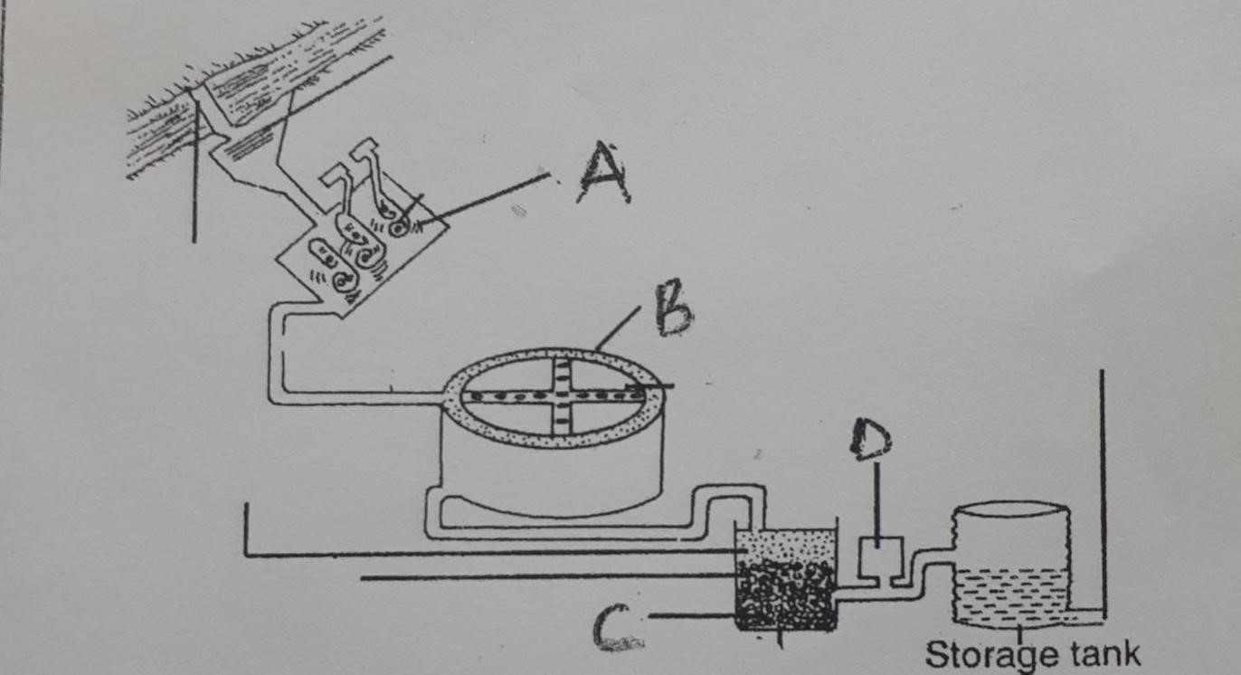

- Name the stages of water treatment labelled. (3mks)
B

C

D

- Explain the treatment of water done in the stage labelled A. (4mks)

- The diagrams below illustrate methods of vegetative propagation. Study it and answer the question that follows.
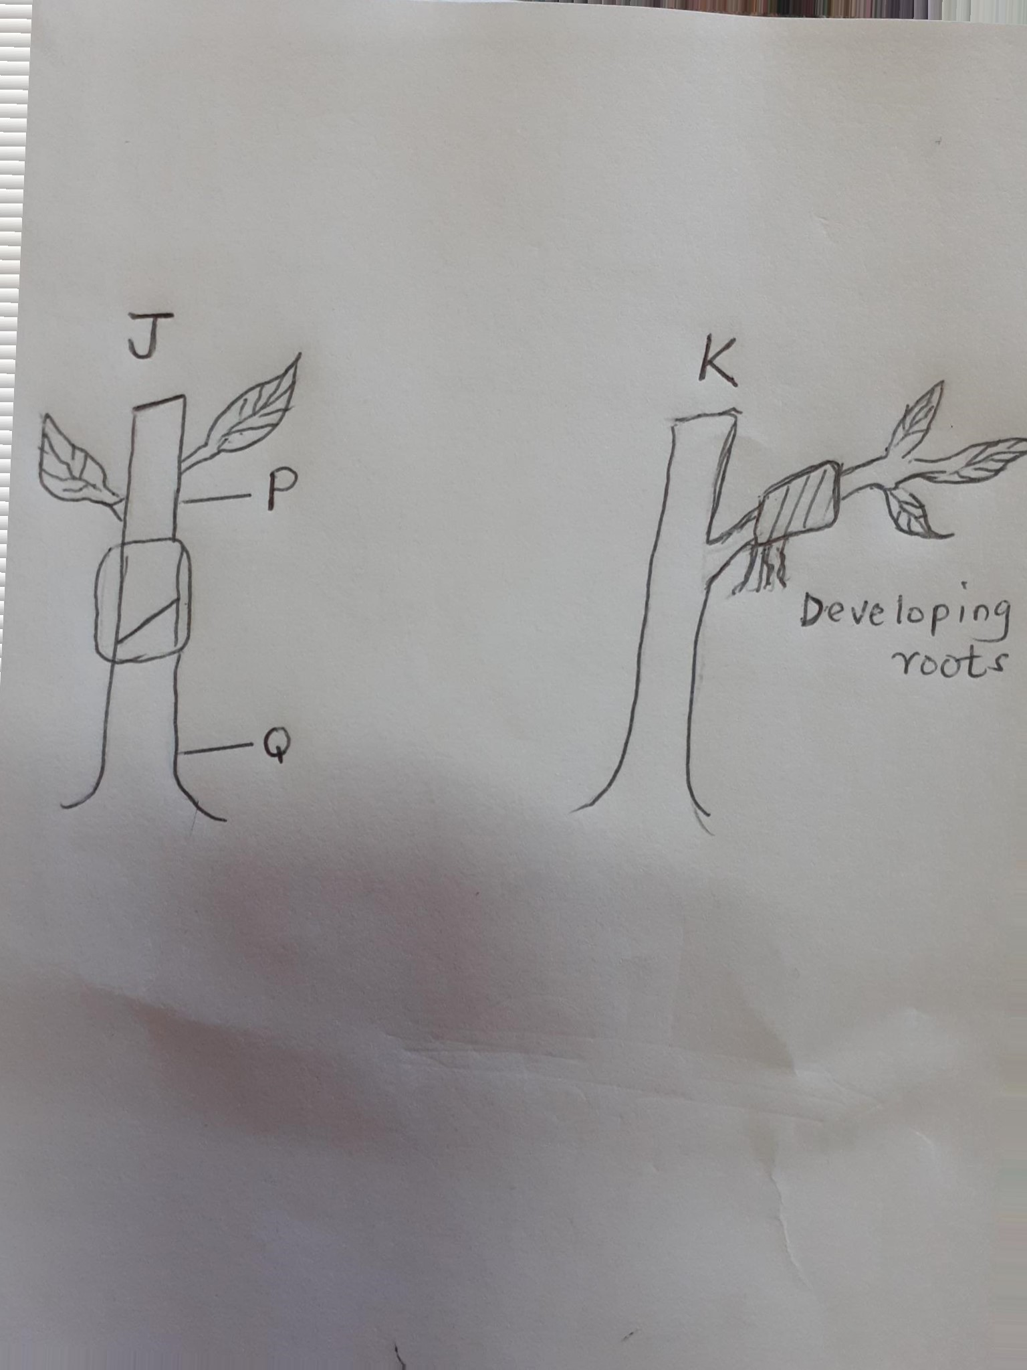

- Name the methods of vegetative propagation illustrated in diagram. (2mks)
J

K

- Name the part labelled P and Q in diagram J. (2mks)
P

O

- State three advantages of method of propagation labelled J. (3mks)

- The diagram below illustrate a type of weed
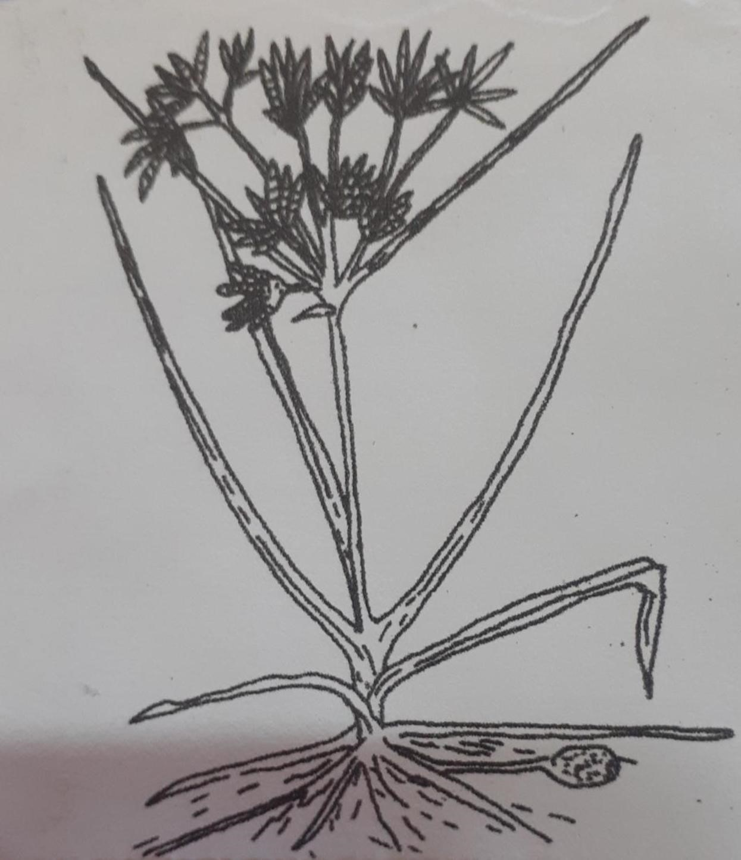

- Identify the weeds illustrated. (1mk)

- Give one reason why it is difficult to control the weed. (1mk)

- State two harmful effects of the weed on crop production. (2mks)

- Calculate the amount of N: P: K 20:10:5 needed to supply 30kg of K₂O. (2mks)
(Show your working)

SECTION C (40 MARKS)
ANSWER ANY TWO QUESTION S FROM THIS SECTION

  - Explain five factors that would increase the seed rate. (5mks)

  - Give five ways in which the government of Kenya can help to encourage agricultural production. (5mks)

  - Describe the harvesting of tea. (5mks)

  - Outline five reasons for keeping farm records. (5mks)

  - Outline six factors that determine the quality of silage. (6mks)

  - Explain eight factors that encourage soil erosion. (8mks)

  - Explain six factors that affect spacing of crops. (6mks)

  - Explain six factors that affect site selection for a nursery bed. (6mks)

  - Outline eight effects of weed on agricultural production. (8mks)

  - Explain six importance of crop rotation. (6mks)

