NAME: ……………………………………..………………………ADM NO…………………………….

DATE: ………………………………………… INDEX NO: …………………………………

Kenya certificate of secondary school
443 / 2
AGRICULTURE PAPER 2
FORM FOUR TERM 2
TIME: 2 HOURS DECEMBER 2020
INSTRUCTIONS TO CANDIDATES
- Write your name and admission number in the spaces provided above.
- This paper has THREE sections: A, B and C.
- Answer ALL the questions in section A and B and any TWO questions in section C.
- ALL answers MUST be written in the spaces provided.

FOR EXAMINERS USE ONLY
SECTION | QUESTIONS | MAXIMUM SCORE | CANDIDATES SCORE
A | 1 – 16 | 30
B | 17 – 20 | 20
C |  | 20
 |  | 20
TOTAL |  | 90

ANSWER ALL THE QUESTION IN SECTION A & B AND ANY TWO IN SECTION C
SECTION A 30MARKS
- Name four exotic beef cattle breeds. (2mks)

- State four factors that determine the amount of water needed by an animal. (2mks)

- State four characteristics of a dairy cow. (2mks)

- Give three signs that would indicate that a cow has died of anthrax. (1¹/₂mks)

- Give five qualities of eggs suitable for incubation. (2¹/₂mks)

- Give one function for each of the following tools and equipment. (2mks)
- Secateurs

- Pipe wrench

- Elastrator

- Cold chisel

- Give four routes through which vaccines can be administered into an animal. (2mks)

- One of the ratios used in mixing concreate is 1:2:3 name the ingredients represented by 1,2 and 3. (1¹/₂mks)
1

2

3

- Name the two groups of vitamins. (1mk)

- State four harmful effects of ticks in livestock. (2mks)

- Give four reasons for feeding a calf on colostrum. (2mks)

- State four factors that affect the quality of honey. (2mks)

- Give three reasons for hoof trimming in sheep. (1¹/₂)

- Name four methods of fish preservation . (2mks)

- Name four methods of dehorning. (2mks)

- Give four advantages of free range system of rearing poultry. (2mks)

SECTION B 20 MARKS
- The diagrams below illustrate farm tools, study them and answer the questions that follow

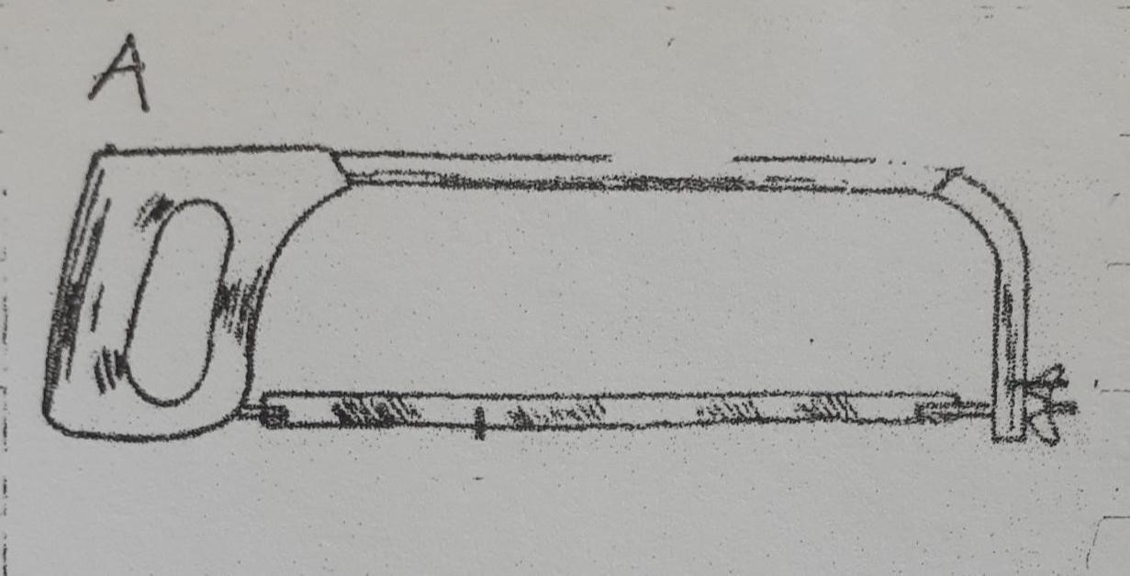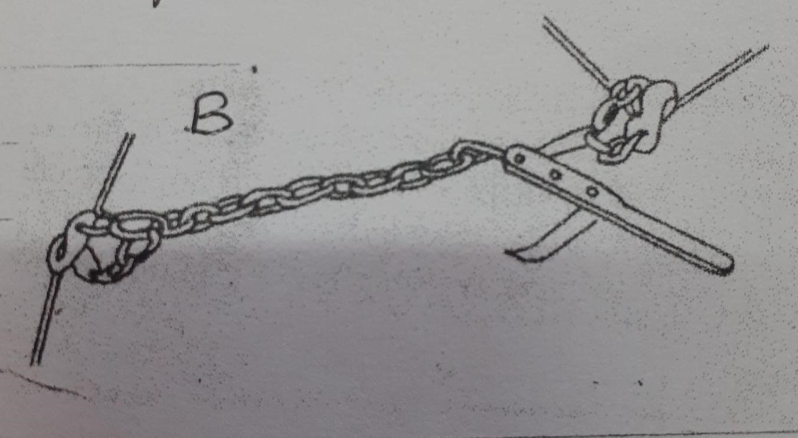

  - Name the tools illustrated (2mks)
A

B

  - State the use of each tool. (2mks)
A

B

  - State two maintenance practices of tool A. (2mks)

- The diagrams below illustrate examples of parasites. Study them and answer the question that follow

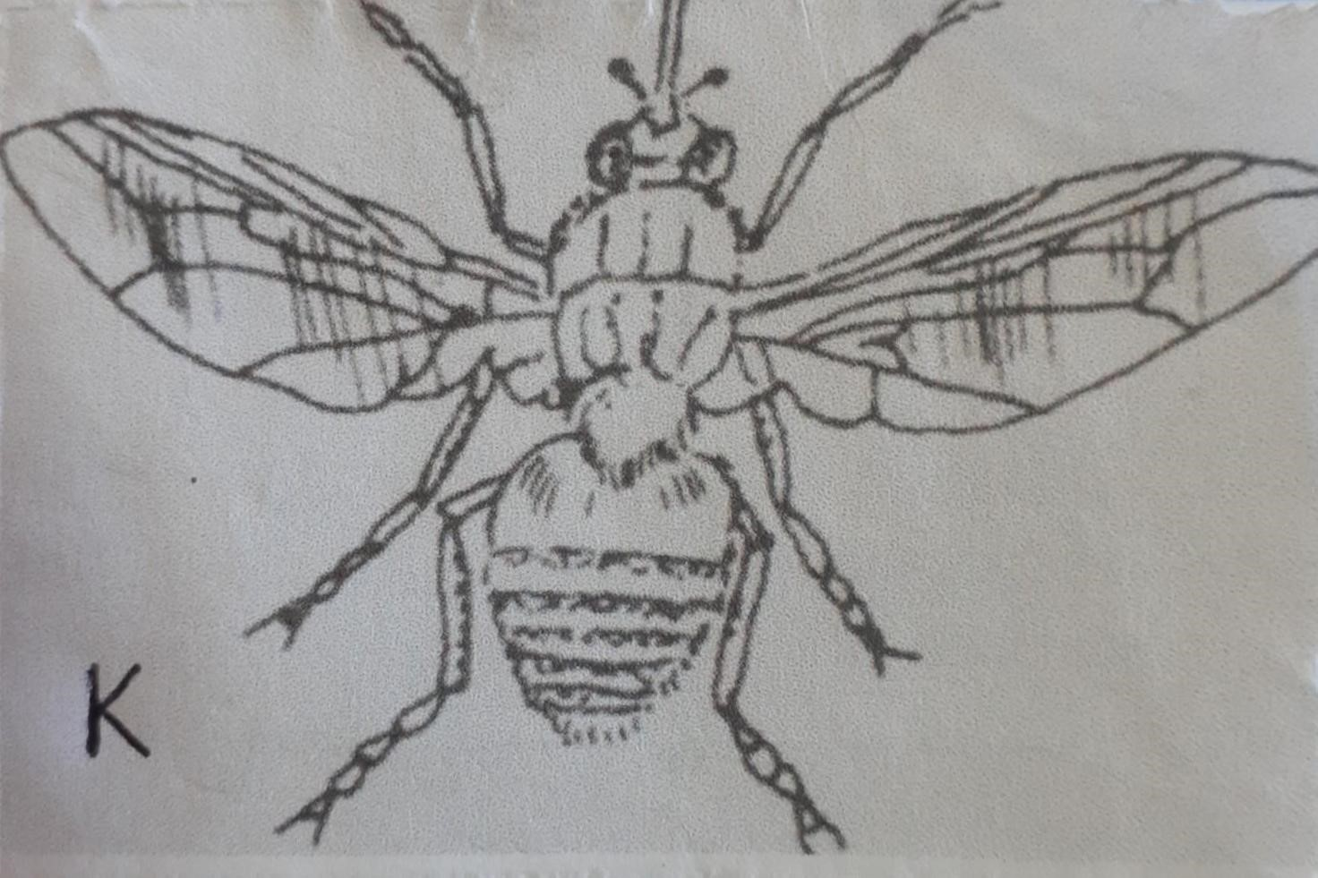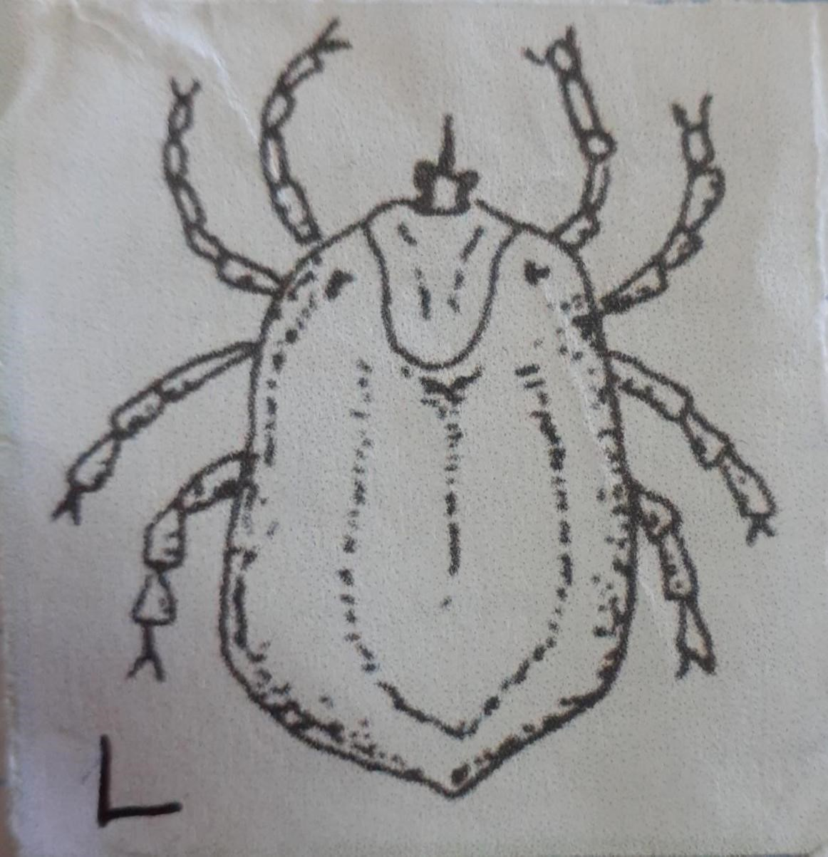

  - Name the parasite labelled (2mks)
K

L
  - Name the disease that is transmitted by parasite K. (1mk)

  - Name three diseases transmitted by parasite L. (3mks)

- The diagram below illustrates the digestive system of poultry. Study it and answer the questions that follow

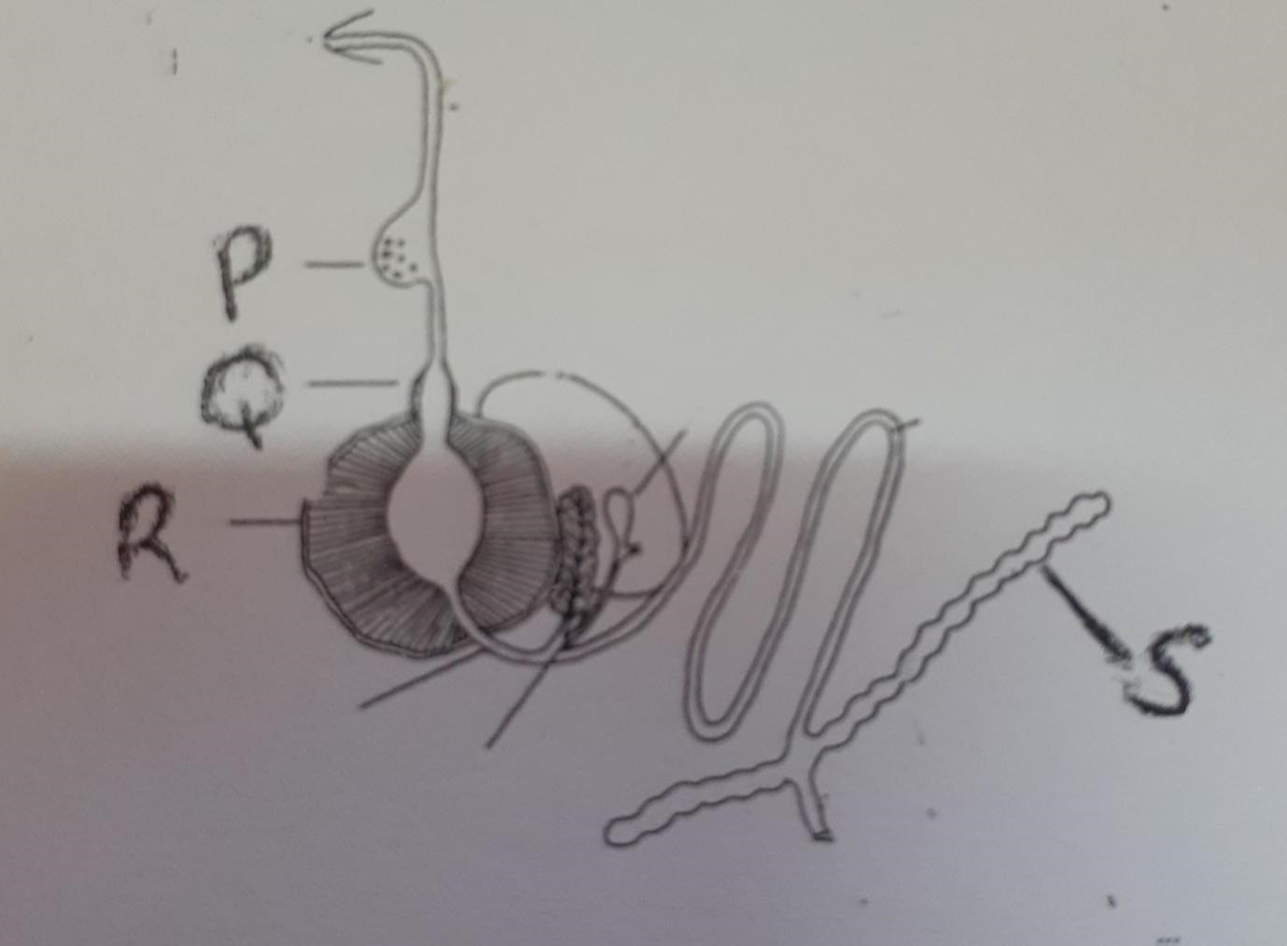

  - Name the parts labelled; (3mks)
Q

R

S

  - Give two functions of the part labelled P. (2mks)

- The diagram below illustrate a type of a fence
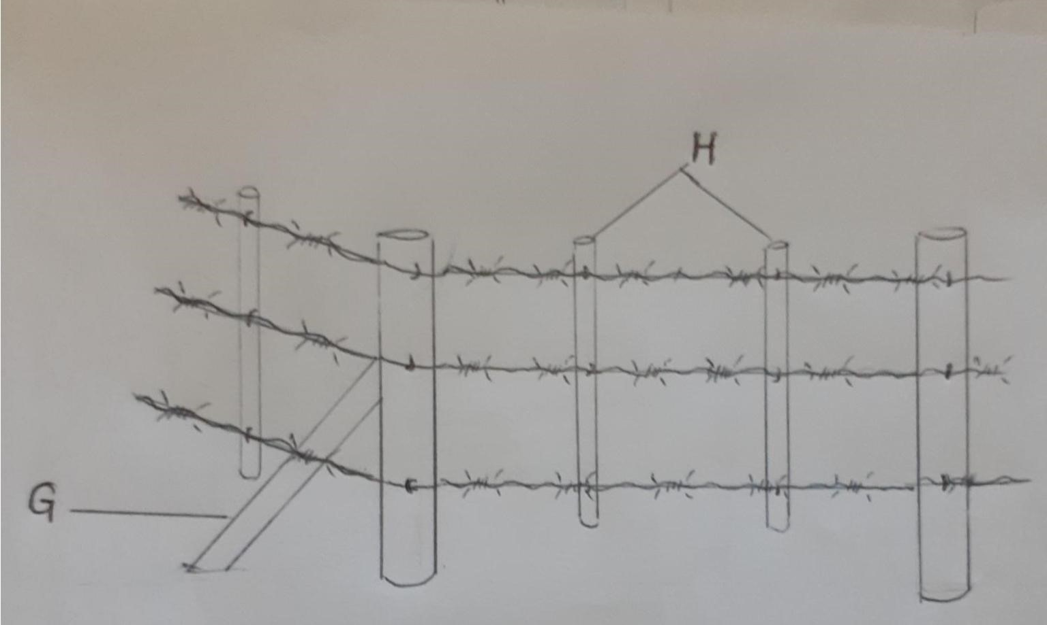

  - Name the type of fence illustrated. (1mk)

  - Name the parts labelled. (2mks)
G

H

SECTION C 40 MARKS
ANSWER ANY TWO QUESTIONS FROM THIS SECTION

- Discuss African swine fever under the following sub heading.
- Animal affected (3mks)

- Symptoms (4mks)

- Control measures (4mks)

- Describe the structure requirements of a calf pen. (7mks)

- Discuss four conditions that may lead to culling in poultry. (4mks)

  - Describe the management of layers in a deep litter house. (10mks)

  - Give five importance of keeping livestock healthy. (5mks)

  - Describe the factors a farmer should consider when selecting a gilt for breeding. (5mks)

  - Describe seven general methods of disease control. (7mks)

  - Describe the factors considered when selecting construction materials in the farm. (7mks)

  - Explain the advantages of artificial insemination as a method of service in livestock. (6mks)

