Name……………………………………………………… Index No………………………..
231/2
BIOLOGY Date……………………………
(Theory)
YEAR 2020 Sign……………………………
2 hours
KENYA NATIONAL EXAMINATIONS COUNCIL
(Kenya Certificate of Secondary education)
INSTRUCTIONS TO CANDIDATES
a) The paper has 2 sections A and B
b) Answer all questions in section A in the spaces provided
c) In section B answer question 6 (compulsory) and either question 7 or 8 in the spaces provided after question 8

FOR EXAMINERS USE ONLY

SECTION | QUESTION | MAXIMUM SCORE | CANDIDATE’S SCORE
A | 1 | 8
A | 2 | 8
A | 3 | 8
A | 4 | 8
A | 5 | 8
B | 6 | 20
B | 7 | 20
B | 8 | 20
 | TOTAL SCORE | 80

- To demonstrate a certain physiological process, the following set of apparatus were assembled

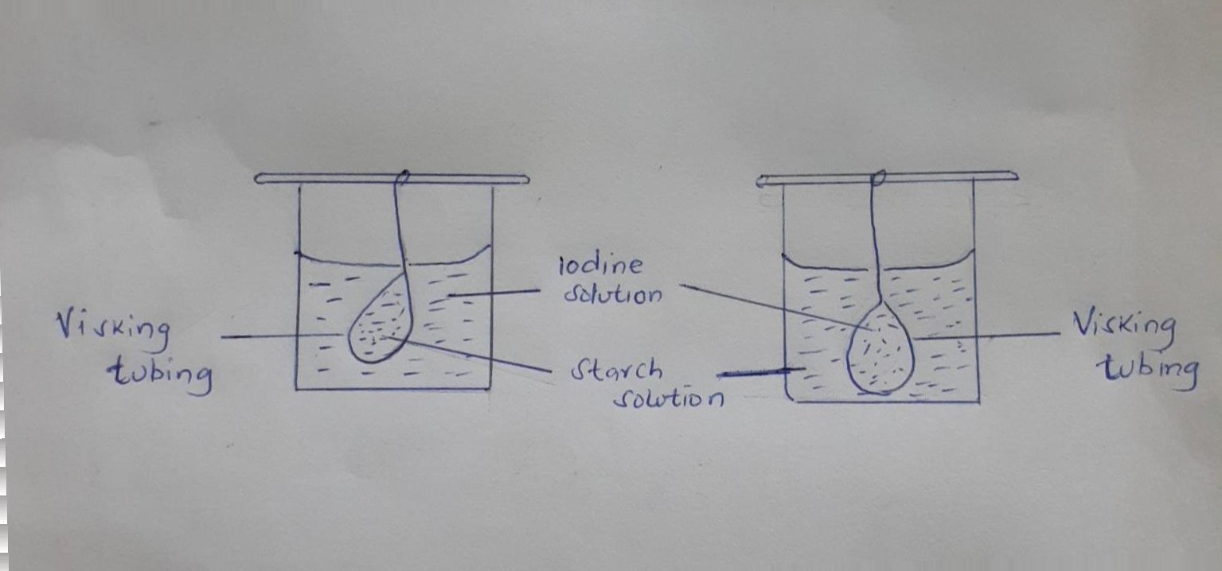

After 20 minutes observation were made and recorded as follows
Experiment | Observation
 | Inside tubing | Outside the tubing
I | Blue black colour | No colour change
II | No colour change | Blue –black colour

- Name the physiological process being investigated. [1mk]

- Account for the results as recorded in the above table in experiment. [2mks]

- What would have been the result if experiment l was repeated using starch that had been boiled with dilute hydrochloric acid, explain your results. [3mks]

- Below are diagrams of water conducting tissues found in plants;

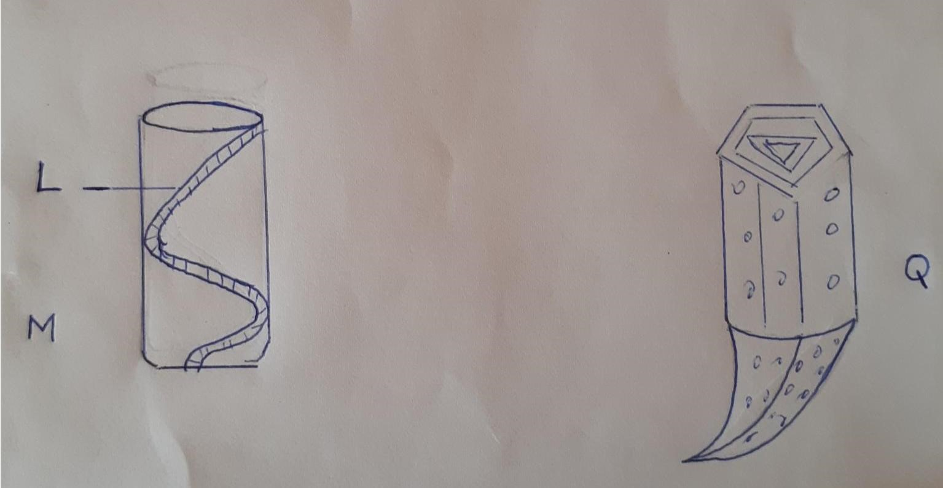

- Name the plant tissues labelled. [2mks]
M

Q

- Name the material that thickens the part labeled L. [1mk]

- State three adaptations of the tissue labelled M. [3mks]

- Tissue Q is less efficient in conduction than M; Explain [1mk]

- Name one other pattern of lignification that occurs in the tissue labelled M. [1mk]

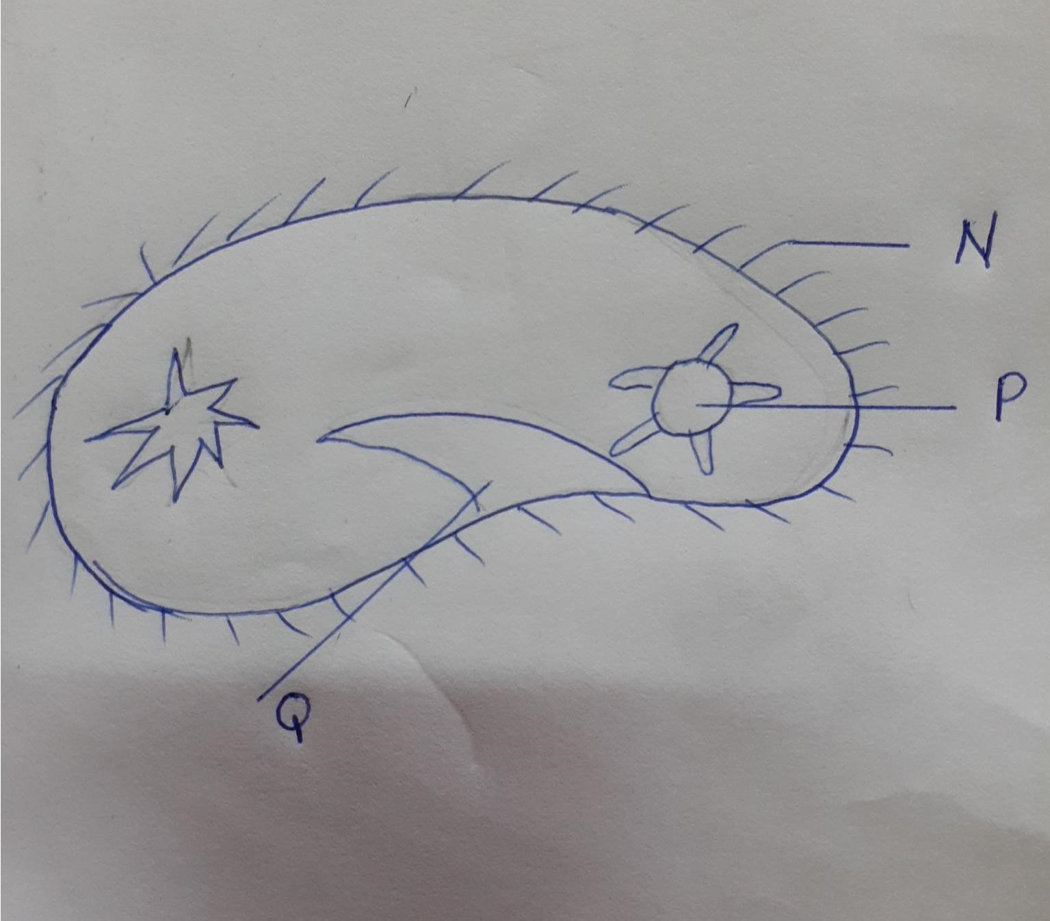

- i. Name the kingdom to which the organism belongs. [1mk]

- Give a reason for your answer in a [i] above. [1mk]

Name the structures labeled N P and Q. [3mks]

- State one observable features that enable the organism to move fast. [1mk]

- State two economic importance of the kingdom in a [i] above. [2mks]

- The figure below represents a mammalian organ.

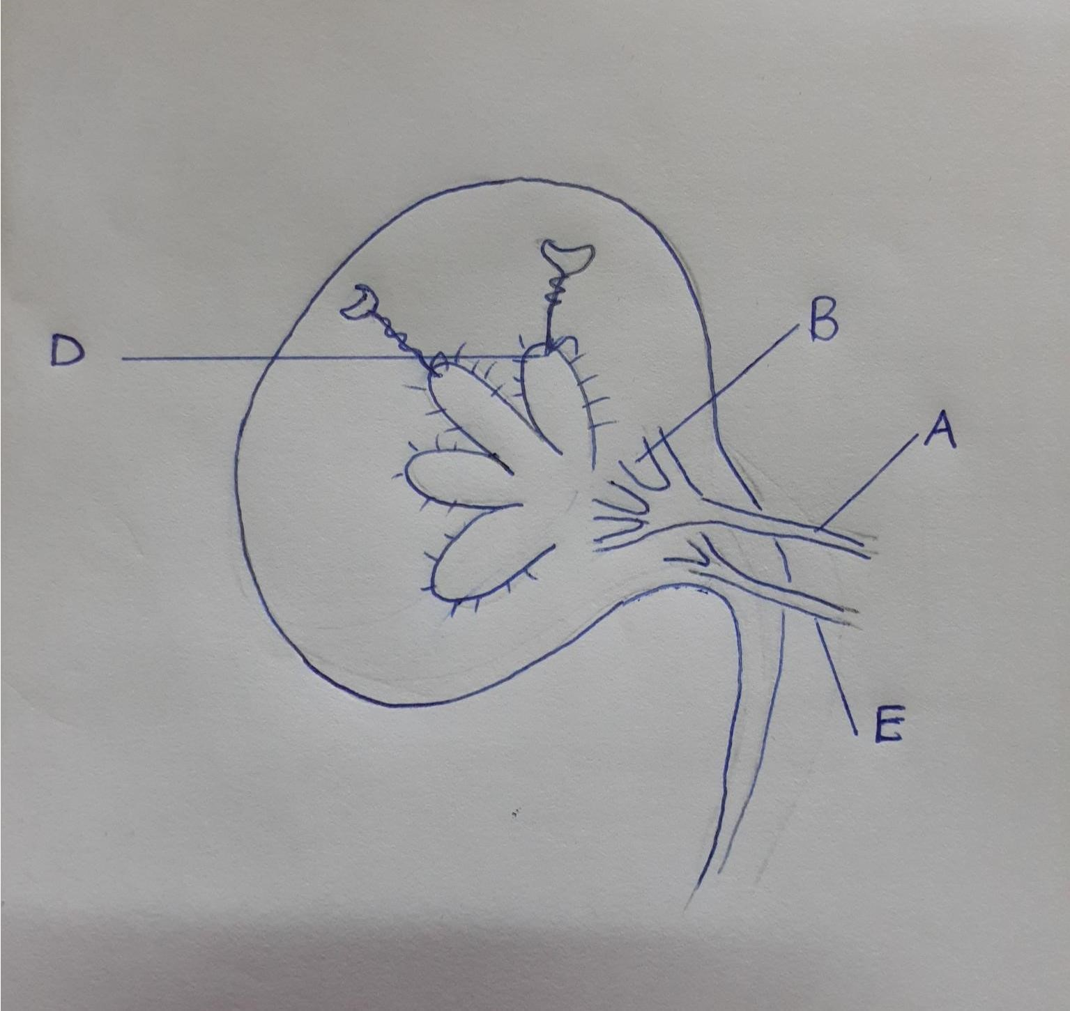

- State the name of the part labeled. [2mks]
- A

- B

- State how the part labeled D would vary in a desert rat and fresh water fish. [2mks]

- State two differences in composition of blood between A and E. [2mks]

- State two functions of the above organ. [2mks]

- a. What is meant by the term linked genes. [1mk]

b. Hemophilia is a genetic condition transmitted through a recessive gene linked to the x chromosome the normal gene may be represented by x^{h}

- What is the genotype of a hemophiliac female? [1mk]

A woman who is a carrier for the hemophilia gene marries a normal man. Work out the phenotypic for their offspring. [4mks]

  - Hemophilia is more common in males than in females. Explain this phenomenon.[2mks]

SECTION B [40 MARKS], Qn. 6 is compulsory and either Qn. 7 or 8
- In an experiment to investigate certain processes in a given plant species, the rates of carbon [IV] oxide released and intake were measured over a long period of time. The results of the investigation were as shown below

Time of the day [hours] | 6 | 8 | 10 | 12 | 14 | 16 | 18 | 20 | 22 | 24
Volume of CO₂ consumed in mm³ | 10 | 43 | 69 | 91 | 91 | 50 | 18 | 0 | 0 | 0
Volume of CO₂ released in mm³ | 38 | 22 | 10 | 3 | 3 | 6 | 31 | 48 | 48 | 48
- On the same axes draw graphs of volume of carbon [IV] oxide consumed and released against time. [7mk)

- Name the process that lead to:
- Carbon [IV] oxide consumption. [1mk]

- Carbon [IV] oxide production. [1mk]

- Account for the shape of the curve for;
- Carbon [IV] oxide consumed. [3mks]

- Carbon [IV] oxide released. [3mks]

- What is meant by compensation point. [1mk]

- From the graph, find the times of the day when the plants attained compensation point. [2mks]

- Explain how temperature affects the rate of carbon [IV] oxide consumption in the plant. [2mks]

- Describe the process of protein digestion absorption and assimilation in human beings. [20mks]
- Describe how fruits and seeds are adapted to water and wind dispersal. [10mks]
Describe two roles in each of the following hormones in growth and development of plants. [10mks]
  - Auxin
  - Ethylene
  - Cytokinins
  - Gibberellins
  - Abscicic acid

