Name ________________________________________Index No._______________________

Kenya Certificate of Secondary Education
CHEMISTRY
PAPER 1
THEORY
DECEMBER 2020
2 HOURS

INSTRUCTIONS TO CANDIDATES
- Write your name and index number in the spaces provided above.
- Answer ALL the questions in the spaces provided in the question paper.
- Mathematical tables and silent electronic calculators may be used.
- All working MUST be clearly shown where necessary.
- This paper consists of 12 printed pages.
- Candidates should check the question paper to ascertain that all the pages are printed as indicated and that no questions are missing.

FOR EXAMINER’S USE ONLY

QUESTIONS | MAXIMUM SCORE | CANDIDATE’S SCORE
1 – 27 | 80

1. (a) Write the systematic names of the following compounds.

(i) CH₃ CH₂ C CCH₃ (1mk)

- CH₃ CH CH₂ CH₃

CH₃ (1mk)

(b) Draw the structure of 2, 3-dibromobutane. (1mk)

2. Water and kerosene are immiscible liquids.
(a) Draw the apparatus that can suitably be used to separate the liquids and label the layers. (2mks)

(b) Name the most suitable method used to separate kerosene and petrol. (1mk)

3. Solutions can be classified as acids, bases or neutral. The table below shows solutions and their pH values.

Solution | pH values
K | 1.5
L | 7.0
M | 14.0
a) Select any solutions that would react to from a solution of pH 7.0 (1mk)

b) Identify two solutions that would react with aluminium hydroxide. Explain. (2mks)

4. 9.12g of a gaseous compound contains 8g silicon while the rest is hydrogen. Determine the empirical formula of the compound. (H = 1.0, Si = 28.0) (3mks)

5. When carbon (IV) oxide gas was passed through calcium hydroxide solution, a white precipitate was formed.
(a) Write an equation for the reaction that took place. (1mk)

(b) State and explain the observation made when excess carbon (IV) oxide gas was bubbled through the white precipitate. (2mks)

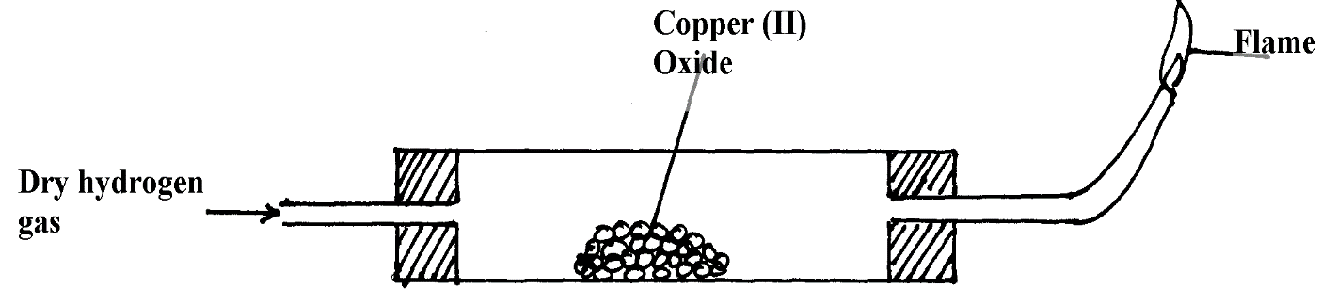
6. In an experiment dry hydrogen was passed over copper (II) oxide as shown below.

a) Identify a mistake in the diagram. (1mk)

b) After the correction, state and explain observation made in the combustion tube. (2mks)

7. Temporary water hardness can be removed by boiling.
i) What is hard water? (1mk)

ii) Write a chemical equation to show how temporary hardness is removed by boiling. (1mk)

iii) State one advantage of hard water. (1mk)
8. The following are observations made from two solids substances X and Y.

Solid | Electrical conductivity in solid state | Solubility in water | Boiling point
X | Poor | Insoluble | Sublimes
Y | Poor | Soluble | High

State the most likely type of bonding in (2mks)
i) Solid X

ii) Solid Y

9. a) State the role of the following parts during fractional distillation of a mixture of water and ethanol.
i) Glass beads in the fractionating column. (1mk)

ii) Fractionating column. (1mk)

b) State any one application of fractional distillation. (1mk)

10. Describe how a solid sample of copper (II) carbonate can be prepared starting with copper metal. (3mks)

11. The diagram below shows how a magnesium is reacted with steam.
Magnesium

Wet cotton Gas C

(a) Identify the condition required in the set up for gas C to be produced. (1mk)

(b) Write an equation for the reaction that produces gas C in the set up after the condition in (a) above is applied. (1mk)

(c) Why is it not advisable to use sodium in place of magnesium? (1mk)

12. (a) The table below shows the pH values of solutions A, B, C, D, E, F, G, and H. Study it and answer the questions that follow.

Solution | A | B | C | D | E | F | G | H
pH | 1.0 | 4.0 | 5.0 | 6.5 | 7.0 | 7.5 | 8.0 | 11.0

Select the solution which is likely to be:

(i) Sodium chloride (½mk)

(ii) Lime water (½mk)

(b) Equal amounts of zinc powder were added to 15cm³ of 1M ethanoic acid and 15cm³ of 1M hydrochloric acid in separate boiling tubes. The amount of hydrogen gas liberated after 2 minutes in the boiling tubes was different. Explain this difference. (2mks)

13. a) State two differences between a luminous and a non-luminous flames. (2mks)

b) The apparatus below is commonly used in a chemistry laboratory. Give its name and state its use. (1mk)
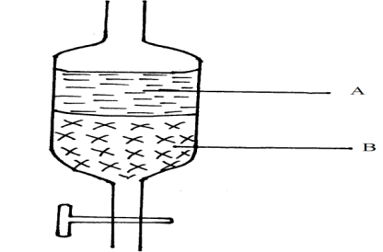

14. Study the energy level diagram below and answer the questions that follow.

Reactants
Energy
kJmol⁻¹

Products

Reaction path

a) Identify the kind of reaction represented by the diagram. Explain. (2mks)

b) (b) Label on the diagram the:
(i) Activation energy, Ea (½mk)

(ii) Enthalpy of reaction, ΔH (½mk)

15. The chromatography below shows the constituents of a flower extract using an organic solvent.
Yellow
Red
Blue
M
•
•
•
•

(i) Name a possible organic solvent you can use for this experiment. (1mk)

(ii) State one property that makes the red pigment to move the furthest distance from M

(1mk)

(iii) On the diagram indicate solvent front. (1mk)

16. 50cm³ of oxygen gas diffused through aporous plug in 80 seconds. How long will it take 100cm³ of sulphur (IV) oxide to diffuse through the same plug? (3mks)

17. Study the set up below for preparation of O₂ and answer the questions that follow.

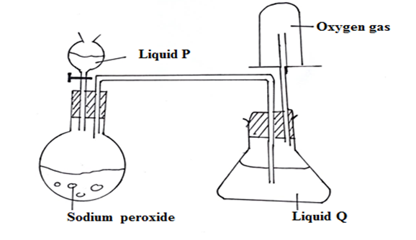
- Name
- Liquid P. (½mk)

- Liquid Q (½mk)

- Identify another substance that can be used in place of liquid Q. (1mk)

- Write an equation for the reaction that produces oxygen gas in the set up above.(1mk)

18. 12.0cm³ of 0.05M hydrochloric acid reacted with calcium hydrogen carbonate to form calcium chloride, water and carbon (IV) oxide.
a) Write the chemical equation for the reaction. (1mk)

b) Calculate the number of moles of hydrochloric acid used. (1mk)

c) Determine the number of moles of calcium hydrogen carbonate used. (1mk)

19. Study the set-up below and answer the questions that follow.

Gas W

Water
Calcium metal

(a) What physical property of calcium is demonstrated in the set-up? (1mk)

(b) Write the equation leading to the formation of gas W. (1mk)

(c) State the observation made if the water was replaced with dilute Sulphuric (VI) acid.

(1mk)

20. Study the bond energies given below to answer the question that follows.
Bond Bond energy (kJmol⁻¹ )
H – H 432
C = C 610
C – C 346
C – H 413

Butene can be converted into butane in the equation:
CH₃CH₂CH = CH₂ + H₂ CH₃CH₂CH₂CH₃
Determine the enthalpy change in the reaction. (2mks)

21. The grid below shows part of the periodic table. The letters used are not the actual symbols of the elements.

 |  |  |  | L |  |  | P
 |  |  |  | M |  |  | N
K

(a) Select the:
(i) element with the largest atomic size (½mk)

(ii) most reactive non-metal (½mk)

(b) On the grid, show the position of element T which forms T³⁻ ions with electron configuration 2.8.8 (1mk)

22. Study the scheme below and answer the questions that follow:
Solid E + Ca(OH)₂ paste
Ammonia gas
Solid F
Step II
Pass through aluminium sulphate solution and filter
Step I
Warm

(a) Name solids E and F (2mks)

(b) Write down a balanced equation for the reactions that lead to formation of solid F
(1mk)

23. The elements nitrogen, phosphorus and potassium are essential for plant growth. Calculate the mass of nitrogen present if 25kg bag contained pure ammonium hydrogen phosphate. (N=14, H=1, P=31, O=16) (3mks)

24. Explain why burning magnesium continues to burn in a gas jar full of sulphur (IV) oxide while a burning splint would be extinguished. (3mks)

25. The following set- up was used to investigate the effect of an electric current on lead (II) chloride.
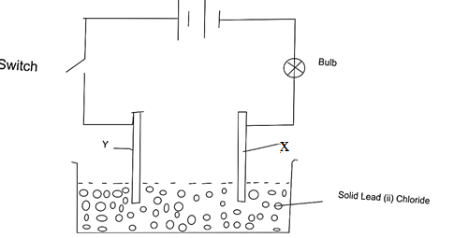
- Identify the electrodes labelled X and Y. (1mk)
X

Y

- When the switch was closed, the bulb did not light. Explain (2mks)

26. In an experiment, chlorine was passed into moist hydrogen sulphide in a boiling tube as shown below:
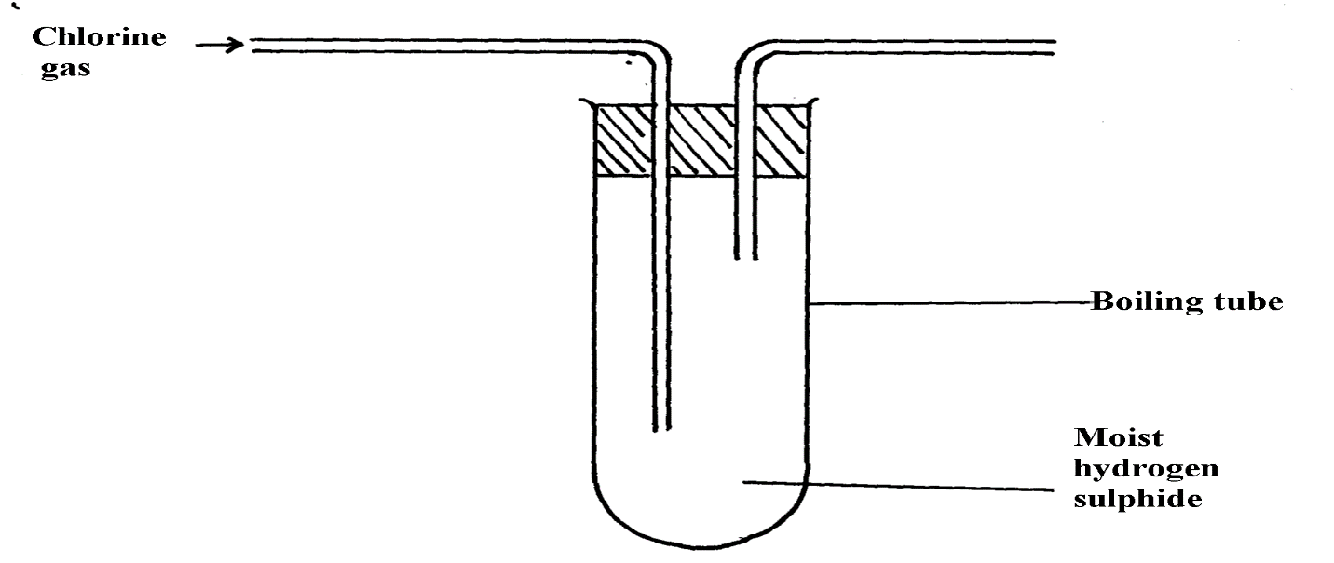

(a) What observation was made in the boiling tube? (1mk)

(b) Write an equation of the reaction that took place in the boiling tube. (1mk)

(c) What precaution should be taken in carrying out this experiment? Give a reason.(1mk)

27. Diamond and graphite are allotropes of carbon:-
(a) What is meant by allotrope? (1mk)

(b) How do they differ in their structure and bonding? (2mks)

