Kenya Certificate of Secondary Education
GEOGRAPHY
PAPER 2
TIME: 2½ HOURS

Section one:Answer all the questions in the section.
1. (a) Give three reasons for the spherical shape of the earth. (3mks)
(b)Name two planets that do not have natural satellites. (2mks)
2. The diagram below represents the structure of the atmosphere. Use it to answer question
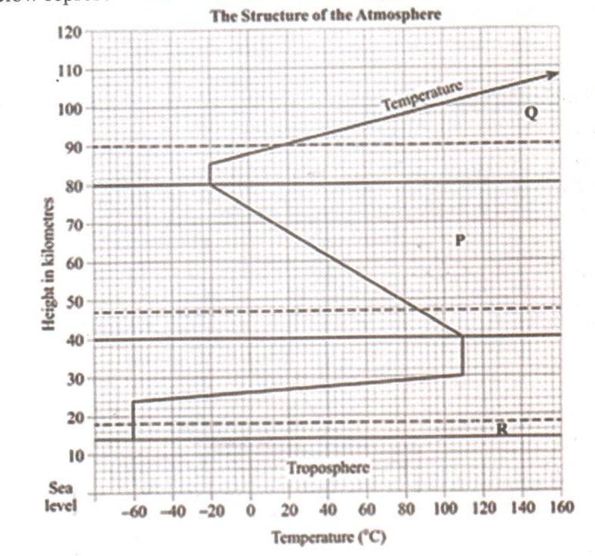
- Name
(i) the parts marked P and Q. (2mks)
(ii) The layer of discontinuity marked R. (1mk)
- State two conditions that favor the formation of the dew.(2mks)

3. (a) Give two processes involved in chemical weathering. (2mks)
(b) Give three factors that influence the rate of weathering. (3mks)
4. (a)Name any three glacial erosion features found in the highlands. (3mks)
(b) State two factors that influence the rate of glacial erosion. (2mks)
5.The diagram below represents zones of natural vegetation on a mountain in Africa. Use it to answer questions
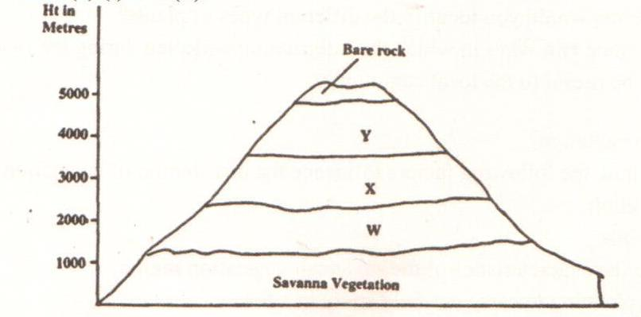
- Name the vegetation zone marked W,X and Y. (3mks)
- State two reasons as to why mountain tops have no vegetation cover. (2mks)
SECTION B (75mks)
Answer question 6 and any other question from this section.
6.Study the map extract provided (Yimbo 1:50,000 sheet 115/1). answer the following questions

- What is the air bearing of the photo principal point in grid square 3274 from the trigonometrical station in the grid square 2778. (2mks)
- Give the latitudinal extent of the area covered by the map. (2mks)
- Using the scale of 1cm rep 20m, draw a cross section from the grid reference 260800 to 320800. (3mks)
On the cross-section mark and name;
- All weather road
- Thicket
- River
all weather road loose surface
- Citing evidence, from the map, state three economic activities carried out in the area covered by the map. (6mks)
- Describe the relief of the area covered by the map. (5mks)
- Suppose you are a student from Yala school (grid square 2793) and are planning to carry out a field study on the velocity of part of river Yala shown on the map.
- State two follow up activities they are likely to carry out after the field study. (2mks)
7. (a) (i) Apart from the rift valley, name two other relief features that were formed as a result of faulting. (2mks)
(ii) With the aid of a well labelled diagram, describe how a rift valley is formed by tensional forces. (8mks)
(b) Explain four effects of faulting on human activities. (8mks)
(c) Students are planning to carry out a field study of an area affected by faulting.
- State four reasons why it is important for the students to have a pre-visit of the area. (4mks)
- Give three disadvantages of using observation in the study of such an area. (3mks)
8. (a) (i)What is a river divide. (2mks)
(ii) Describe three ways in which a river transports its load. (6mks)
(b) Describe six characteristics of a river in its old age. (6mks)
(c) Describe the following drainage patterns;
- Centripetal. (2mks)
- Dendritic. (3mks)
(d) You have planned to carry out a field study of river in its youthful stage.
- Give any two preparations of the study. (2mks)
- Name two features that you are likely to observe. (2mks)
- Give two reasons why it would be necessary to carry out a pre-visit of the area of study. (2mks)

9. (a) List two external land farming processes that may lead to formation of lakes. (2mks)
(b) Identify three sources of water found in a lake. (3mks)
(c) Explain three ways in which lakes may influence the environment in which they are found. (6mks)
(d)
- State three characteristics of lakes formed due to faulting. (3mks)
- Explain three reasons why some lakes in Kenya are drying up. (6mks)
(e) You intend to carry out a field study on lake Kanyaboli in Siaya county;
- Design a working schedule you will use for the study. (3mks)
- Why would it be important to hold group discussions during breaks in the process of data collection. (2mks)
10 (a) Differentiate between a well and a spring. (2mks)
(b) With aid of a well labelled diagram describe the three zones of underground water.(6mks)
(c) List four conditions necessary for the formation of an artesian well. (4mks)
(d) Explain three ways in which groundwater is of significant to human activities. (6mks)
(e) You intend to carry out a field study on a Karst scenery;
- Name two surface features they are likely to observe.
- Give two reasons why there are few settlements in Karst landscape. (2mks)
- State three human activities they are likely to observe in the area of study. (3mks)

