NAME: ………………………………………………….. INDEX.NO: ……..……………………

SCHOOL: ………………………………………………..CANDIDATES SIGN: ………..….…

DATE: …………………………………………………

441 /2
HOMESCIENCE
(CLOTHING CONSTRUCTION)
(PRACTICAL)
PAPER 2
2 ½ HOURS
DECEMBER 2020

MERU CENTRAL CLUSTER EXAMINATION
KENYA CERTIFICATE OF SECONDARY EDUCATION (KCSE)

TIME: 2 ½ HOURS.

Instructions to candidates
- This paper consists of 3 printed pages.
- Candidates should check the question paper to ascertain that all the pages are printed as indicated and that no questions are missing.
- Candidates MUST use machine stitches appropriately in the construction of the garment. Hand stiches used INSTEAD of machine stiches will not be marked.
- Hand stitches will only be allowed for the making of hemming, tacking and loop stitches.

A pattern of a girls dress is provided. You are advised to study sketches, instructions and layout carefully before you begin the test.
Materials provided
- Pattern pieces
- Bodice front
- Bodice back
- Skirt front
- Skirt back
- Collar
- Cut out a cross way strip measuring 18cm long by 4cm wide
- Plain light weight cotton fabric 70cm long by 90cm wide
- Cotton sewing thread to match the fabric
- One large envelope
THE TEST
Using the materials provided, cut out and make the LEFT SIDE of the girl’s dress to show the following processes:
- Cutting out (18 marks)
- Making of the dart at the front bodice (6 ½ marks)
- Making of the shoulder seam using an open seam (13 ½ marks)
- Making of the side seam on the bodice and skirt using a French seam (22 marks)
- Attaching of the bodice pieces to the skirt pieces using an overlaid seam and neatening of half of the back seam using overcasting stitches (9 marks)
- Preparation of the collar. Attaching of the collar using a crossway strip (13 marks)
- Edge stitching at the hem ready for attachment (2 marks)
- Overall presentation (6 marks)
At the end of the examination; firmly sew on your work, on a single fabric, a label bearing your name and index number. Remove the needle and pins from your work. Fold your work neatly and place it in the envelope provided.
Do not put scraps of fabric in the envelope.

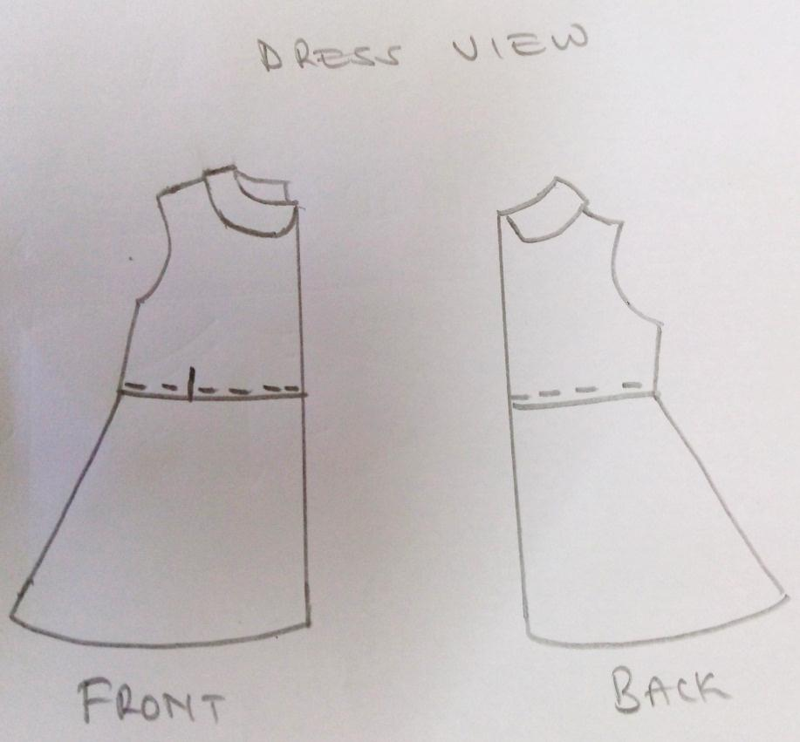
LAY OUT (NOT DRAWN TO SCALE)
