MAGS 2 CYCLE 7 EXAM.
MARCH/ APRIL.
Name…………………………………… ……………………… Index No:………………………….

Signature …………..……….
BIOLOGY Date: …………………………….

231/1
Biology
Paper 1
2 hours

INSTRUCTIONS TO CANDIDATES
- Write your name, Index number and school in the spaces provided above.
- Answer All questions in the spaces provided on the question paper.
- Sign and write the date of examination in the spaces provided above.
- Additional pages must NOT be inserted.

FOR EXAMINER’S USE ONLY
Question | Maximum Score | Candidate’s Score
1-31 | 80

This paper consists of 7 printed pages. Candidates should check to ascertain that all pages are printed as indicated and that no questions are missing.

- What is meant by the term sex linkage. (1mk)
………………………………………………………………………………………………
- Part of one strand of DNA molecule was found to have the following sequence
G-C-C- G – A – T- T – T – A – C – G – G
What is the sequence
(i) of the complimentary DNA strand? (1mk)
………………………………………………………………………………………………
(ii) On a m-RNA strand copied from this DNA portion? (1mk)
………………………………………………………………………………………………
- State two regions in a plant where the end products of photosynthesis are translocated to? (2mks ……………………………………………………………………………………………
………………………………………………………………………………………………
………………………………………………………………………………………………
- With reference to circulatory system only give two reasons why birds and mammals are more active compared to other organisms? (2mks)
………………………………………………………………………………………………
………………………………………………………………………………………………
- (a) What three characteristics are used to divide the phylum Arthropoda into classes? (3mks)
………………………………………………………………………………………………
………………………………………………………………………………………………
………………………………………………………………………………………………
(b) The diagram below shows an organisms from a division in Kingdom plantae. Study it and answer the questions that follow.
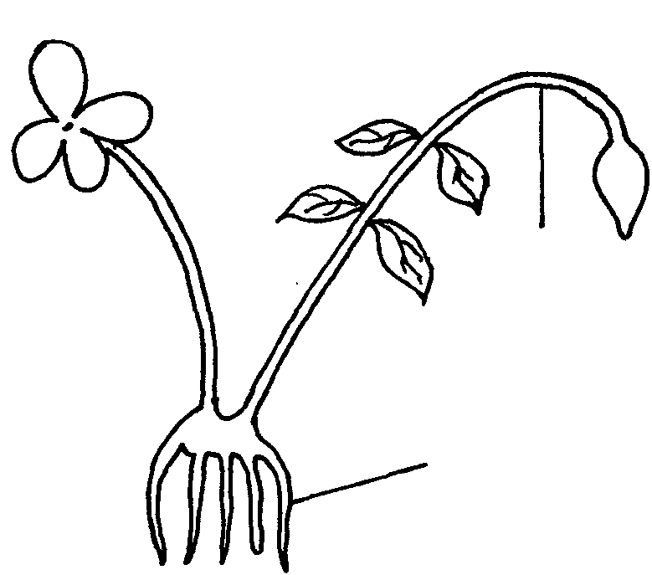
Y
X

- Identify the division from which the plant was obtained. (1mk)
…………………………………………………………………………………………
(ii) Name the parts labelled X and Y (2mks )
X…………………………………………………………..
Y……………………………………………………………

- What is the relationship between a genus and a species? (1mk)
………………………………………………………………………………………………
………………………………………………………………………………………………
- A drawing of 3 cm was made of a giant spider whose actual length was 7cm. calculate the magnification of the drawing? (3mks)

- Explain why osmosis is described as a special type of diffusion? (1mk)
………………………………………………………………………………………………
………………………………………………………………………………………………
- The following table shows the estimated number of organisms recorded in a dam.
Organisms | Number
Small fish | 3500
Microscopic algae | 12000
Crocodiles | 100
Large fish | 950
Mosquito larvae | 8900

- Construct a possible food chain for the dam? (1mk)

- Construct a pyramid of numbers for the given data? (1mk)

- Explain the shape of pyramid obtained? (2mks)
…………………………………………………………………………………………
…………………………………………………………………………………………

- (a) Explain why leaves of most plants are thin and broad. (2mks)
………………………………………………………………………………………………
………………………………………………………………………………………………
(b) State the function of the following enzymes during digestion in the stomach?
(i) Pepsin (1mk)
………………………………………………………………………………………………
(ii)Renin (1mk)
………………………………………………………………………………………………
- Explain the following:
- Respiratory surface must be moist? (1mk)
………………………………………………………………………………………………
- Respiratory surface must be thin (1mk)
………………………………………………………………………………………………
- Palisade cells are cylindrical shaped and arranged with long axis perpendicular to the leaf surface. (1mk)
………………………………………………………………………………………………….
12.The diagram below represents the vertical section of a fruit.
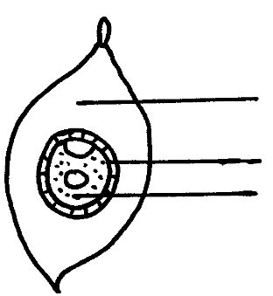
Fibrous Mesocarp

Hard waterproof endocarp
Endosperm

- Suggest the possible agent of dispersal of this fruit. (1mk)
…………………………………………………………………………………………
…………………………………………………………………………………………
- Explain two observable features that adapt the fruit to its mode of dispersal. (2 mks)
…………………………………………………………………………………………
…………………………………………………………………………………………

13.Explain why the body temperature of a healthy person rises slightly during humid days? (2mks) …………………………………………………………………………………………………..
.……………………………………………………………………………………………
14(a) (i) Name the respiratory surface in insects. (1mk)
………………………………………………………………………………………………
(ii)State any one feature that adapts the structure named in a(i) above to its function. (1mk)………………………………………………………………………………………………
- Why are the fish gills highly vascularized? (1mk)
…………………………………………………………………………………………
…………………………………………………………………………………………
15State the function of the following organelles:
(i) Granulated Endoplasmic reticulum (1mk)
………………………………………………………………………………………………
(ii) Nucleolus (1mk)
………………………………………………………………………………………………
- State two gaseous exchange sites in plants? (2mks)
………………………………………………………………………………………………
………………………………………………………………………………………………
………………………………………………………………………………………………
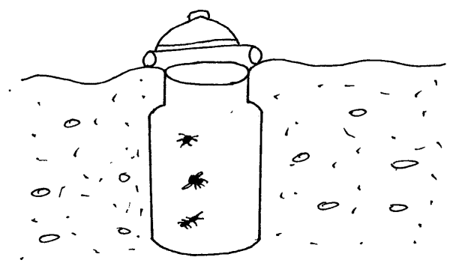
- The diagram below shows an apparatus used during collection of specimen in biological study.

- Identify the apparatus? (1mk)
………………………………………………………………………………………………
- What is the use of the apparatus named above? (1mk)
………………………………………………………………………………………………
- List three limitations of fossil records as an evidence of organic evolution? (3mks)
………………………………………………………………………………………………
………………………………………………………………………………………………
………………………………………………………………………………………………
- Distinguish between enzyme co-factors and co-enzymes? (2mks)
………………………………………………………………………………………………
………………………………………………………………………………………………
- Give two reasons for the rapid growth during the exponential phase of growth curve? (2mks)
………………………………………………………………………………………………
………………………………………………………………………………………………
………………………………………………………………………………………………
- Give two reasons why Carolus Linneaus preferred the use of latin language in the scientific naming of living organisms. (2mks)
………………………………………………………………………………………………
………………………………………………………………………………………………
- State three roles played by active transport in living organisms. (3mks)
………………………………………………………………………………………………
………………………………………………………………………………………………
………………………………………………………………………………………………
- List three factors affecting the rate of respiration? (3mks)
………………………………………………………………………………………………
………………………………………………………………………………………………
………………………………………………………………………………………………
- Study the diagram below and answer the questions that follow.
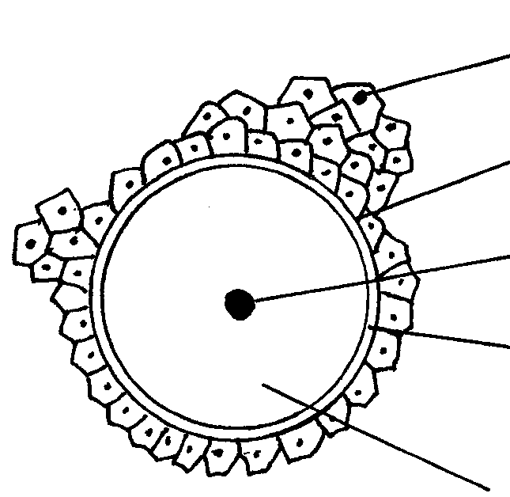
W
Y
X
Nucleus

Xytoplasm

- Identify the cell (1mk)
………………………………………………………………………………………………
………………………………………………………………………………………………
………………………………………………………………………………………………
- Label the parts X,Y and W (3mks)
X……………………………………………………………………………………………
Y……………………………………………………………………………………………
W……………………………………………………………………………………………
- Explain why it is becoming more difficult to treat malaria using chloroquine? (2mks)
………………………………………………………………………………………………
………………………………………………………………………………………………
………………………………………………………………………………………………
………………………………………………………………………………………………
- State two ways by which the ileum is adapted for absorption of food materials? (2mks)
………………………………………………………………………………………………
………………………………………………………………………………………………
………………………………………………………………………………………………
- Name two processes that contribute to variation during gamete formation? (2mks)……………………………………………………………………………………
………………………………………………………………………………………………
………………………………………………………………………………………………
28.Damage to the mammalian liver may lead to indigestion of fats. Explain this observation. (2 mks) ………………………………………………………………………………………………….
………………………………………………………………………………………………….
29.Name the disease of blood characterized by
i) Abnormally large number of white blood cells. (1 mk)
………………………………………………………………………………………………………
ii) Cresent-shaped haemoglobin instead of the normal biconcave shape. (1 mk)
………………………………………………………………………………………………………
30. During a strenuous exercise the chemical process represented by the equation below takes place in the human muscle cells.
C₆H₁₂O₆ 2CH₃CH(OH)COOH+150KJ
(Substance X)
- Name the process represented above . (1 mk) ……………………………………………………………………………………………
b)Name substance X ………………………………………………........................................ (1mk)
31. The diagram below represents a stage of growth in two different seeds.

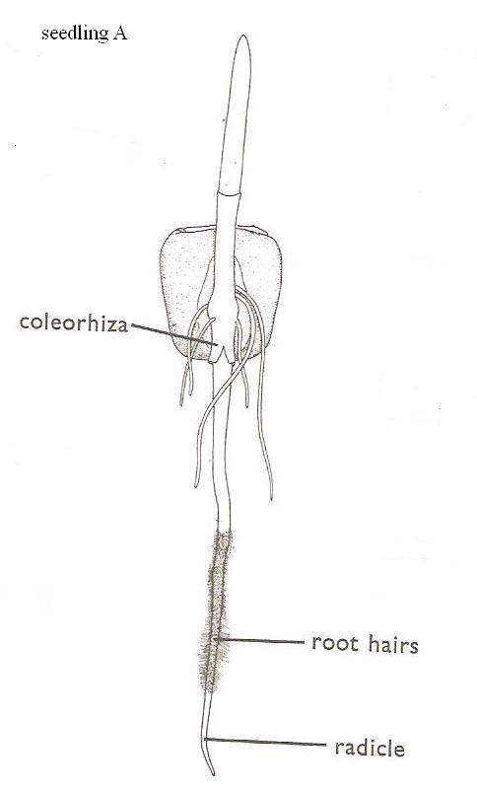

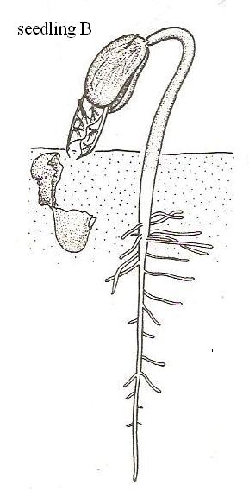

[a] Identify the type of germination exhibited by seedlings A and B. [2 marks]
Seedling A…………………………………………………………………………………………………………………….
Seedling B……………………………………………………………………………………………………………………
[b] State the role of oxygen during germination. [1 mark] ……………………………………………………………………………………………………………………………………………………………………………………………………………………………………………………………………………..
[c] Account for the loss of weight in cotyledons in germinating seeds. [1 mark] ………………………………………………………………………………………………………………………………………………………………………………………………………………………………………………………………………………
[d] (i) State the role of juvenile hormone during metamorphosis in insects. [1 mark]
……………………………………………………………………………………………………………………………………………………………………………………………………………………………………………………………………………..
(ii) Name the glands that secrete juvenile hormone [1mark]

……………………………………………………………………………………………………………..

