Name…………………………………… …………………………………..…Adm No:……………..

233/2 Candidate’s Signature …………..……………
CHEMISTRY Date: …………………………………………..
PAPER2
THEORY
MARCH, 2020
TIME: 2 HOURS

MAGS JOINT EVALUATION TEST-2020

Kenya Certificate of Secondary Education (K.C.S.E.)
233/2
Chemistry
Paper 2
2 Hours

INSTRUCTIONS TO CANDIDATES

- Write your name and Index number in spaces provided above.
- Sign and write the date of examination in the spaces provided above
- Answer all the questions in the spaces provided above.
- KNEC Mathematical tables and silent electronic calculators may be used.
- All working must be clearly shown where necessary.
- Candidates should answer the questions in English.

For Examiners Use Only
Question | Maximum score | Candidate’s score
1 | 12
2 | 13
3 | 12
4 | 12
5 | 10
6 | 13
7 | 08
Total score | 80

This paper consists of 10printed pages. Candidates should check to ascertain that all pages are printed as indicated and that no questions are missing.

- (a) Define the following terms:
- Strong bases (1mk)

- Amphoterism (1mk)

- Solubility (1mk)

b) Using the equation below, identify the species that acts as the base in the forward reaction. Give a reason. (2mks)
NH_{3(g)} + H₂O_{(l)} NH₄⁺_{(aq)} + OH⁻_{(aq)}

c) A solution of ammonia gas in water causes a greater deflection of the ammeter while a solution of ammonia gas in methylbenzene does not cause deflection. Explain this observation. (1mk)

d) Write a well-balanced chemical equation for the reaction between sodium hydroxide solution and
zinc oxide. (1mk)

e) Explain how hard water is softened by ion exchange method. (2mks)

f) The table below gives the solubilities of sodium chloride and sodium sulphate at 0ºC and 40 ºC.
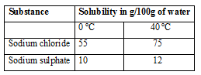

When an aqueous mixture containing 60g of sodium chloride and 7g of sodium sulphate in 100g of
water at 80 ºC was cooled to 0 ºC, some crystals were observed.
- Identify the crystals and determine the mass of the crystals formed. (2mks)

- Name the method used to obtain the crystals. (1mk)

- a) Define
- Molar heat of combustion. (1mk)

- Heating value of a fuel. (1mk)

- In an experiment to determine the heat of combustion of ethanol. CH₃CH₂OH, a student set up apparatus as shown in the diagram below. Study the set up and the data and answer the questions that follow.
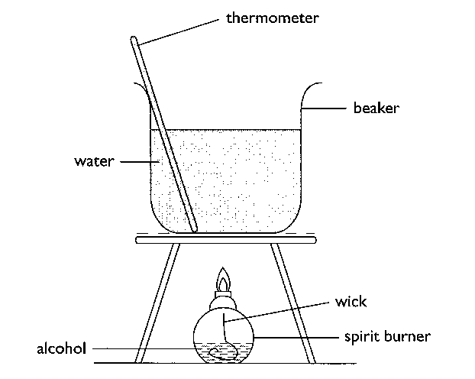
Volume of water = 100cm³
Final temperature of water = 36.0⁰c
Initial temperature of water = 22.0⁰c
Final mass of lamp an ethanol = 84.75g
Initial mass of lamp and ethanol = 85.10g
Density of water = 1 g/cm³
(Specific heat capacity of water = 4.2kJKg⁻¹K⁻¹)

- Calculate:
- Number of moles of ethanol used in this experiment. (C=12, O=16, H=1)(1 mk)

- The amount of heat given outin this experiment. (2mks)

- The heat of combustion per mole of ethanol. (1 mk)

ii) Write a thermochemical equation for the combustion of ethanol. (1 mk)

- Explain how the molar heat of combustion for ethanol obtained above differs with the theoretical value. (2mks)

- State one precaution that should be adhered to when carrying out this experiment. (1mk)

- In this experiment an assumption that links ethanol and water is made. State the assumption.
(1 mk)

- Draw an energy level diagram for the combustion of ethanol. (2mks)

- The figure below represents a section of the periodic table. Study it and answer the questions that follow. Note that the letters do not represent the actual symbols of the elements.
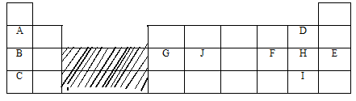
- Consider elements H and I.
(i) Explain why theatomic radius of element H is smaller than its ionic (1mk)

(ii) When element H was dissolved in water and blue litmus papers dipped, the colour of the
litmus paper changed from blue to red to white. Explain. (2mks)

(iii) Explain what is likely to be observed when element H is bubbled through a solution
containing the ions of element I. (2mks)

- Compare the atomic radius of elements G and J. Explain the difference. (2mks)

- Use dot and cross diagram to show bonding in a compound of B and H. (1mk)

- G chloride has an unexpected bond type and structure.State the type of bond and the structure.
Bond type (lmk)
Structure (lmk)

- A piece of blue litmus paper is placed in a solution of B chloride and a solution of
G chloride. Explain what would be observed in each case.
(i) B chloride solution (lmk)

(ii) G chloride solution (1mk)

4. In an experiment to study the rate of reaction, 2.5g of copper (II) sulphate crystals were added to a given mass of zinc granules and 100cm³ dilute hydrochloric acid at 27ºC. The volume of hydrogen released was measured at 10 second intervals. The results obtained are tabulated below.
Time (seconds) | 0 | 10 | 20 | 30 | 40 | 50 | 60 | 70 | 80 | 90
Volume (cm³) | 0 | 60 | 85 | 105 | 114 | 116 | 118 | 122 | 122 | 122

- Why were the following not used in the reaction?
- Nitric (V) acid (1mk)

- Iron powder (1mk)

- On the grid below plot a graph of volume of gas against time and label it X (3mks)

i) Use the graph to calculate the rate of reaction at t=25seconds (2mks)

ii) Explain why the volume of gas produced does not exceed 122cm³ (1mk)

iii) Sketch graph Y on the same grid to show the results if the experiment is repeated at 20ºC. (1mk)

iv) How does the catalyst used (copper (II) sulphate) speed up the reaction? (1mk)

c) i) State Le’Chatelier’s principle. (1mk)

ii) What is the effect on the position of equilibrium when dilute hydrochloric acid is added to the closed
system of the reaction below (1mk)
NH_{3 (g)} + H₂O _{(l)} NH₄⁺_{(aq)} + OH⁻_{(aq)}

5. (a) Give the IUPAC names of the following organic compounds. (2 mks)

(i) CH₃ – CH₂ – CH – CH₃
|
CH – CH₃
|
CH₃

(ii) CH₃ – C $≡$ C – CH₃

(b) Study the flow chart below and answer the questions that follow:

A
D
H₂SO₄(aq)

H₂/ Pt
Step I
Propane
C
Soda lime

B

- Identify substances (2mks)

A
B
C
D

(ii) State how substance A and propanecould be distinguished chemically. (1 mk)

(iii) Give the components of soda lime in step I (2mks)

(iv) What is the industrial application of the process that converts substance A to propane?
(1mk)

(c) In the laboratory propene can be prepared using propanol, broken porcelain and sodium hydroxide.
State the use of broken porcelain and sodium hydroxide solution
Broken porcelain (1mk)

Sodium hydroxide solution (1mk)

6. a) Draw a fully labeled diagram of the apparatus you would use to electrolyse an electrolyte in the
aqueous state. (3mks)

b) Explain why crystals of sodium chloride are non-conductorsof electricity butwhen melted they
conducts electric current more readily. (2mk)

c) Answer the following questions in relation to the electrolysis of molten lead (II) iodide.
i) State what happens to molten lead (II) iodide when an electric current is passed through it.
(1mk)

ii) At what electrode is a metal formed? Write an equation to show how the metal is formed. (2mks)

iii) Why is it necessary to carry out this experiment in a fume chamber? (1mk)

iv) What is a binary electrolyte? (1mk)

- Give the application of electrolysis in
- Chemical manufacturing industry (1mk)

- Metal extraction industries (1mk)

- Jewellery e.g. necklaces manufacturing industries (1mk)

7. The diagram below represents the industrial manufacture of hydrochloric acid. Study it and answer the
questions that follow.
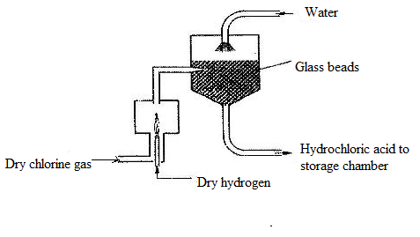
- Name the main source of hydrogen in this process. (1mk)

- The reaction between chlorine and hydrogen can be very explosive. How can this be avoided?
(1mk)

- What is the role of glass beads in the absorption chamber? (1mk)

- Explain why the storage chamber for hydrochloric acid is made up of steel lined with rubber.
(1mk)

- The acid obtained is 35% pure. Calculate its molarity, given that at 25ºC, the density of the acid is 1.08g/cm³ (H=1, Cl=35.5) (3mks)

- Explain why hydrochloric acid is not used to acidify potassium manganate (VII) solution.(1mk)

