NAME………………………………………………….INDEX NO…………………………
ADMNO. ………………………. CLASS: ……………….DATE…………………………..

231/3
BIOLOGYPAPER 3
MINI MOCK
PRACTICALS
TIME: 1 ¾ HOURS

MASTERCLASS INNER CIRCLE
CHAMPIONS LEADERSHIP INSTITUTE
Kenya Certificate of Secondary Education (K.C.S.E)

231/3
BIOLOGYPAPER 3
MINI MOCK
PRACTICALS
TIME: 1 ¾ HOURS

INSTRUCTIONS TO CANDIDATES.
a) Write your name and index number in the spaces provided above.
b) Sign and write the date of examination in the spaces provided above.
c) Answer ALL questions in the spaces provided above.
d) All workings MUST be clearly shown where necessary.

FOR EXAMINERS’ USE ONLY.
Question | Maximum Score | Candidates’ Score
1  2  3 | 12  13  15
TOTAL | 40

This paper consists of 6 printed pages.
Candidates should check the question paper to ascertain that all pages are printed as indicated and no questions are missing.
- Below is a section through a mammalian organ.

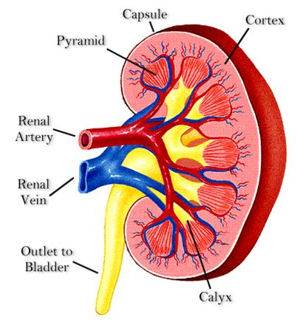
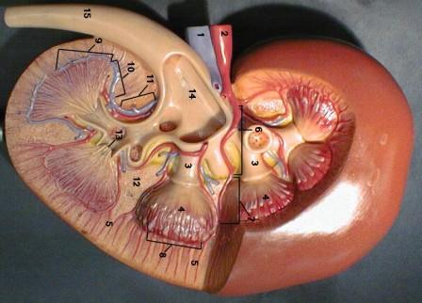
A
B
C

i) Identify the section (1mark)

………………………………………………………………………………………………

ii) Name the parts labeled A, B and C (3marks)

A ………………………………………………………………………………….

B …………………………………………………………………………………...

C …………………………………………………………………………………...
iii) State two functions of the photographed specimen. (2marks)

………………………………………………………………………………………………

……………………………………………………………………………………………....

(iv) Label on the photograph using G and L the region where the Glomerulus, and
Loop of Henle are located respectively. (2marks)

………………………………………………………………………………………………………
……....................................................................................................................
(v) Name a process that occurs in the glomerulus and Loop of Henle (2marks)

a) Glomerulus …………………………………………………………………………….

b) Loop of Henle ………………………………………………………………………….

(vi) Name two renal diseases (2marks)

……………………………………………………………………………………………… ………………………………………………………………………………………………
- You are provided with specimen W1, a coloured dye labelled solution S.
Place the petiole to stand in a small beaker containing coloured dye undisturbed for 30 minutes after which cut a thin section across the stem closer to the end dipped in dye. Examine the cut surface using a hand lens.
a) i) Make a drawing of the cut section indicating the positions of the coloured dye (2marks)

ii) Calculate the magnification of your drawing (show your working) (2marks)

b) The diagram below shows across section of the stem of a different plant W2 whose
petiole was also immersed in coloured dye.
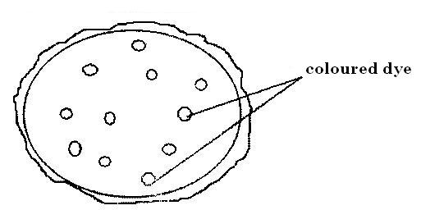

i) State one difference in the distribution of coloured dye in the two plants. (1mk)

………………………………………………………………………………………………………………
………………………………………………………………………………………………………………………………………………………………………………………………………………………………
ii) Name the tissue which takes up the dye in petioles of W1 (1mk)

……………………………………………………………………………………………………………… c) i) You are provided with solution W3 . It is a solution translocated in the stem of plant W1. The solution has been boiled with dilute hydrochloric acid neutralized with a bicarbonate solution. Using the reagents provided, test for the food substances present in solution W3. And fill the table below appropriately. (6marks)
Food substance | procedure | observation | Conclusion

ii) Suggest the type of sugar translocated in the stem of plant W1. (1mark)

………………………………………………………………………………………………………………
- You are provided with specimens A, B and C. Examine them.
- With reason state the class to which each specimen belongs. (6marks)

A ……………………………………………………………………………………………..

Reason:

………………………………………………………………………………………………………………
………………………………………………………………………………………………………………
B ………………………………………………………………………………………………….

Reason
………………………………………………………………………………………………………………
………………………………………………………………………………………………………………
C ………………………………………………………………………………………………

Reason

………………………………………………………………………………………………………………
………………………………………………………………………………………………………………
- State five differences between leaves and three differences between stems of A and C. (7marks)

- State five differences between the leaves.

- State two differences between the stems.

- How is specimen A adapted to its habitat. (2marks)

