NAME………………………………………………………… ADM NO……… CLASS ………..
INDEX………………………………………………… Date…………………………………..
MASTERCLASS INNER CIRCLE
CHAMPIONS LEADERSHIP INSTITUTE

231/1
BIOLOGY PAPER 1
MINI –MOCK
80 MKS
TIME: 2 HOURS

INSTRUCTIONS TO CANDIDATES.
- Answer ALL the questions in this paper in the spaces provided.
- Candidate should check the question paper to ascertain the pages are printed as indicated and no questions are missing

- Some form one students wanted to collect the following animals for study in the laboratory. State the PRECAUTION they should observe when collecting. (3mks)
  - Flying insects
………………………………………………………………………………………………………………………………………………………………………………………………
  - Crawling stinging insects ……………………………………………………………………………………………………………………………………………………………………………………………………
  - Small animals from tree barks ………………………………………………………………………………………………………………………………………………………………………………………………

- State the transport and synthetic roles of endoplasmic recticulum (2mks)
    - Transport role
………………………………………………………………………………………………
    - Synthetic role
………………………………………………………………………………………………
- (a) What is the significance of diffusion to plant pollination (1mk)
………………………………………………………………………………………………
………………………………………………………………………………………………
(b) Explain movement of air molecules is not energy-driven process (1mk)
………………………………………………………………………………………………
………………………………………………………………………………………………
………………………………………………………………………………………………
………………………………………………………………………………………………

- The diagram below represents an organelle of a cell
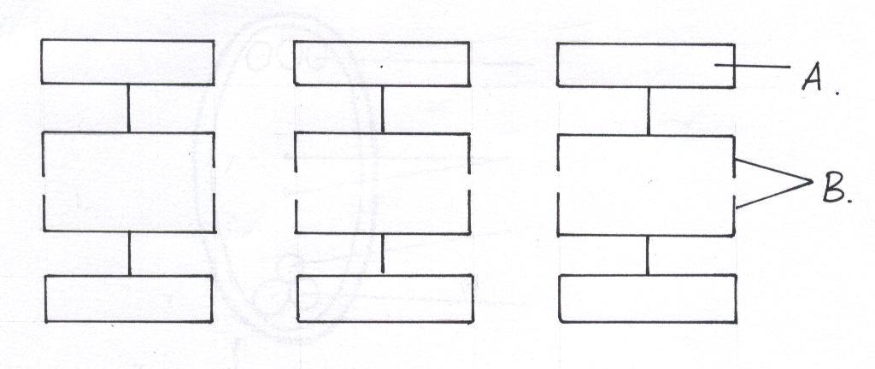

(a) Identify the organelle (1mk)
………………………………………………………………………………………………
(b) Name the part labeled A and B (2mks)
A……………………………………………………….
B……………………………………………………….

(c) Explain any two conditions that may hinder the proper functioning of the above organelle
(2mks)
………………………………………………………………………………………………
………………………………………………………………………………………………
………………………………………………………………………………………………
………………………………………………………………………………………………
- (a) Define the term respiratory quotient (1mk)
………………………………………………………………………………………………
………………………………………………………………………………………………
(b) Give the end product of anaerobic respiration in animals (1mk)
………………………………………………………………………………………………
………………………………………………………………………………………………
………………………………………………………………………………………………
(c) Name the chemical compound formed in the mitochondria which is the source of energy
(1mk)
………………………………………………………………………………………………

(d) Explain why fats are not considered as the main respiratory substrate yet they yield a lot of energy when completely oxidized (2mks)
………………………………………………………………………………………………
…………………………………………………………………………………………………
…………………………………………………………………………………………………..

- Study the diagram below and answer the question that follows
Starch grains
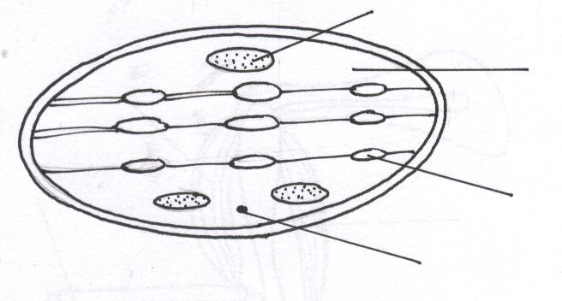
A
B
Fat lipid droplet

(a) Identify the structures labeled A and B (2mks)
A…………………………………………………..
B………………………………………………….

(b) What process takes place in the parts labeled (2mks)
A………………………………………………….
B………………………………………………….
- State the adaptations of the pulp cavity in a mammalian tooth to its function? (2mks)
………………………………………………………………………………………………
………………………………………………………………………………………………
- (a) Differentiate between transpiration and guttation (2mks)
………………………………………………………………………………………………
………………………………………………………………………………………………
………………………………………………………………………………………………
(b) State two conditions that are necessary for opening of the stomata (2mks)
………………………………………………………………………………………………
………………………………………………………………………………………………
………………………………………………………………………………………………
- What are the functions of the dorsal aorta and the vena cava (2mks)
………………………………………………………………………………………………
………………………………………………………………………………………………
………………………………………………………………………………………………

- (a) Explain why tracheids are not efficient in transporting water up the plant (1mk)
………………………………………………………………………………………………
………………………………………………………………………………………………
………………………………………………………………………………………………
(b) What is the advantage of xylem vessels being dead (1mk)
………………………………………………………………………………………………
………………………………………………………………………………………………
- Explain the effects of vigorous exercise on
(a) Breathing rate (1mk)
………………………………………………………………………………………………
………………………………………………………………………………………………
(b) Pulse rate (1mk)
………………………………………………………………………………………………
………………………………………………………………………………………………
(c) Arterioles of a person (1mk)
………………………………………………………………………………………………
………………………………………………………………………………………………
- The diagram below represents the internal structure of a bean seed

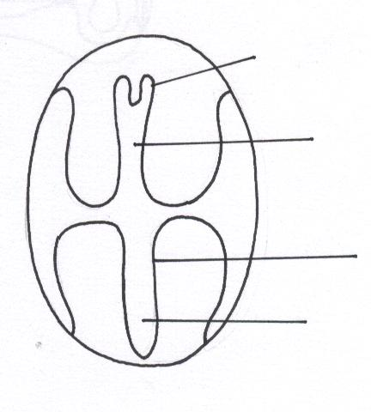
plumule
X
Y
Hypocotyl

(a) Name the parts of the seed embryo represented by letter X and Y (2mks)
X………………………………………………….
Y………………………………………………….

(b) What type of germination would result if the hypocotyl elongates faster (1mk)
………………………………………………………………………………………………
(c) What is the significance of the part labeled Y emerging first during germination (1mk)
………………………………………………………………………………………………
………………………………………………………………………………………………
………………………………………………………………………………………………
- (a) State two advantages which a constant body temperature gives mammals and birds over the animals (2mks)
………………………………………………………………………………………………
………………………………………………………………………………………………

(b) How does body size affects heat loss in an animal (1mk)
………………………………………………………………………………………………
………………………………………………………………………………………………
………………………………………………………………………………………………
(c) How does sweating increase heat loss in mammals (3mks)
………………………………………………………………………………………………
………………………………………………………………………………………………
………………………………………………………………………………………………
………………………………………………………………………………………………

- (a) Study the diagram below and answer the questions that follows

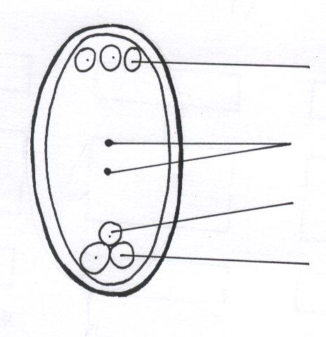
Polar nuclei
A
B
C

Name the parts labeled A, B and C (3mks)
A…………………………………………………….
B……………………………………………………
C……………………………………………………

(b) What does the part B form after fertilization (1mk)
………………………………………………………………………………………………
- Tabulate the differences between male and female gametes of human beings (3mks)
………………………………………………………………………………………………
………………………………………………………………………………………………
………………………………………………………………………………………………
………………………………………………………………………………………………

- State three unique features of class Insecta (3mks)
………………………………………………………………………………………………
………………………………………………………………………………………………
………………………………………………………………………………………………

- What type of evolution is illustrated by the pentadacytl limb (1mk)
………………………………………………………………………………………………

- Study the diagram below and answer the following questions

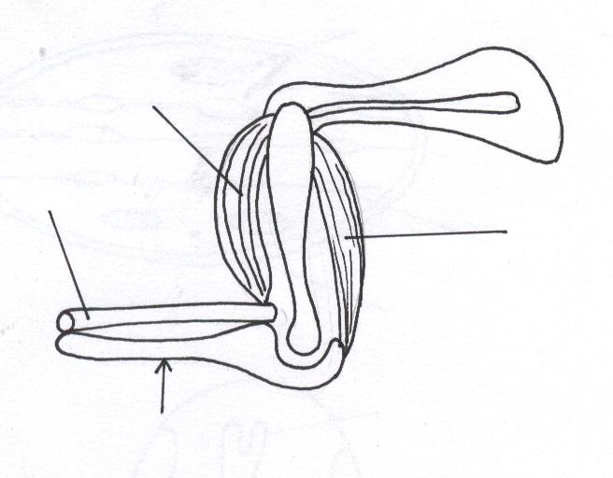
A
C
B
D

(a) Name the bones labeled C and D (2mks)
C ……………………………………………………………
D……………………………………………………………

(b) What happen to structure A and B as the arm is straightened (1mk)
………………………………………………………………………………………………
………………………………………………………………………………………………
………………………………………………………………………………………………
- Define the following terms used in genetics
(a) Cloning (1mk)
………………………………………………………………………………………………
………………………………………………………………………………………………
(b) Gene therapy (1mk)
………………………………………………………………………………………………
………………………………………………………………………………………………
………………………………………………………………………………………………
- Name the blood vessel
(i) Bearing blood with less oxygen and at the lowest pressure (1mk)
………………………………………………………………………………………………
………………………………………………………………………………………………
(ii) That link arterioles to venules (1mk)
………………………………………………………………………………………………
………………………………………………………………………………………………
(iii) State two forms in which carbon (IV) oxide is transported in blood (2mks)
………………………………………………………………………………………………
………………………………………………………………………………………………
………………………………………………………………………………………………
- Explain what happens when the erector pilli muscle of the skin contracts (3mks)
………………………………………………………………………………………………
………………………………………………………………………………………………
………………………………………………………………………………………………
………………………………………………………………………………………………
………………………………………………………………………………………………
………………………………………………………………………………………………
………………………………………………………………………………………………
- Give three differences nervous and hormonal communication (3mks)
………………………………………………………………………………………………
………………………………………………………………………………………………
………………………………………………………………………………………………
………………………………………………………………………………………………
………………………………………………………………………………………………

- The diagram below represent a pyramid of bio mass derived from a certain ecosystem
Consumer

Producers

(a) Suggest the type of ecosystem from which the pyramid was derived (1mk)
………………………………………………………………………………………………
………………………………………………………………………………………………
(b) State the significance of short food chains in ecosystem (1mk)
………………………………………………………………………………………………
………………………………………………………………………………………………

- In an experiment some germination seeds were placed in a large air tight flask for four days
(a) What are the expected changes in composition of oxygen and carbon (IV) oxide (1mk)
………………………………………………………………………………………………
………………………………………………………………………………………………
(b) Give reason for your answer to (a) above (3mks)
………………………………………………………………………………………………
………………………………………………………………………………………………
………………………………………………………………………………………………

- Name the hormone secreted by human placenta (1mk)
………………………………………………………………………………………………
- The state of dormancy in which some animals go into during the dry season is called (1mk)
………………………………………………………………………………………………
- State the two economic importance of the plants in class Dicotyledonae (2mks)
………………………………………………………………………………………………
………………………………………………………………………………………………

END

