MASTERCLASS INNER CIRCLE
CHAMPIONS LEADERSHIP INSTITUTE
CHEMISTRY 233/3
MARKING SCHEME
1.Table 1
CT-1
D-1
AC-1
P.A=1
F.A=1
=5mks
 | I | II | III
Final burette reading (cm3) | 37.8 | 37.9 | 38.0
Initial burette reading (cm3) | 0.0 | 0.0 | 0.0
Volume of solution B (cm3) | 37.8 | 37.9 | 38.5
Find the average volume of √ ½
$\text{37}\text{.}8+\text{37}\text{.}9+\text{38}\text{.}0\begin{aligned}\frac{3}{=\text{37}\text{.}9{\text{cm}}^{3}}\end{aligned}$

√ ½
- (b) (i) 8.8 √ ½ =0.22M√ ½
40
(ii) Moles of B used
$\frac{\text{answerinmoles}(a)x0\text{.}\text{22}}{\text{1000}}$ correct answers

Mole ratio 1:1 √ ½
Moles of A =correct answer above
Table II
CT-1
D-1
AC-1
P.A=1
F.A=1
=5mks
 | I | II | III
Final burette reading (cm3) | 11.6 | 11.7 | 11.8
Initial burette reading (cm3) | 0.0 | 0.0 | 0.0
Volume of solution B (cm3) | 11.6 | 11.7 | 11.8

- $$\begin{aligned}\frac{}{\text{11}\text{.}6+\text{11}\text{.}7+\text{11}\text{.}8}\end{aligned}3=\text{11}\text{.}7{\text{cm}}^{3}$$
(b) (i) Moles of B used
Answer in (a) x 0.22 =correct answer
1000
Mole ratio 1:1√ ½
Moles of D= correct answer above
(ii) answer in b(i) x 250
25
Correct ans √ ½ or
Answer in b(i) x 10√ ½
Correct asn √ ½
(iii) Answer in b(ii) procedure I x 100√ ½
100
Correct answer √ ½ or
Answer in b(i) procedure I
10
Correct ans √ ½
(iv) Answer in b(iii) above –asnwer in b(ii) √ ½
Correct answer √ ½ I
(v) CO₃²⁻ : H⁺
1 : 2√ ½
Answer in (iv) above I
2
(c) (i)Answer in (v) above x 106√ ½
Correct ans √ ½
(ii) Answer in c(i) above x 100√ ½
0.5
Correct answer √ 1.2
2.
Volume of water in boiling tube (cm³) | Temperature in ºC at which crystals first appear | Solubility of solid Q in g/100g of water
5  8  11  14  17 | 70  56  49  40  36 | 80.0  50.0  36.4  28.6  23.5

(b)(i) 61.5ºC
(ii) 57-29=28g
28 x100
57
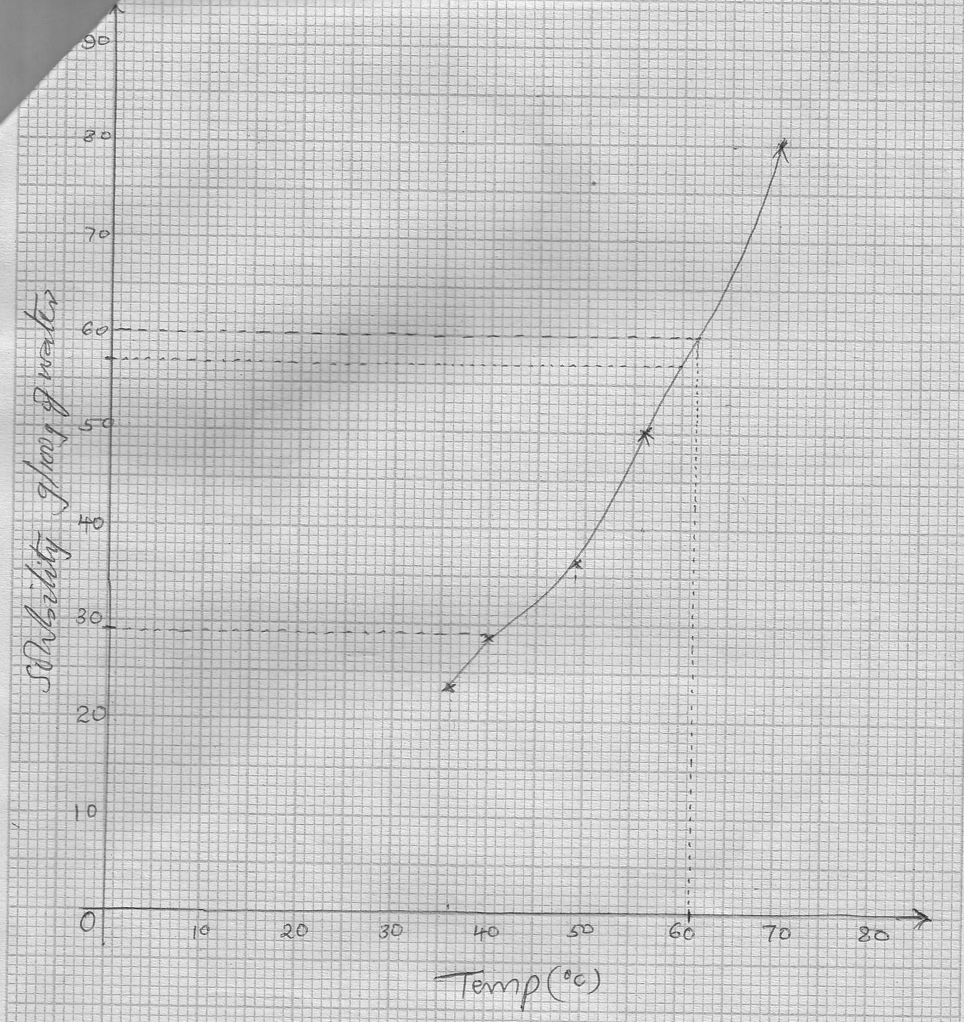

Observations  White solid dissolves to form a colourless filtrate and white residue √ ½  (1mk) | Inferences  Sparingly soluble compound √  (1mk)
3.

(ii)
Observations  Orange K₂Cr₂O₇/H+ turns green  (1mk) | Inferences  C = C , -C = C - √ ½  (1mk)

(iii)
Observations  Effervescence √ ½ of colourless gas √ ½  (1mk) | Inferences  O  - C – OH √1  (1mk)
(b)(i)
Observations  Effervescence √ ½  No white ppt√ ½  (1mk) | Inferences  CO₃²⁻√ ½  ^{Pb2+},Ag⁺ absent √ ½  (1mk)
(ii)
Observations  White ppt soluble √1  (1mk) | Inferences  Zn2+ √1  (1mk)

