Name: …………………………………………………………… Index no ……..…...................................

Admission Number …………………….........Class:………………Date: ………………………………
MATHEMATICS
PAPER 2
TIME: 2 ½ HOURS

MASTERCLASS INNER CIRCLE
CHAMPIONS LEADERSHIP INSTITUTE
MATHEMATICS PAPER 2

TIME: 2 ½ HOURS

INSTRUCTIONS TO CANDIDATES:
- Write your name ,index number , Admission number, Class and write date of examination in the spaces provided
- The paper contains two sections. Section I and Section II.
- Answer all the questions in section I and any five questions in section II.
- Answers and working must be written on the question paper in the spaces provided below each question.
- Marks may be given for correct working even if the answer is wrong.
- Non programmable silent electronic calculators and KNEC mathematical table may be used, except where stated otherwise.

FOR EXAMINERS USE ONLY

SECTION 1
Question | 1 | 2 | 3 | 4 | 5 | 6 | 7 | 8 | 9 | 10 | 11 | 12 | 13 | 14 | 15 | 16 | TOTAL
Marks

SECTION II
Question | 17 | 18 | 19 | 20 | 21 | 22 | 23 | 24 | TOTAL
Marks

TOTAL MARKS

This paper consists of 12 printed pages. Candidates should check to ascertain that all papers are printed as indicated and that no questions are missing

SECTION I (50MARKS)
Answer all questions in this section
1. Water flows from a pipe at the speed of 250litre per minute. If the pipe is used to drain a tank full
of water measuring 3.2m by 2.5m by 2 m. how many minutes would it take to drain the tank
completely.
(3mks)

2. Given that tan ( 90-x) = 3+ 2√5, without using calculator or mathematical tables, determine tan x,
leaving your answer in the form a + b√c . (3mks)

3. Two variable P and Q are such that P varies partly as Q and partly as the square root of Q. Determine
the equation connecting P and Q when Q = 16, P = 500 and when Q = 25, P = 800. (4mks)

4. If (x + 3) ( x + 4) is equivalent to ( x + a)²+b. Find the values of a and b. (3mks)

5. In the figure below, A triangle A¹B¹C¹ is the image of triangle ABC under a rotation centre O.
By constructor, find and label centre O. Hence determine the angle of rotation. (4mks)
A

A¹

C
B
C¹

B¹

6. Use logarithms tables to evaluate. (3mks)
$\frac{-2}{5}$
$$\frac{0.275 x 563}{456.5 (33+\log{4.5)}}$$

7. Taps A and B can fill a tank in 4 and 9 hours respectively. Both taps are turned on for 2hours after
which tap A is closed. Find how long tap B takes to fill the remaining part of the tank. (3mks)

8. (a) Expand and simplify the binominal expression ( 2+ 2y)⁵ in ascending powers of y ( 2mks)

- Use the expansion up to the fourth term to evaluate ( 2.02)⁵ correct to 4 decimal places. (2mks)

9. There are three athletes A,B, C in a 100m race. A is twice as likely to win as B, while B is twice as
likely to win as C. Find the probability that A does not win the 100m race. (2mks)

10. Find the distance between the centre A of a circle whose equation is 2x² + 2y² + 6x + 10y + 7 = 0
and the point B ( -4 ,1). (3mks)

11. Nairobi and Kisumu lie on the same longitude. The latitude of Nairobi is 1º12’s and that of Kisumu is
5º50’N. Calculate the distance between them in nautical miles (3mks)

12. Find the value of X in the equation ( log₃X)² + 3 log ₃X = 4 (4mks)

13. Using the line below, measure out Line AB of length 3cm, construct on one side of line AB the locus of a point P such that $<$APB = 30⁰. (3mks)

14. The area of a triangle where height is 4.4cm measured to the nearest millimeter is 13.2cm². Determine
the maximum possible length of the base of the triangle to 4 s.f. (3mks)

15. Two similar cylindrical containers are such that the capacity of the larger container is 5 litres and that of the smaller is 320 millitres. If the base area of the larger container is 0.25m². Find the radius of the base of the smaller container. (4mks)

16. A book cost ksh. 3,600 when bought in cash. A customer bought at hire purchase by making a down payment of ksh. 1,000, then a ten monthly instalments of ksh. 300 per month. Calculate the rate of interest per month. (3mks)

SECTION B (50MARKS)
Answer any five questions from this section

17. The taxation rate, for 2007 were as in the table below.
Income ( Ksh. P.M) Tax rate ( %)
1 - 2000 5
2001 – 4000 10
4001 - 6500 15
Above 6500 20

In certain month in 2007, Mutai paid a tax of Ksh. 3000 after having been given a personal relief
Ksh. 1056 per month.
- How much tax per month could he have paid if he did not get tax relief. (2mks)

- Calculate his total taxable income in Ksh. P.m. (6mks)

- Given that his total taxable allowance amount to Ksh. 4520 P.m. Calculate his monthly basic
salary in Kenya shillings. (2mks)

18. (a) complete the table below for the functions y = 2 Cos x and y = sin 2x for -180º ≤ x ≤ 180º
(2mks)
Xº | -180 | -150 | -120 | -90 | -60 | - 30 | 0 | 30 | 60 | 90 | 120 | 150 | 180
2xº | -360 | -300 | -240 | -180 | -120 | -60 | 0 | 60 | 120 | 180 | 240 | 300 | 360
2 cos x | -2 | -1.73 |  | 0 |  | 1.73 | 2 | 1.73 | 1 |  | 1 |  | 2
Sin 2x |  | 0.87 | 0.87 | 0 | -0.87 |  | 0 | 0.87 | 0.87 |  | -0.87 |  | 0
(b) On the grid provided, draw the same axis the graphs of y = 2 cos x and Y= sin 2x for-180º
≤ x ≤ 180º (1mk)

- Use the graphs in (b) above to find;
(i) The values of x such that 2 cos x – sin 2x = 0 (1mk)

(ii) State the amplitude and period of graph y = 2 cos x . (2mks)

(iii) Find the difference in the value of y when x = - 45º ( 1mk)

19. The position of two towns A and B on earth’s surface are (61⁰N, 140⁰E) and (61⁰N, 39⁰W) respectively. (Take $π$ = $\frac{22}{7}$ and radius of the earth as 6370km).

- Fine the difference in the Longitude between A and B, hence find the distance between two towns in nautical miles. (3mks)

- The position of another point C is (61⁰N, 40⁰W). Calculate the shortest distance between A and C. (3mks)

- Another point D is 430km east of town B and on the same latitude. Find the position of D. (4mks)

20. The figure below shows triangle OAB in which OA is vector a and OB is vector b. Points D and E
~
~
are such that AD = 1 AB and OE = 1 OA
- 3
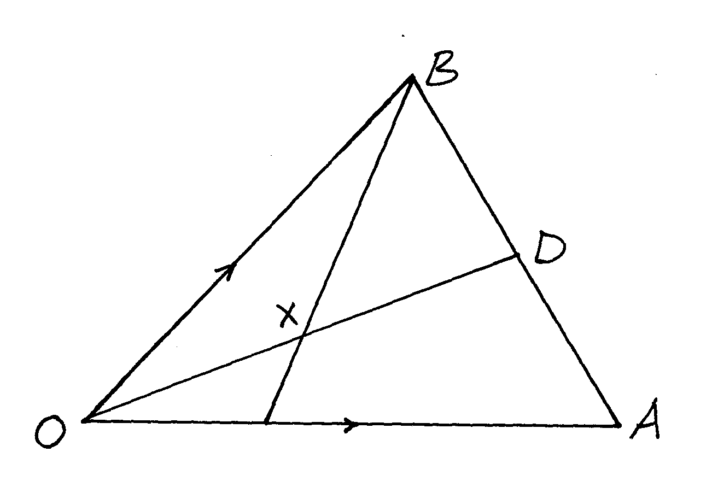

b
~

E
a
~

- Express in terms of a and b
~
~

(i) OD (1mk)

(ii) BE (1mk)

(b) If OX = KOD and BX = h BE where k and h are constant ,express Ox in terms of
(i) k, a and b (2mks)
~
~

(ii) h, a and b (2mks)
~
~

(c) Find the values of h and k ( 4mks)

21. The table below shows marks of 50 candidates in an exam.

Marks | F
21-30 | 5
31-40 | 7
41-50 | 9
51-60 | 11
61-70 | 8
71-80 | 5
81-90 | 5

Calculate
- The interquartile range. (4mks)

- The standard deviation using an assumed mean of 55.5. (6mks)

22. The probabilities that James, Shadrack and Olusala will be late for breakfast are $\frac{1}{4}$, $\frac{1}{5} and\frac{1}{6}$ respectively. Using a tree diagram, calculate the probability that on any morning;
(a) Draw the tree diagram. (2mks)

(b)None of them will be late. (2mks)

(c)Only one of them will be late. (2mks)

(d)At least one of them will be late. (2mks)

(e) Atmost one of them will be late. (2mks)

23. (a) An arithmetic progression is such that the first term is -5, the last is 135 and the sum of
progression is 975.
Calculate
(i) The number of terms in the series. (4mks)

(ii) The common difference of the progression. (2mks)

- The sum of the first three terms of a geometric progression is 27 and first term is 36.
Determine the common ratio and the value of the fourth term. (4mks)

24. The displacement h metres of a particle moving along straight line after t seconds is given by
h = -2 t³ + 3 t² + 3t
2

- Find its initial acceleration. (3mks)

- Calculate :
(i) The time when the particle was momentarily at rest. (2mks)

(ii) Its displacement by the time it comes to rest momentarily. (2mks)

(c) Calculate the maximum speed attained. (3mks)

