MASTERCLASS INNER CIRCLE
CHAMPIONS LEADERSHIP INSTITUTE
PHYSICS 232/3
MARKING SCHEME
1. (b) Lo=60±10mm ( ½ mk)
(c) L1=120±10mm( ½ mk)
(d) L=600
=60mm
=6cm (1mk)
(e) M=100±5g (1mk(
(f)
Oscillations,N | 5 | 7 | 10 | 13 | 15 | 18 | 20
t(s) | 3.46 | 4.97 | 7.06 | 9.27 | 10.59 | 12.54 | 14.10 | 5mks
N+10t ^{s}  10 | 3.806 | 5.467 | 7.766 | 10.20 | 11.65 | 13.80 | 15.51 | 1mk
N+10t (S)²  10 | 14.48 | 29.90 | 60.31 | 104.0 | 135.7 | 190.3 | 240.6 | 1mk
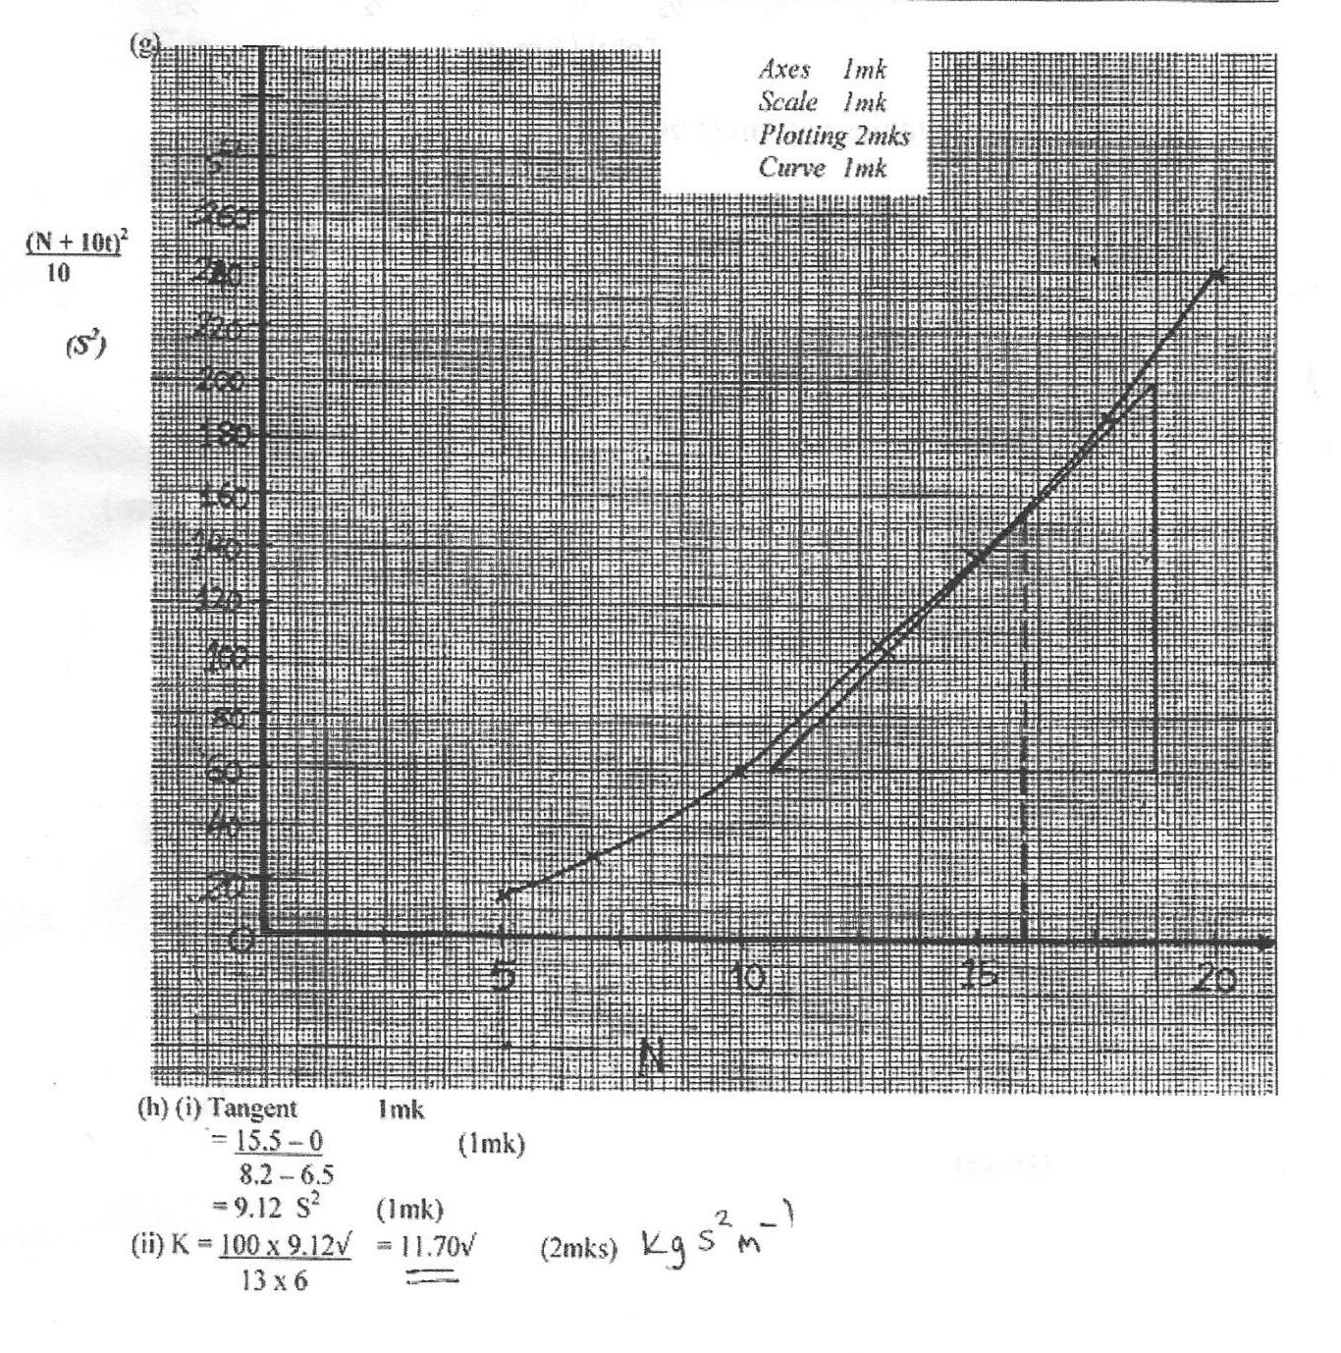
2.(a) f_{o}=10cm
Table 2
L(cm) | 2 | 3 | 4 | 5 | 6 | 7 | 8 | 9
X(cm)
¹/_{L}(cm⁻¹)
½ ½ ½ ½ ½ ½ ½ ½
Total (4mks)
Values of x must be up to 1d.p
P2
S1
S=$\frac{Δx}{Δ\frac{1}{L}}$
(b) Expected graph

X

¹/_{L}
(c) (Triangle must be shown of the graph $\text{gradient}\frac{Δx}{Δ\frac{1}{L}}h$ (3mks)
(d) $x={\frac{f}{L}}^{2}+\frac{L\left(f+ℓ\right)}{L}$
f ² is the gradient
hence f=$\sqrt{\text{slope}}$
slope from the graph √3
Part B
(ii) E=1.5±0.1v√1
(iii) V=1.4±0.1v√1
I=0.12A±0.001A
(iv) E-V=1r
0.1=0.12 x r√1
r = 0.1 =0.83Ω√1
0.12

