NAME ………………………………………………….ADM. NO……………CLASS ……………..

232/1

PHYSICS
PAPER 1
(THEORY)
2HOURS
MASTERCLASS INNER CIRCLE
CHAMPIONS LEADERSHIP INSTITUTE
INSTRUCTION TO THE CANDIDATES
- Write your name and admission number in the space provided.
- This paper consists of two sections A and B.
- Answer all questions in section A and B
- All workings must clearly be shown in the space provided after every question.
- Electronic calculators may be used.
- Take acceleration due to gravity, g = 10 ms⁻².
SECTION A (25 MARKS)
Answer all the questions in this section in the spaces provided.
1. A miner refines gold of the mas 25 mg.
Express this quantity in kilograms and in standard form. (1 mark)
……………………………………………………………………………………………………………………………………………………………………………………………………
2. A hole of area 2.0 cm² at the bottom of a tank 2.0m deep is closed with a cork. Determine the force on the cork when the tank is filled with water. (Density of water is 1000kg/m³ and acceleration due to gravity is 10m/s²). (3 marks)
…………………………………………………………………………………………………………………………………………………………………………………………………………………………………………………………………………………………………………………………………………………………………………………………………………

3. When determining the upper fixed point on a thermometer, the bulb is hang in steam coming from boiling water as shown in figure 1.

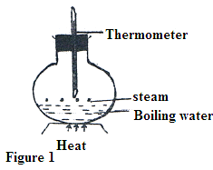

Give a reason why the bulb should not be placed in boiling water. (2 marks)
………………………………………………………………………………………………………………………………………………………………………………………………………………………………………………………………………………..……………………..

4. Water is known to boil at 100⁰C. A student heated some water and noticed that it boiled at 101⁰C.State two possible reasons for this observation. (2 marks)

……………………………………………………………………………………………………………………………………………………………………………………………………
5. Figure 2 below shows a spiral spring fixed on a bench vertically. A mass of 0.5 kg is placed on top as shown in the figure 2(a) and (b) below.

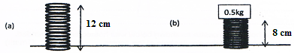
In (a) the height h_{o} of the spring is 12 cm while in (b) the height is 8 cm. calculate the energy stored in the spring. (3 marks)

………………………………………………………………………………………………………………………………………………………………………………………………………………………………………………………………………………..……………………
- State any two factors that affect momentum of a body. (2 marks)

……………………………………………………………………………………………………………………………………………………………………………………………………………………………………… ………………………………………..……………………
- A vehicle is moving at a speed of 5 m/s on flat road. The speed is then increased to 20m/s.
State what happens to the friction force between the vehicle and the road during the change.
(2 marks)

………………………………………………………………………………………………………………………………………………………………………………………………………………………………………………………………………………..……………………

Figure 3 below shows a simple pendulum. Use the figure to answer questions 8 and 9.
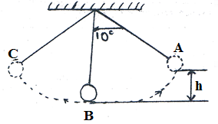
- State the type of equilibrium exhibited by the pendulum bob as it is displaced from A to B to C and back. (1 mark)

……………………………………………………………………………………………………………………………………………………………………………………………………
- If the bob of the pendulum has a mass of 20g and passes position B at 20m/s. determine the maximum height h it rises to from the mean position. (3 marks)

………………………………………………………………………………………………………………………………………………………………………………………………………………………………………………………………………………..……………………
- Figure4 shows a velocity-time graph for the motion of a certain body.
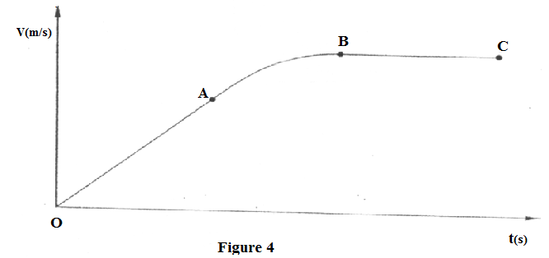
Describe the motion of the body in the region.
- OA (1 mark)
……………………………………………………………………………………………………………………………………………………………………………………………………
- AB (1 mark)
……………………………………………………………………………………………………………………………………..………………………………………..……………………

- BC (1 mark)
……………………………………………………………………………………………………………………………………………………………………………..……………………
- An object of mass 5kg moves such that the velocity-time graph of its motion is shown in figure 5 below.

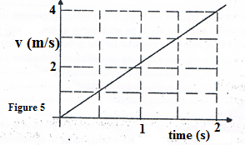
Determine the force acting on the object. (3 marks)
……………………………………………………………………………………………………………………………………………………………………………..……………………
……………………………………………………………………………………………………………………………………………………………………………..……………………

Section B (55 marks)
Answer all questions in the space provided.
- (a) State the difference between boiling and evaporation. (2 marks)
……………………………………………………………………………………………………………………………………………………………………………..…………..…………
…………………………………………………………………………………………………
(b) 1200g of a liquid at 10⁰C is poured into a well-logged calorimeter. An electric heater rated 1KW is used to heat the liquid. The graph in fig 4 below shows the variation of temperature of the liquid with time.

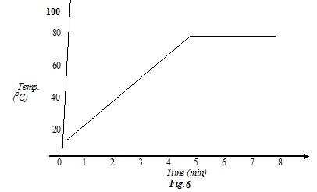
Use the graph to answer the following questions.
- What is the boiling point of a liquid? (1 mark)
…………………………………………………………………………………………………How much heat is given out by the heater to take the liquid to the boiling point? (2 marks)
…………………………………………………………………………………………………………………………………………………………………………………………………………………………………………………………………………………………………...….
- Determine the specific heat capacity of the liquid stating any assumptions made. (2 marks)
…………………………………………………………………………………..………………
…………………………………………………………………………………..………………
…………………………………………………………………………………..………………

- If 50g of the liquid vapour was collected by the end of the 8th minute, determine the specific latent heat of vaporization of the liquid. (3 marks)

…………………………………………………………………………………..…………………………………………………………………………………………………..………………………………………………………………………………………………..…………

- (a) Give conditions necessary for a gas to obey gas laws. (1 marks)

…………………………………………………………………………………..…………………………………………………………………………………………………..…………
(b) The Figure 7 below shows an experimental set up that may be used to investigate gas law of an ideal gas.
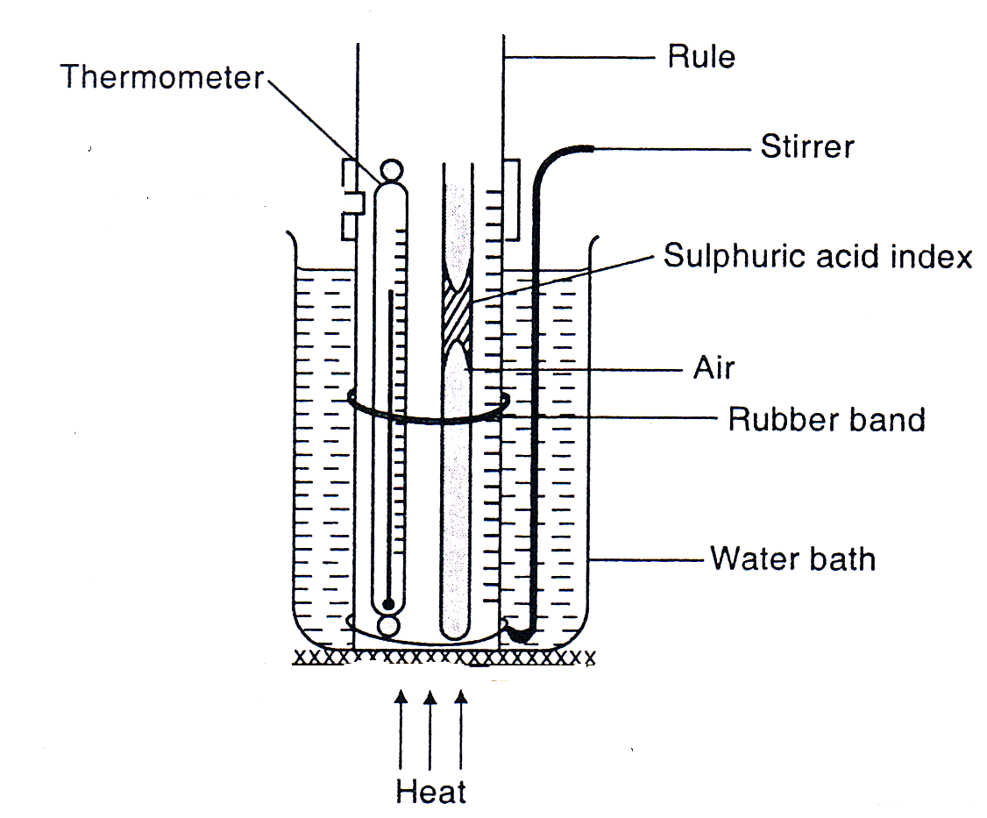

- Describe how the experiment can be used to verify the law. (3 mark)
……………………………………………………………………………………………………………………………………………………………………………………………………………………………………………………………………………………………………………………………………………………………………………………………….
(ii) Explain why the results obtained in the experiment above is not accurate. (1 mark)
………………………………………………………………………………………………………………………………………………………………………………………………
(iii) State two purposes of the concentrated Sulphuric acid drop. (2 marks)
………………………………………………………………………………………………………………………………………………………………………………………………………………………………………………………………………………………………

- Using kinetic theory of matter, explain how the volume of the trapped air increases.
(2 marks)
………………………………………………………………………………………………………………………………………………………………………………………………………………………………………………………………………………………………………………………………………………………………………………………………
- Give any assumptions made in the experiment above. (2 marks)
………………………………………………………………………………………………………………………………………………………………………………………………………………………………………………………………………………………………………………………………………………………………………………………………
- A mass of 1200 cm³ of oxygen at 27⁰C and pressure 1.2 atmospheres is compressed until its volume is 600 cm³ and its pressure is 3 atmospheres. Calculate the Celsius temperature of the gas after compression. (3 marks)
…………………………………………………………………………………………………………………………………………………………………………………………………………………………………………………………………………………………………………………………………………………………………………………..……………..………
- (a) Define velocity ratio of a machine. (1 mark)
……………………………………………………………………………………………………………………………………………………………………………………………………

(b) Figure 8 shows a drum of mass 90 kg being rolled up a plane inclined at 25⁰ to the horizontal. The force F applied is 420N and the distance moved by the drum along the plane is 5.2 m
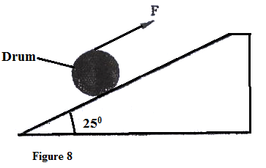
Determine:
(i) The work done by the effort (3 marks)

………………………………………………………………………………………………………………………………………………………………………………………………………………………………………………………………………………………………………………………………………………………………………………………………

(ii) The work done in raising the drum (3 marks)

………………………………………………………………………………………………………………………………………………………………………………………………………………………………………………………………………………………………………………………………………………………………………………………………

(iii) The efficiency of the inclined plane as a machine (2 marks)

………………………………………………………………………………………………………………………………………………………………………………………………………………………………………………………………………………………………………………………………………………………………………………………………
- Give a reason why the efficiency in (iii) above is less than 100%. ( 2 marks)
………………………………………………………………………………………………………………………………………………………………………………………………………………………………………………………………………………………………………
- (a) (i) State Newton’s second law of motion. (1 mark)

………………………………………………………………………………………………… ……………………………………………………………………………………………………………………………………………………………………………………………………
- A striker kicks a ball of mass 250g initially at rest with a force of 75N. If the foot was in contact with the ball for 0.10sec. Calculate the take-off velocity of the ball. (3 marks)
………………………………………………………………………………………………
………………………………………………………………………………………………
………………………………………………………………………………………………
………………………………………………………………………………………………
(b) A bullet of mass 20g moving at 400 m/s strikes a block of wood of mass 3.5kg initially at rest. The bullet sticks into the block and the two moved off together on a horizontal surface, where a frictional retarding force of 4N is acting between the block and surface.
(i) Determine the initial common velocity of bullet and wooden block. (2 marks)

…………………………………………………………………………………………………
………………………………………………………………………..……………………….. ………………………………………………………………………………………………………………………………………………………………………………………………….
(ii) What distance does the block move before coming to rest? (3 marks)
………………………………………………………………………………………………
- Explain why it is safer for a high jumper to land on a mattress than on a hard ground.
(2 marks)
…………………………………………………………………………………………………
………………………………………………………………………..……………………….. …………………………………………………………………………………………………
- (a) State the principle of moments. (1 mark)
……………………..…………………..…………………………………………………………………..………………………………………….…………………………..……………...…………….…………………………………………………………………………………...

(b) A uniform metal strip is 3.0cm wide, 0.6cm thick d 100cm long. The density of the metal is 2.7 g/cm^{3.}
- Determine the weight of the strip. (3 marks)
……………………..…………………..…………………………………………………………………..………………………………………….…………………………..……………...…………….…………………………………………………………………………………...
- The strip placed on a pivot and kept in equilibrium by forces as shown in figure. 9
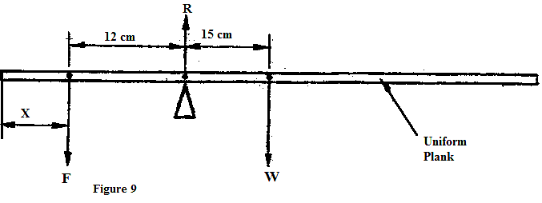
Determine the value of F and R (3 marks)

……………………..…………………..…………………………………………………………………..………………………………………….…………………………..……………...…………….…………………………………………………………………………………...

- (a)Figure. 10 shows a sheet of paper rolled into a tube.

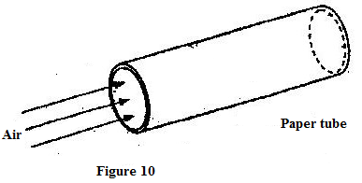
When a fast stream of air is blown into the tube as shown in the diagram the paper tube collapses. Explain the observation. (2 marks)

……………………..…………………..…………………………………………………………………..………………………………………….…………………………..……………...…………….…………………………………………………………………………………...
(b) A garden sprinkler has small holes each 2.00 mm² in area. If water is supplied at the rate of 3.0 × 10⁻³ m³s⁻¹ and the average velocity of the spray is 10m/s. calculate the number of small holes. (2 marks)

……………………..…………………..…………………………………………………………………..………………………………………….…………………………..……………...…………….…………………………………………………………………………………...

This is the last printed page.

