Name: . ………………………………………………………….. Index No. ………………….……

Class:…………………………… Admno…………………… Candidate’s Sign: …………..….

Date: …………………………….

312/2
Paper 2
GEOGRAPHY
Time: 2 ¾ Hours

MASTERCLASS INNER CIRCLE
CHAMPIONS LEADERSHIP INSTITUTE
Kenya Certificate of Secondary Education (K.C.S.E)
MINI MOCK EXAMINATION
312/2
Paper 2
GEOGRAPHY
Time: 2 ¾ Hours

INSTRUCTIONS TO CANDIDATES
- This paper consists of two sections A & B.
- Answer all the questions in section A.
- In section B answer question 6 and any other two questions. All answers must be written in the answer booklet provided.

FOR EXAMINER ONLY
Section A | 6 | 7 | 8 | 9 | 10 | TOTAL

This paper consists of 5 printed pages.
Candidates should check the question paper to ascertain that all the
Pages are printed as indicated and no questions are missing.

Section A: 25marks
Answer all questions
1.a) Name two mining methods used to extract diatomite in Kariandusi in Kenya. (2marks)

b) Outline three reasons why land dereliction occurs. (3marks)

2.a) Distinguish between indigenous forest and exotic forest. (2marks)

b) State three benefits of agro-forestry. (3marks)

3.a) Apart from flooding name two other natural hazards experienced in Kenya. (2marks)

b) Identify three ways through which water is polluted. (3marks)

4.a)Give three economic factors that influence settlement. (3 marks)

b) State two factors that contribute to the emergence of slums in urban centers. (2marks)

5.a) Name three natural habitats for wildlife. (3marks)

b) State two factors that hinder domestic tourism in Kenya. (2marks)

SECTION B: 75 MARKS
Answer question 6 and any other TWO questions

6. a) i) Give two documents from where information on population data is
obtained (2marks)

- The pyramid below represents the population structure of Kenya.
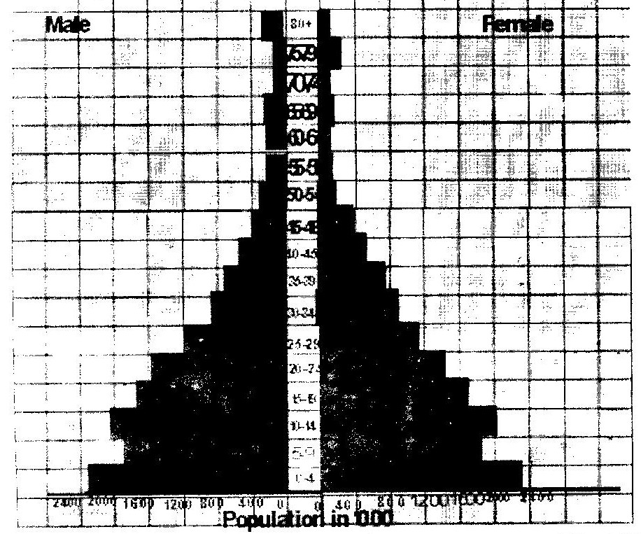

Describe the characteristics of the population as represented by the pyramid. (3marks)
b) i) In 1989 Kenya population was 21.4 million while in 1999 it was
28.7 million. Calculate the population growth rate over the 10 year period. (Show your calculations) (2marks)
ii) Explain two factors which may have led to the large population
increase between 1989 and 1999. (4marks)
c) Explain three consequences of high population growth rate. (6marks)
d) Explain four physical factors that influence population distribution in East
Africa. (8marks)

7. a) State three physical conditions that favour large scale sugarcane farming
in Kenya. (3marks)
b) Describe the cultivation of sugarcane farming in Kenya. (6marks)
c) Explain five problems facing sugarcane farming in Kenya. (10 marks)
d) Your class visited a sugar factory for a field study on sugar processing.
i) Outline four stages of sugar processing that the class may have
observed. (4marks)
ii) Name two by-products of sugar that the class may have identified
during the study. (2marks)

8. (a) Differentiate between land reclamation and land rehabilitation. (2marks)
(b) Explain how the following factors favoured the development of the Mwea – Tebere irrigation scheme;

- Climate (2marks)
- Topography (2marks)
- Population (2marks)

(c) State four benefits of Mwea Tebere irrigation scheme to Kenya. (4marks)

(d)i. Define the term irrigation. (1mark)
ii. Name three types of irrigation used in Kenya. (3marks)
iii. Explain three problems facing irrigation farming in Kenya. (6marks)
iv. State possible solutions to the problems stated in d(iii) above. (3marks)

9. (a) i. Differentiate between fishing and a fishery. (2marks)
ii. Name three major types of fish. (3marks)
(b)Explain four factors that favour marine fishing in Japan. (8marks)
(c)Explain four significance of the fishing industry in Kenya. (8marks)
(d) State four problems facing fishing in Kenya. (4marks)

10. a)( i)Name two non – renewable sources of energy. (2marks)
(ii)Explain five physical factors that influence the location of a hydroelectric power station. (5marks)
b)A part from generating Hydro-Electric Power (H.E.P), give three other benefits of the construction of Masinga Dam. (6marks)
c)Explain three benefits that would result from rural electrification in Kenya. (6marks)
d)In what three ways did the power shortages resulting from the drought of the years 1999 and 2000 affect the industrial sector in Kenya? (6marks)

