MIDTERM 1, 2021 EXAM
FORM 3 AGRICULTURE
TIME: 1 HOUR
INSTRUCTIONS: ANSWER ALL QUESTIONS
- Define hybrid vigour as used in livestock production (1mk)

- Outline three disadvantages of artificial insemination in cattle management (3mks)

- Give any three reasons why bees swarm from a hive ( 3mks)

- Below is a diagram of a sheep with some parts labeled A, B, and C. Study the diagram and answer the questions that follow.
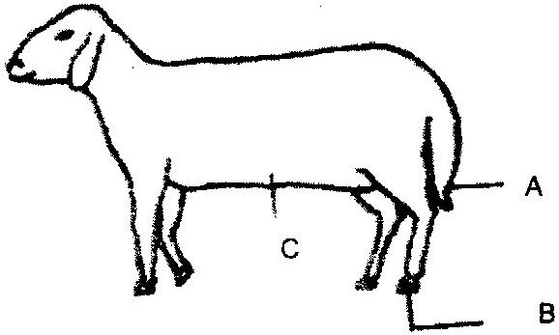

- What operation is usually carried out on the part labeled A during a sheep’s early stages of life? (1mk)

- Why is it necessary to carry out the operation in (i) above? (2mks)

- At what stage of sheep should the operation in (i) above be carried out? (1mk)

- Give two methods of carrying out the operation in (i) above (1mk)

- Which operation is usually carried out on part labeled B (1mk)

- Give four signs which indicate that a sow is about to farrow (4mks)

- Give three reasons for treating timber to the used in construction of farm buildings (3mks)

- State six features of an ideal calf pen (3mks)

- State four features of a good maize granary.(4mks)

- Name two notifiable diseases in cattle. (1mk)

- State two ways by which proper feeding contribute to disease control in livestock. (1mk)

- (a) Give two causes of blossom end rot in tomatoes (2mks)

(b) State two methods of controlling blossom end rot in tomatoes (2mks)

12. What four aspects of rainfall should a Kenyan farmer consider while growing crops (2mks)

- One of the recommended ratio of mixing ingredients for making Concrete block is 1:3:4.
- Name ingredients represented by the numbers 1, 3 and 4 in the mixture. (3mks)

- If stronger concrete blocks were to be made, name the ingredient that would be increased. (1mk)

- State three properties of concrete that make it suitable for constructing farm buildings. (3mks)

- Describe the life cycle of a three- host tick. (8mks)

