MIDTERM 1, 2021 EXAM
FORM 4 AGRICULTURE
TIME: 1 HOUR
INSTRUCTIONS: ANSWER ALL QUESTIONS
1. Give three methods of controlling cannibalism in a flock of layers in deep litter system. (3mks)

2. Describe four characteristics of a poor layer which should be considered during culling (4mks)

3. The diagram below is a cross section of part of a cow’s udder
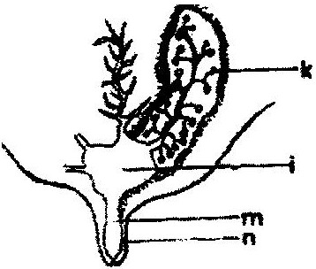

- Label on the diagram the parts marked k, I, m and n. (2mks)

(b) i) What is milk let down? (1mk)

ii) Which hormone stimulates milk let down. (1mk)

(c)State three practices which are carried out to control mastitis in lactating cows. (3mks)

4. Explain three qualities that make colostrum suitable for newly born calves. (3mks)

5. State any five practices that would ensure clean milk production (5mks)

6 State six reasons why agriculture is important in Kenya economy. (3mks)

7. State two methods of increasing ploughing depth when using a disc plough. (2 mks)

8. State four ways of improving the labour productivity of farm labour. (4mks)

9. a) Define opportunity cost as used in Agricultural economics (1mk)

- State two situations under which the opportunity cost is nil (2mks)

10. State four variable costs in bean production (2mks)

11. a) Below is a graphical representation of the law of diminishing returns.
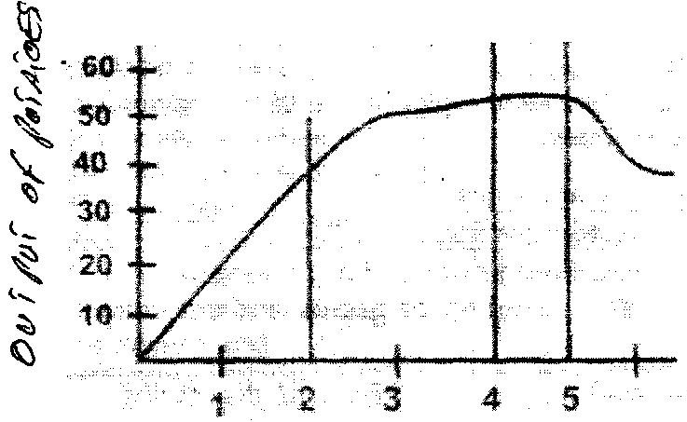

a) Explain what happens in each of the Zones marked by lines in relation to output. (3mks)

- Which of the three is a rational zone of production? (1mks)

- State any three precautions a potatoes farmer would take to minimize risks in the production of potatoes. (2mks)

12. Compare the use of an ox-drawn mould board plough with that of a tractor-drawn mould board plough (8 mks)

