NAME: ……………………..…………. ADM NO: ……….. CLASS: …………

BIOLOGY
FORM 2
MID-TERM 1 EXAM 2021

Answer all the questions in the spaces provided.

1. (a) State the function for co-factors in cell metabolism. (1 mk)

(b) Give one example of a metallic co-factor. (1 mk)

2. The diagram below shows all human tooth.
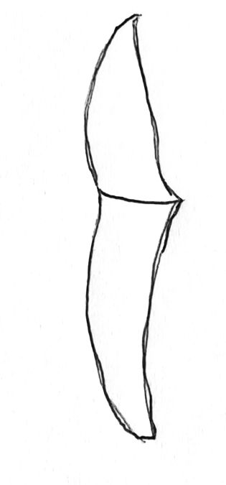
(a) Identify the tooth . (1 mk)

(b) How is the tooth adapted to its function. (2 mks)

(c) State the role of the following vitamins in the human body. (2 mks)

3. Name two enzymes in the human digestive system which are secreted in an active form.

4. Name the part of chloroplast where the following reactions occur. (2 mks)
(a) Carbon (IV) oxide fixation.

(b) Photolysis.

5. Explain the importance of the following in photosynthesis. (3 mks)
(i) Light –

(ii) Carbon (iv) oxide –

6. The diagram below represents a transverse section of a young stem.

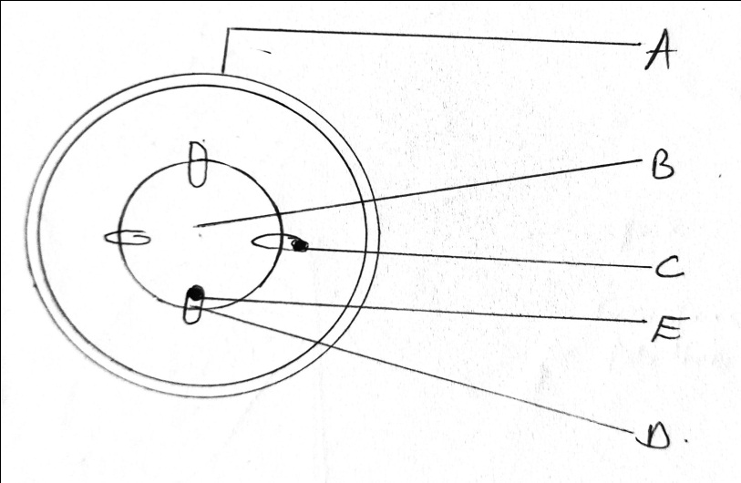

(a) Name the part labeled A and B. (2 mks)

(b) State the function of the parts labeled C, D and E. (3 mks)

(c) List three differences between the section shown above and one that would be
obtained from the root of the same plant. (3 mks)
ROOT | STEM

7. State three ways in which xylem vessels are adapted to their functions. (3 mks)

8. Name two processes that bring about the translocation of manufactured food. (2 mks)

9. The diagram below shows a section of a plant organ.

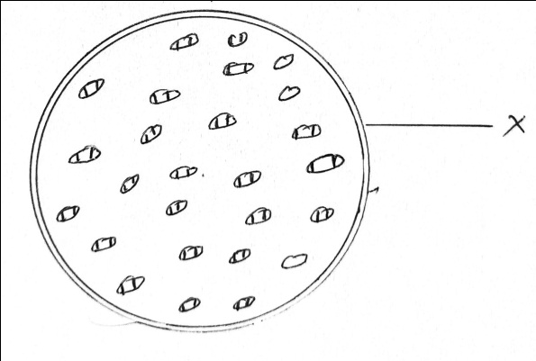

(a) ) Name the part of the plant on which the organ above was obtained (1 mk)

(b) (i) Name the class to which the plant organ was obtained. (1 mk)

(ii) Give a reason for your answer in (b) (i) above. (1 mk)

(c) Name the part labeled X. (1 mk)

10. Distinguish between haemolysis and plasmolysis.
(i) Haemolysis . (1 mk)

(ii) Plasmolysis - (1 mk)

11. State the function of the following cell organelles.
(i) Ribosome - (1 mk)

(ii) Lysosome - (1 mk)

12. (a) What is a single circulatory system. (1 mk)

(b) Name an organism which has single circulatory system. (1 mk)

(c) Name the opening to the chamber of the heart of an insect. (1 mk)

13. (a) Explain two roles of diffusion in human being. (4 mks)

(b) What is meant by each of the following terms?
(i) Crenated cell. (1 mk)

(ii) Flaccid. (1 mk)

14. A spotted plant was kept in the dark for 48 hours. Two leaves X and Y were treated as
shown in the diagram below.

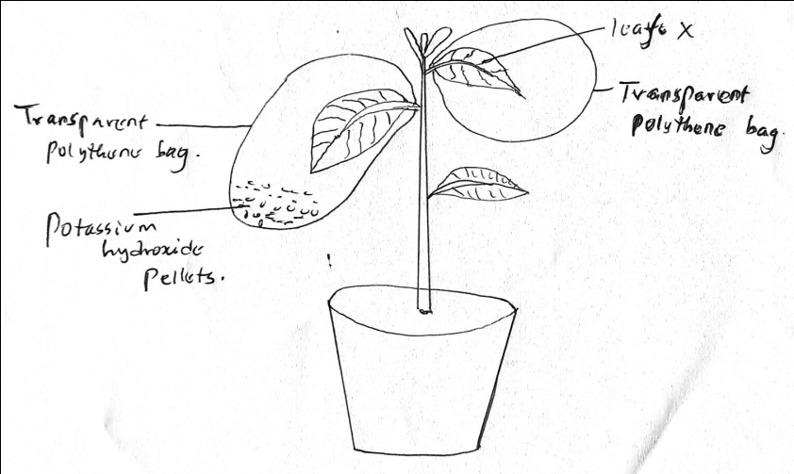

The experimental set up was kept in sunlight for six hours after which a starch test was
carried out on the two leaves.

(a) What were the results of the starch test on leaves X and Y. (2 mks)

(b) Give reasons for your answer in (a) above. (2 mks)

15. Name one end product of dark reaction in photosynthesis. (1 mk)

