NAME: ……………………..…………. ADM NO: ……….. CLASS: …………

BIOLOGY
FORM 3
MID-TERM 1 EXAM 2021
TIME:

Answer all the questions in the spaces provided.

1. A student caught an animal which had the following characteristic.
Body divided into two parts
Simple eyes
Eight legs
The animal belongs to class?
(1mk)
The animal belongs to class ………………………………..

2. What is the function of the following cell organelles?
(a) Golgi apparatus. (1mk)

(b) Ribosomes (1mk)

3. Why is oxygen important in the process of active transport in cells? (2mks)

4. What happens to red blood cells when placed in concentrated solution? (2mks)

5. Why is it that xylem vessels do not collapse even when they do not contain water (1mk)

6. Below is a dental formula of a given animal
i $\frac{0}{2}$ c$\frac{0}{0}$ pm $\frac{3}{3}$ m $\frac{2}{2}$
With reasons identify the mode of feeding (3mks)
Reason:

7. The chart below shows a feeding relationship in a certain ecosystem.
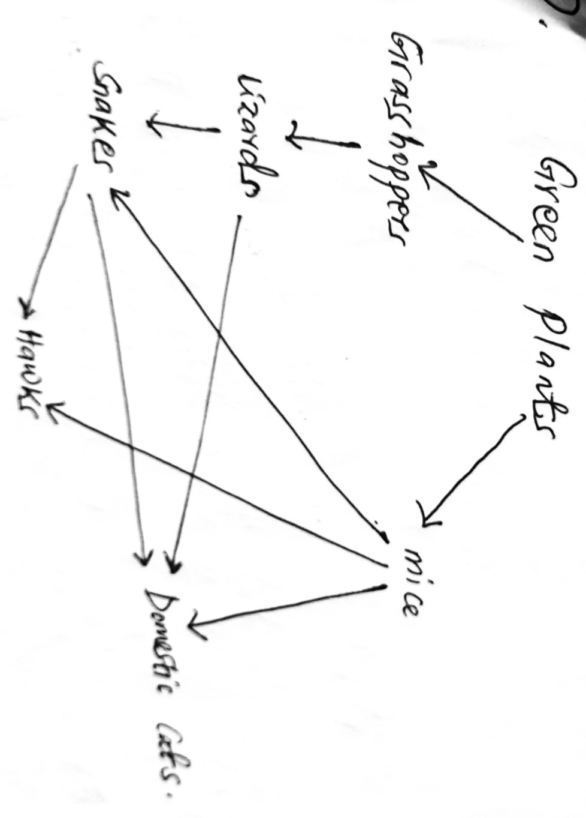
(a) Construct two food chains ending with a tertiary consumer in each case (2mks)

(b) Which organism has the largest variety of predators in the food web (1mk)

(c) Name secondary consumers in the food web (2mks)

(d) Suggest three ways in which the ecosystem would be affected if there was prolonged droughts
(3mks)

8.(i) Distinguish a community and population (2mks)

(ii) Explain how birds of prey are adapted to obtaining their food (2mks)

9.(i) Name the bacteria found in root nodules of leguminous plants (2mks)

(ii) What is the role of the bacteria named in (i) above (1mk)

10. In a fish pond the number of fish was estimated by use of the following information
First capture =50
Second capture =90
Marked captured =25

(i) Identify the method suggested above (1mk)

(ii) Name two other sampling methods used in estimating populations (2mks)

(iii) Calculate the total number of fish in the pond (2mks)

(iv) Give three assumptions in the above methods (3mks)

11. A person was found to pass out large volumes of dilute urine frequently (2mks)
Name the:
(a) Disease the person was suffering from.

(b) Hormone that was deficient.

12. State two ways by which Acquired Immune deficiency Syndrome (AIDS) virus is transmitted.
(2mks)

13. (a) Name the causative agents of the following diseases in humans. (2mks)
(i) Typhoid

(ii) Amoebic dysentery

(b) Name the disease caused by Plasmodium falciparum (1mk)

14. Describe three effects of dumping untreated sewage into a river. (3mks)

(b) Name one process that is responsible for loss of energy from one trophic level to the next. (1mk)

15. Using a microscope, a student counted 55 cells across a field of view whose diameter was 600 cm.
Calculate the average length of cells. Show your working. (2mks)

16. Name two structures used for gaseous exchange in plants. (2mks)

17. (a) Name the class in the phylum arthropod which has the largest number of individuals. (1mk)

(b) State three external differences between chilopoda and diplopoda (3mks)

18. Explain how you would estimate the population of fish in a bond. (3mks)

