JOINT EXAMINATION
PHYSICS FORM ONE
MID TERM ONE AUGUST 2021
TIME 1 HOUR
NAME……………………..………………….ADM………….CLASS…………
- Define the term physics. (1mk)

- State any 6 branches of physics. (3mks)

- What is a laboratory? (1mk)

- State four safety rules that should be followed while you are in the laboratory. (4mks)

- While stating an example in each case, differentiate between derived quantity and basic quantity. (4mks)

- Explain the relationship between the following;
(i) Physics and mathematics (1mk)

(ii) Physics and chemistry (1mk)

- Give three reasons for studying physics. (3mks)

- Convert each of the following as indicated.
(i) 10 tones into kg (1mk)

(ii) 12g into mg (1mk)

(iii) 2,000,000mg into kg (1mk)

- State any two instruments that we can use to measure a length (2mks)

- Define the following term and state the S.I unit in each case (3mks)
(i) Mass
(ii) Volume
(iii) Area
- Calculate the area of a triangle whose base is 4.0cm and its length is 3.0cm (3mks)
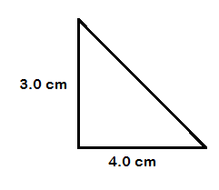

- The density of water is 1g/cm3 express in kg/m3

