COMPUTER STUDIES
FORM 4
CAT TERM ONE 2021
Instruction: Answer all questions in space provided. (30mks)

1(a) List three paragraph formatting activities in word processing (3 mks)

2.(a) Convert 91B₁₆ to octal (3mks)

(b) 9.625₁₀ to binary

3.(a) State two applications areas of desktop publishing software. (2mks)

(b) Explain the following graphic terms
- Rotate-

- Crop

4.Name three types of optical disks (3 mks)

5. The diagram below shows four common network topologies A, B, C
and D
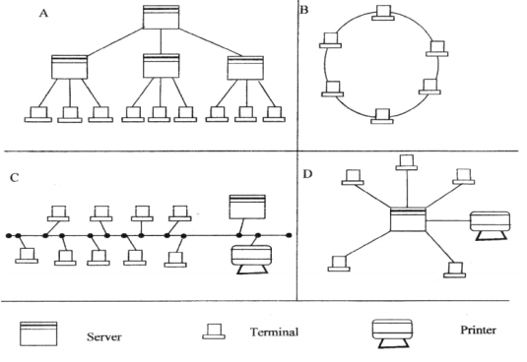

i) Name the network topologies labeled A, B, C and (4 marks)
_{A}

_{B}

_{C}

Using six bits, find the two's complement of -23₁₀. (4 marks)

6.Define the following web related terms:
i) Web browser (2 mark)

ii) Hyperlink (2 mark)

iii) Hypertext document (2mark)

7. Give a reason for each of the following
(a) Changing a password regularly ( 1 mk)

(b) Typing and re- typing a new password when changing it ( 1 mk

8. Explain why input screens are better data entry designs than entering
data directly to a table. (2 marks)

