NAME……………………….……………………………………CLASS……….ADM:..................
DATE…………………………….………………………………. SIGNATURE…………………...

FORM 4 GEOGRAPHY MID TERM 1, 2021 EXAM
DURATION: 1HOUR 15 MINUTES

INSTRUCTIONS TO CANDIDATES
- Answer ALL the questions in this paper.
- All the answers must be written on the foolscaps provided.

SECTION A
1. (a) What is agriculture? (2 marks)
(b) State three Physical factors favouring dairy farming in Denmark. (3 marks)

(c) Give five similarities between dairy farming in Kenya and dairy farming in the Denmark. (5 marks)

2 (a) Differentiate between land reclamation and land rehabilitation. (2 marks)

(b) The outline map of Kenya below shows some irrigation schemes.
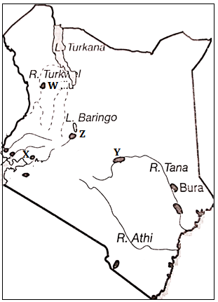

(ii) Identify the irrigation schemes marked W, X, Y and Z. (4 marks)

(ii) Apart from irrigating dry lands, outline four other methods used to reclaim land in Kenya (4 marks)
(c) Give three differences between land reclamation in Kenya and land reclamation in Netherlands (6 marks)

3. (a) Define the term fisheries. (2 marks)
(b) Give three examples of demersal fish. (3 marks)

(c) Explain three reasons why freshwater fishing is more widespread than
Marine fishing in East Africa. (6 marks)

4. (a) Differentiate between a national park and a game reserve. (2marks)

(b) State five reasons for establishment of national Park and Game Reserve. (5 marks)

(c) Explain three reasons why Switzerland receives more tourists than Kenya (6 marks)

