GEOGRAPHY
FORM 1 MID TERM 1 2021
TIME: 1Hr
NAME………………………………………….…………….CLASS……….ADM………..
INSTRUCTIONS;
Attempt all the questions.

1. Define the term Geography. (2mks)
………………………………………………………………………………………………………………………………………………………………………………………………………………………………
2. Name two main branches of geography. (2mks)
……………………………………………………………………………………………………………………………………………………………………………………………………………………………….
3. Explain the relationship between Geography and mathematics. (2mks)
……………………………………………………………………………………………………………………………………………………………………………………………………………………………………………………………………………………………………………………………………………….
4. State any four importance of studying geography. (4mks)
………………………………………………………………………………………………………………………………………………………………………………………………………………………………………………………………………………………………………………………………………………………………………………………………………………………………………………………………………………………………………………………………………………………………………………………………………………………………………………………………………………………………………………………………………………………………………………………………………………
5. What is the solar system? (2mks)
………………………………………………………………………………………………………………………………………………………………………………………………………………………………………………………………………………………………………………………………………………
6. List two theories that explain the origin of the solar system. (2mks)
………………………………………………………………………………………………………………………………………………………………………………………………………………………………
7. State four proofs that indicate that the earth is spherical. (4mks)
………………………………………………………………………………………………………………………………………………………………………………………………………………………………………………………………………………………………………………………………………………………………………………………………………………………………………………………………………………………………………………………………………………………………………………………………………………………………………………………………………………………………………………………………………………………………………………………………………………
8. Identify the three forces that are responsible for the shape of the earth. (3mks)
………………………………………………………………………………………………………………………………………………………………………………………………………………………………………………………………………………………………………………………………………………………………………………………………………………………………………………………………
9. Differentiate between rotation and revolution of the earth. (2mks)
……………………………………………………………………………………………………………………………………………………………………………………………………………………………………………………………………………………………………………………………………………….
10. When the time at Kabale (30⁰E) is noon, what is the local time at Wajir (40⁰E). (3mks)

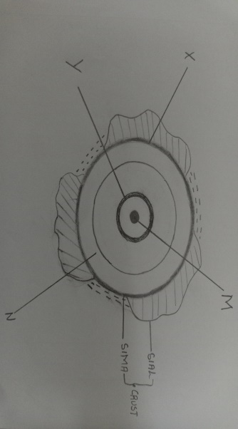
11. The diagram below shows the internal structures of the earth. Use it to answer the questions that follow.

(a) Name the main layers M and N
M____________________________________ (2mks)
N____________________________________
(b) Identify the discontinuities X and Y
X____________________________________ (2mks)
Y____________________________________

