MATHEMATICS
FORM 3
MID-TERM 1 EXAMS 2021
TIME: 1$\frac{1}{4}$ HRS
SECTION I (20MKS): Answer all questions in this section in the spaces provided
- Evaluate;
  - Sin $\frac{2}{3}π^{c}$ (2mks)

  - Tan 1.2^{c} (2mks)

- If $\log_{2}x+\log_{x}2=2$, find x. (3mks)

- The angle of elevation of the top of a building from a point P is 45º. From another point T, 15 meters nearer the foot of the building, the angle of elevation of the top of the building is 52º. Calculate the height of the building (correct to 1 decimal place). (4mks)

- Given that the dimensions of a rectangular book cover are 20.2 cm and 25.0 cm. Find the percentage error in calculating the area (correct to 2 decimal places). (3mks)

- Simplify by rationalizing the denominator: (3mks)
$$\frac{2}{4-√5}$$

- Use the method of completing the square to solve for x
${4x}^{2}+12x-9=0$ (3mks)

SECTION II (30 MKS): Answer any 3 questions in this section
- The figure below represents a frustum of a right pyramid on a square base. The vertical height of the frustum is 3 cm. Given that EF = FG = 6 cm and that AB = BC = 9 cm.

A
B
D
E
C
F
G
H
Calculate correct to 2 decimal places;
  - The vertical height of the pyramid. (2mks)

  - The surface area of the frustum. (4mks)

  - Volume of the frustum. (4mks)

- Complete the table below for the function $y=x^{2}+5x-3$ (2mks)

X | -6 | -5 | -4 | -3 | -2 | -1 | 0 | 1
x² | 36 |  |  | 9 |  | 1 |  | 1
5x | -30 |  | -20 |  |  |  | 0
-3 | -3 | -3 |  |  | -3 | -3
Y | 3 | -3 | -7 |  | -9 |  | -3 | 3

- On the grid provided, draw the graph of $y=x^{2}+5x-3$ (3mks)

- State the equation of the line of symmetry for the graph (1mk)

- Use the graph to solve the equations;
- $x^{2}+5x-3=0$ (1mk)

- $x^{2}+4x-2=0$ (3mks)

- The figure below is a triangle XYZ. ZY = 13.4cm, XY = 5cm and angle xyz = 57.7⁰
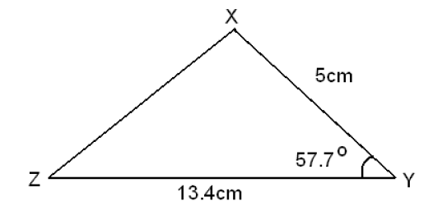
Calculate
- Length XZ. (3mks)

- Angle XZY. (2mks)

- If a perpendicular is dropped from point X to cut ZY at M, Find the ratio MY:ZM (3mks)

- Find the area of triangle XYZ. (2 mks)

- (a) Complete the table below by filling in the blank spaces. (2mks)
x | 0⁰ | 30⁰ | 60⁰ | 90⁰ | 120⁰ | 150⁰ | 180⁰ | 210⁰ | 240⁰ | 270⁰ | 300⁰ | 330⁰ | 360⁰
Cos x |  | 0.87 |  |  | -0.5 |  | -1.0 |  |  | 0.00 |  | 0.87
(b) On the grid provided, draw the graph of y = Cos x for 0⁰ ≤ x ≤360⁰ (5mks)
(Take the scale: 1cm for 30⁰ on the x-axis and 4 cm for 1 unit on the y-axis).

(c) Use the graph in (b) above to solve the following;
i. Cos x = 0.91
ii. Cos x = -0.5
iii. Cos x = 0.3 (3mks)
- A truck left town P at 8:00 a.m and traveled towards town Q at an average speed of 80km/h. At 8.30a.m, a van left town Q towards town P at an average speed of 120km/hr. Given that the distance between the two towns is 400km, Calculate:-
  - The time the van arrived in town P (2mks)

  - The time the two vehicles met (4mks)

  - The distance from town P to the meeting point

  - The distance of the truck from town Q when the van arrived in town P

