NAME: ………………….……………………………..…ADM NO: …….…..CLASS: ………
JOINT EXAMINATION
MID TERM ONE 2021 EXAM
PHYSICS FORM TWO
TIME: 1 HOUR
1. State basic law of magnetism (1mks)

2. Give a reason why a concrete beam reinforced with steel does not crack when subjected to change in temperature (1mks)

3. Name two adaptations that can be made to a mercury thermometer to make it more sensitive (2mks)

4. An oil drop of average diameter 0.7mm spreads out into a circular patch of diameter 75cm on the surface of water in a trough.
i) Calculate the average thickness of a molecule of oil (3mks)

ii) State two assumptions made in (i) above (2mks)

5. A block measuring 20cm x 10cm x 5cm rests on a flat surface. A block has a weight of 3N. determine the maximum pressure it exerts on the surface. (3mks)

6. A Vanier calipers shown below have a zero error of -0.06cm.(6mks)
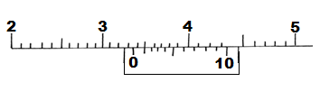

State the actual reading on the instrument (2mks)

7.State two ways in which stability of a body can be increased (2mks)

8. 200 coulombs of charge passes through a point in a circuit for 0.6 minutes. What is the magnitude of current flowing? (2mks)

9. Distinguish between hard magnetic material and a soft magnetic material (2mks)

10. A coil of insulated wire is wound around a U – shaped soft iron core XY and connected to a battery as shown in the figure below
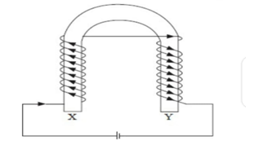
State the polarities of ends X and Y (2mks)
X ………………………………
Y ………………………………
11.Define moment of a force and state its SI unit (2mks)

12.Express each of the following number in standard form (3mks)
a)201

b) 2670

c)0.0000009047

13. What is the reading of the micrometer screw gauge in the figure below. (3mks)

