BUSINESS STUDIES
FORM 4
MID TERM
TERM 1 2021
TIME: 1HR

NAME ……………………………………………….. ADM …………….. CLASS………….

Instructions:
Answer all the questions in the spaces provided

- State four ways in which the government may motivate its industries to delocalize. (4mks)

- Highlight any four solutions to the unemployment problem in Kenya. (4mks)

- The following information belongs to the business of Kadogo retailers as at 31st March 2020.
Purchases 1800
Opening stock 1000
Carriage in 400
Purchases returns 200
Closing stock 600
a. Calculate (a) the average stock. (2mks)

b. The cost of sales. (2mks)

- Outline any four factors considered by a business proprietor before allowing credit to a customer. (4mks)

- Mention any four contents of a business plan. (4mks)

SECTION B
Answer all questions in this section.
- Explain two differences between an oligopoly and a monopoly. (4mks)

b. Global enterprises stated business with sh. 500,000 in cash on 1st December 201,
December 2: Deposited sh. 300,000 cash into the bank
8: Purchased goods in cash sh. 25,000
11: Took Sh. 30,000 cash for personal use.
19: Paid wages sh. 100,000 by cheque
25: Cash sales sh.75, 000
30: Paid wages sh. 100,000 by cheque.
Required:
Enter the above transactions in Global enterprises ledger accounts. (6mks)

- The following diagram represents the circular flow of income between firms and households in an economy. Identify the flows labeled A,B, C and D. ( 4 Marks)

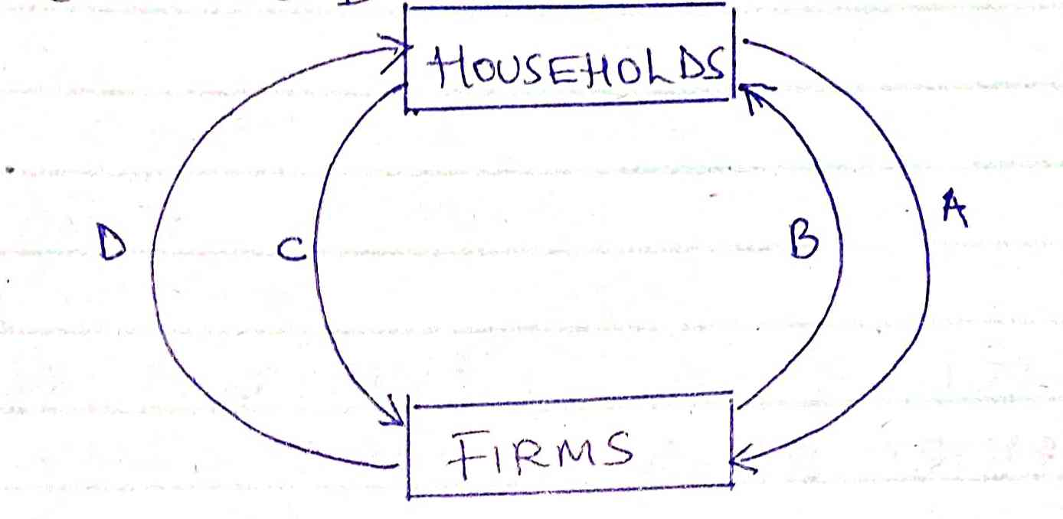

A
B
C
D

b) Dorcas holdings had the following balances on 31st December 2019.
Sh
Furniture 240,000
Debtors 160,000
Creditors 80,000
Stock 80,000
Bank 120,000
Cash 24,000
Salaries due 64,000

Required:
i. Calculate Dorcas holdings capital as at 31st December 2019. (2mks)

ii. Prepare opening entries in Dorcas’ General Journal. (4mks)

- Outline two advantages of using the internet as a means of communication. (4mks)

b. Explain three circumstances under which a high population growth maybe desirable. (6mks)

