CHEMISTRY
FORM 3
MID TERM
TERM 1 2021
TIME: 1HR 15MIN
NAME ……………………………………………….. ADM …………….. CLASS………….

Instructions:
Answer all the questions in the spaces provided

- A substance contains 25.6% copper, 12.8% sulphur, 25.6% oxygen and 36.0% water of crystalisation. Calculate its simplest formula. (Cu=64, S=32, O=16 and H1) (4mks)

- An organic compound has an empirical formula CH₃O and relative molecular mass 62. What is its molecular formula? (2mks)

- State Charles’s law. (1mk)

b. Draw a sketch graph to illustrate Charles’s law. (2mks)

c. At a temperature of 57^{O}C, nitrogen gas occupies a volume of 750cm³. At what temperature will the gas occupy 100cm³? Express the answer in degrees Celsius. (3mks)

- A given mass of a gas occupies 20cm³ at 25^{O}C and 670mmHg pressure. Find out the volume it will occupy at;
a. 10^{O}C and 335mmHg. (3mks)

b. O^{O}C and 760mmHg. (3mks)

- Write ionic equation for the reactions between:
- Barium chloride solution and copper (II) Sulphate solution. (2mks)

- Zinc and copper (II) sulphate. (2mks)

- Zinc metal and hydrochloric acid reacts according to the following equation.
Zn(s) + 2HCl(aq) ZnCl₂(aq) + H₂(g)
1.96g of Zinc metal were reacted with 100cm³ of 0.2m hydrochloric acid.
- Determine the reagent that was in excess. (Zn=65.4) (2mks)

- Calculate the total volume of hydrogen gas that was liberated at S.T.P (S.T.P = 22.4l) (2mks)

- Complete the table below which show properties of indicators used in titrations. (3mks)
Indicator | Colour in Acid | Colour un Alkali | Colour in neutral
Phenolphthalein |  | Pink | Colourless
Methyl orange | Pink |  | Orange
Screened methyl orange | Red | Green

- Solution A was made up by dissolving 2.65g, of a metal carbonate, X₂CO₃ in water and diluting the solution to 250cm³. B is a 0.25m solution of hydrochloric acid. 20cm³ portions of A were titrated with solution B using methyl orange indicator with the following results.
- Complete the following table. (1 ½ mks)
Burette readings | 1st | 2nd | 3rd
Final reading (cm₃) |  |  | 48.1
Initial reading (cm³) | 0.0 | 16.1 | 32.1
Volume of solution B used (cm³) | 16.1 | 16.0

- The volume of the pipette used. (1mk)

- Calculate the average volume of solution B used. (1mk)

b. The equation of the reaction is;
2HCl(aq) + X₂CO₃(aq) 2XCl(aq) + H₂O(l) +CO₂(g)
Calculate the concentration of the solution A in;
- Moles/litre (3mks)

- g/litres (2mks)

c. Calculate the Relative Atomic Mass of X. (C=12, O=16, X=?) (3mks)

- State the Gay Lussac’s law. (1mk)

- If it takes 30 seconds for 100cm³ of Carbon (IV) Oxide to diffuse across a porous plate. How long will it take 150cm³ of nitrogen (IV) oxide to diffuse across the same plate under similar condition? (C=12, N=14, O=16) (3mks)

- A form three student set up an experiment to explain the rate of diffusion of ammonia and hydrogen chloride in air. Study it and answer the question that follows.

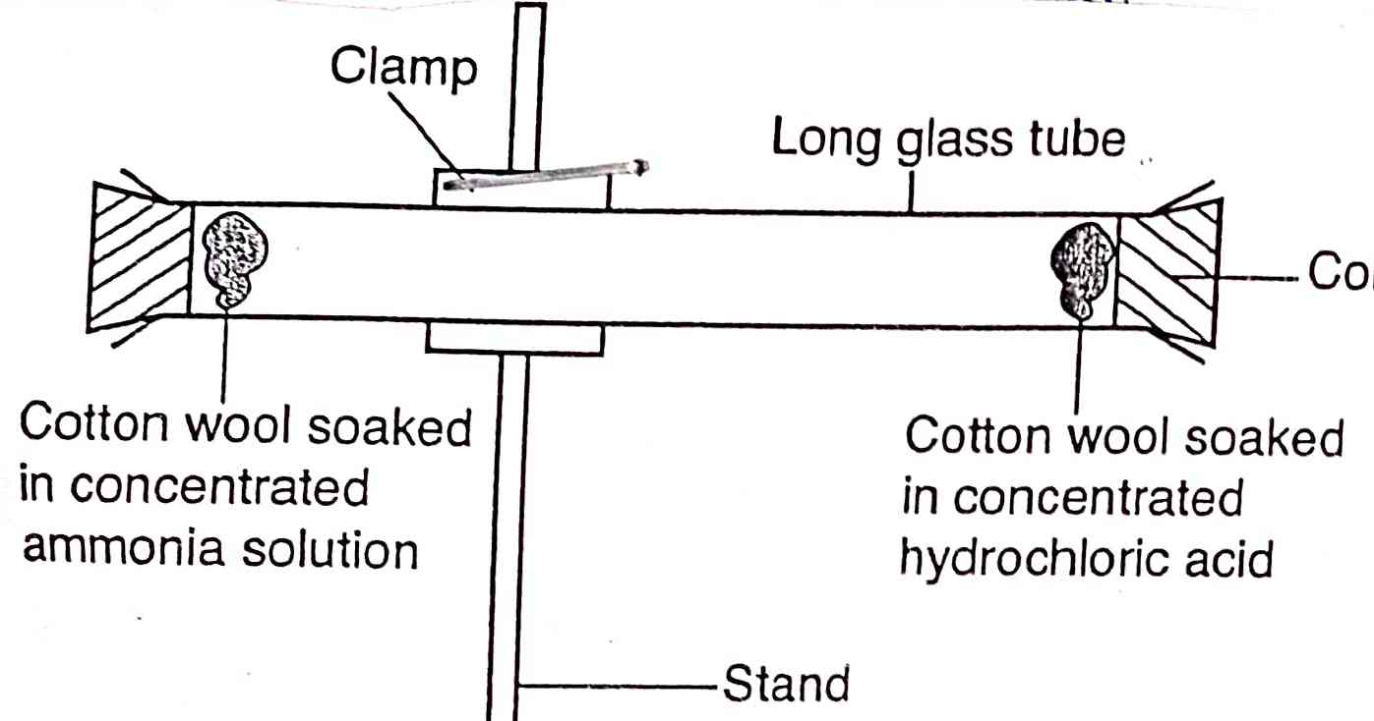

- What observation is made in the glass tube? Explain? (2mks)

- Determine the molecular masses of ammonia (NH₃) and hydrogen chloride (HCl) (N=14, H=1, Cl=35.5) (1mk)

- Which gas covered a longer distance? ( ½ mk)

- Name two laboratory apparatus that are used to measure fairly accurate volumes of liquids. (2mks)

