CHEMISTRY
FORM 4
MID TERM
TERM 1 2021
TIME: 2HRS
NAME ……………………………………………….. ADM …………….. CLASS………….

Instructions:
Answer all the questions in the spaces provided

- Define a soluble base. (1mk)

b. Aqueous solutions of 2M ethanoic acid and 2M nitric (v) acid were tested for electrical conductivity. Which solution is a better conductor of electricity? Explain. (2mks)

- Explain why it is not advisable to prepare a sample of carbon (IV) oxide using lead (II) carbonate and dilute sulphuric (VI) acid. (2mks)

b. State a method that can be used to collect dry carbon (IV) oxide gas. Give a reason. (1mk)

- The following are formulae of organic compounds. Use the formular to answer the questions that follow.
CH₃CH₂CH₂OH;
CH₃COOH;
CH₃CH₂CH₂CH₃;
CH₃CCCH₃;
Select;
- i. Two compounds which when reacted together produce a pleasant smelling compound. (1mk)

ii. Name the compound formed in (i) above. (1mk)

iii. Select an unsaturated hydrocarbon.

- Name the compound selected in a (iii) above. (1mk)

- State Boyle’s law. (1mk)

b. Explain why a balloon filled with helium gas deflates faster than a balloon of the same size filled with argon gas. (2mks)

- 30.0cm³ of aqueous sodium hydroxide containing 8.0g per litre of sodium hydroxide were completely neutralized by 0.294g of a dibasic acid. Determine the relative formula mass of the dibasic acid. (Na=23, O=16, H=1) (3mks)

- Study the flow chart in figure below and answer the questions that follow.

Gas N
Barium
Nitrate solution
Nitric (v) acid
Dilute
Solid M
Aqueous Potassium salt

Gas N forms a white suspension with aqueous calcium hydroxide.
- Name the anion present in the potassium salt. (1mk)

- Write an ionic equation for the formation of solid M. (1mk)

- Give the uses of gas N. (2mks)

- Element U has atomic number 12 while element V has atomic number 16.
- Using dot (.) and cross(x) diagram show bonding in the two elements. (1mk)

- State the bond type in the compound formed in (a) above. Explain. (2mks)

- When ethane gas is compressed at a high temperature, a solid is formed.
- Give the name of the solid. (1mk)

- Explain why it is not advisable to allow the solid accumulate in the environment. (2mks)

- In the Harber process, nitrogen reacts with hydrogen according to the following equation.
3H₂(g) + N₂(g) 2NH₃(g) ; H= -92KJmol⁻¹
- What would be the effect of adding a catalyst on the position of the equilibrium?
(1mk)

- What would be the effect of increasing the pressure to the system on the position of the equilibrium? Explain. (2mks)

- Explain why it is not advisable to use temperatures higher that 773K in the haber process. (2mks)

- You are provided with solid potassium hydrogen carbonate. Describe how a solid sample of potassium nitrate can be prepared. (2mks)

- Define the term molar heat of displacement. (1mk)

b. The following ionic equation represents the reaction between Zinc metal and an aqueous solution of copper ions.
Zn(s) + Cu²⁺(aq) Zn²⁺(aq) + Cu(s) H =-ve
Draw an energy level diagrams to represent the reaction. (2mks)

- Study the setup below and answer the questions that follow.

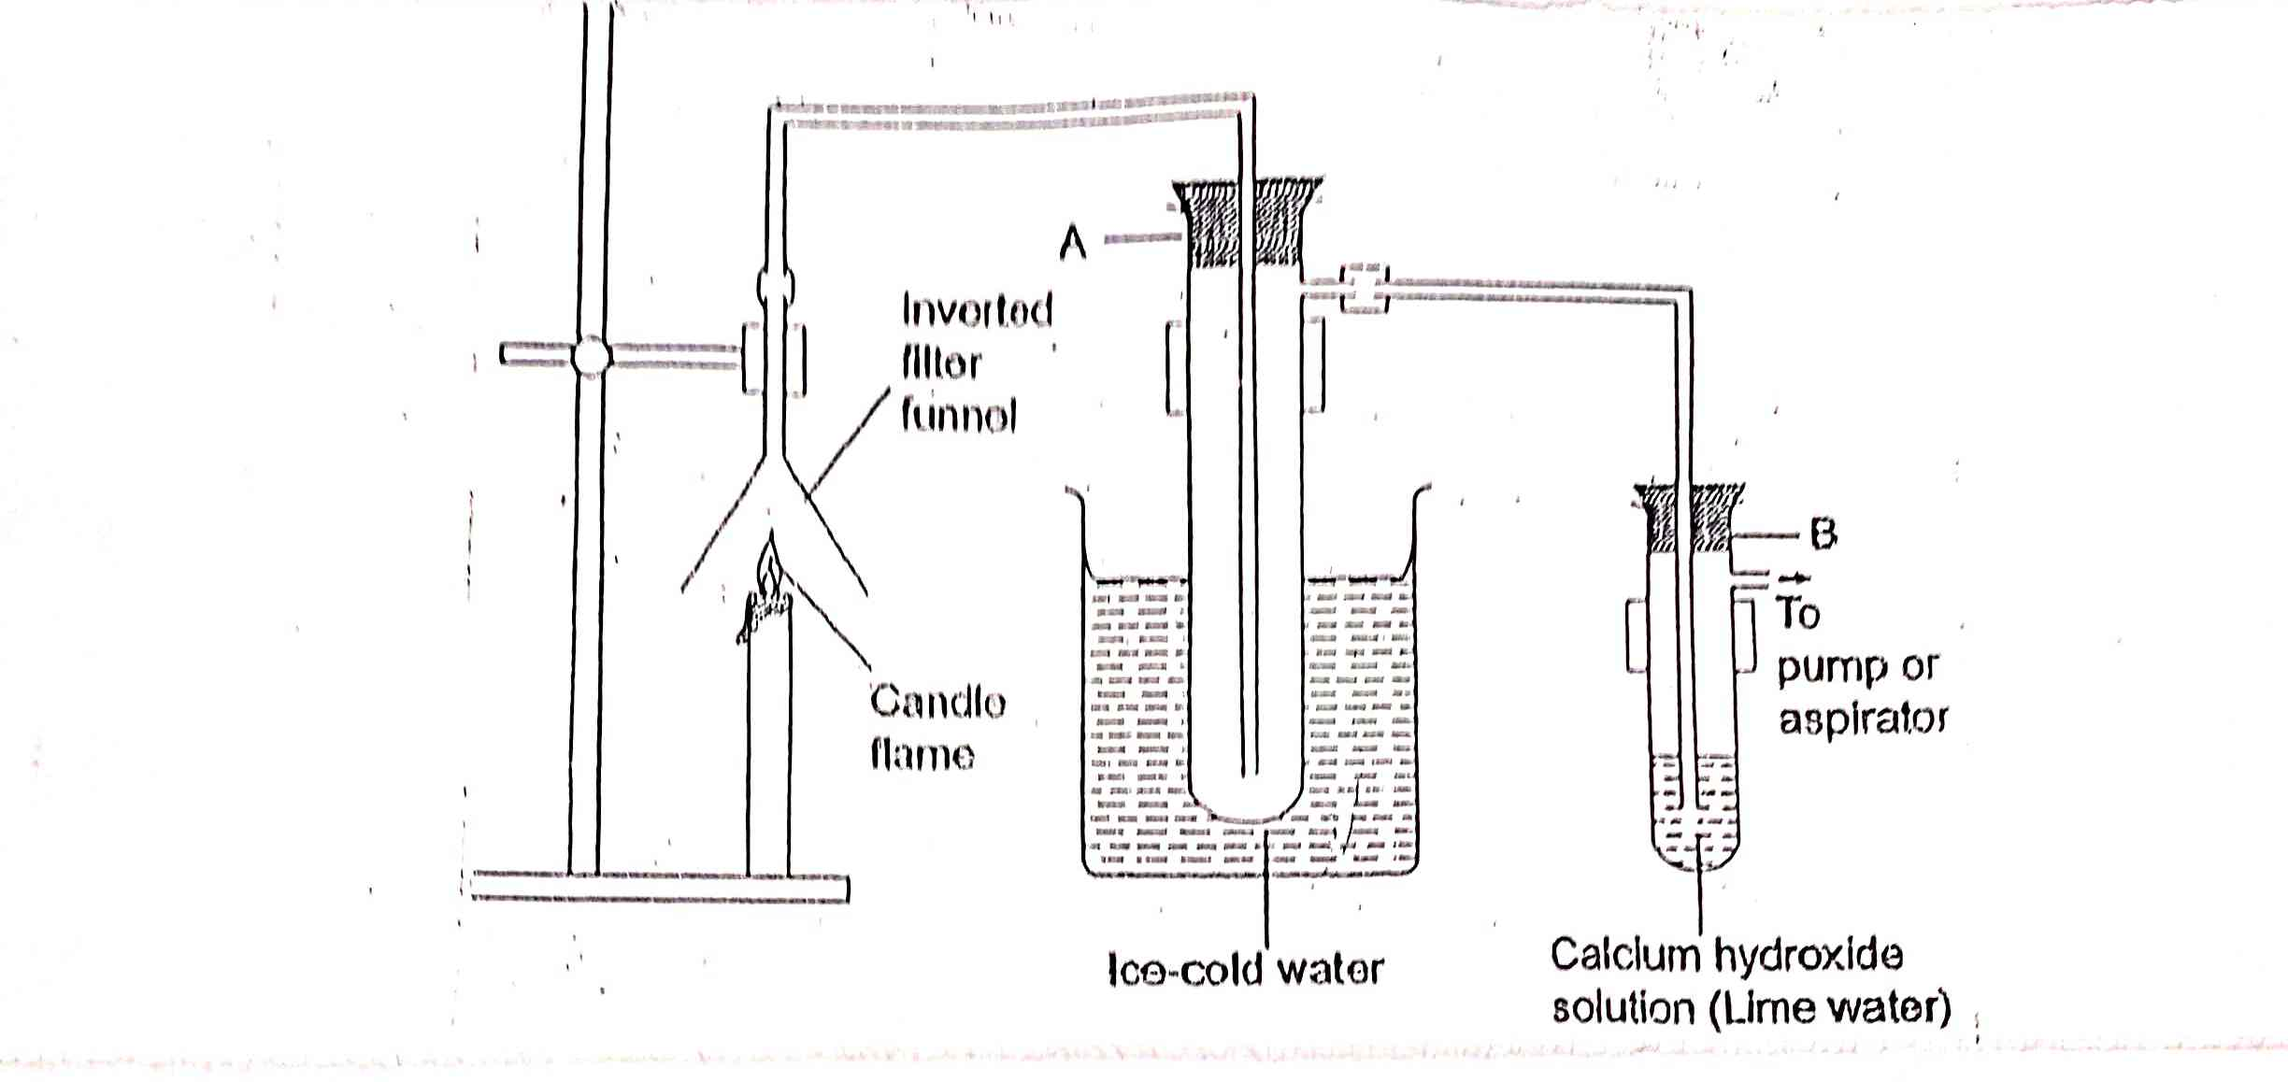

- Name the substance that was collected in test tube A. (1mk)

- Write an equation for the reaction which occurs in tube B: in
- In the first few minutes of the experiment. (1mk)

- After a long time. (1mk)

- Explain the equations in (b) above. (2mks)

- Give a suitable conclusion for the experiment in the set up. (1mk)

- Explain why a solution of sodium chloride conducts electricity while that of sugar does not. (2mks)

- Explain why commercial indicators are preferred to flower extracts as acid-base indicators. (2mks)

- (NH₄)₂HPO₄ is a fertilizer used by farmers to boost their crop production.
- Calculate the mass of phosphorous in a 20kg packet of (NH₄)₂HPO₄ (N=14, H=1, P=31, O=16) (2mks)

- State one advantage of this fertilizer, (NH₄)₂HPO₄ over urea CO(NH₂)₂ (1mk)

- Name the technique used to separate coloured substances in green leaves. (1mk)

