AGRICULTURE FORM 1
END OF TERM
TERM 1 2021
TIME: 1 HR 30 MINUTES
NAME ……………………………………………….. ADM …………….. CLASS………….

Instructions:
Answer all the questions in the spaces provided
- Name three forms of horticultural farming. (3mks)

- State any five methods of farming. (5mks)

- Outline five roles of agriculture in the Kenyan economy. (5mks)

- List five biotic factors that affect agricultural production. (5mks)

- List four aspects of rainfall that a farmer may consider when deciding on what crop to grow in an area. (4mks)

- Give four factors influencing soil formation. (4mks)

- Draw a well labeled diagram of soil profile. (7mks)

- The experiment set-up below illustrated capillarity action in different soils. Observe it closely and answer the questions that follow.

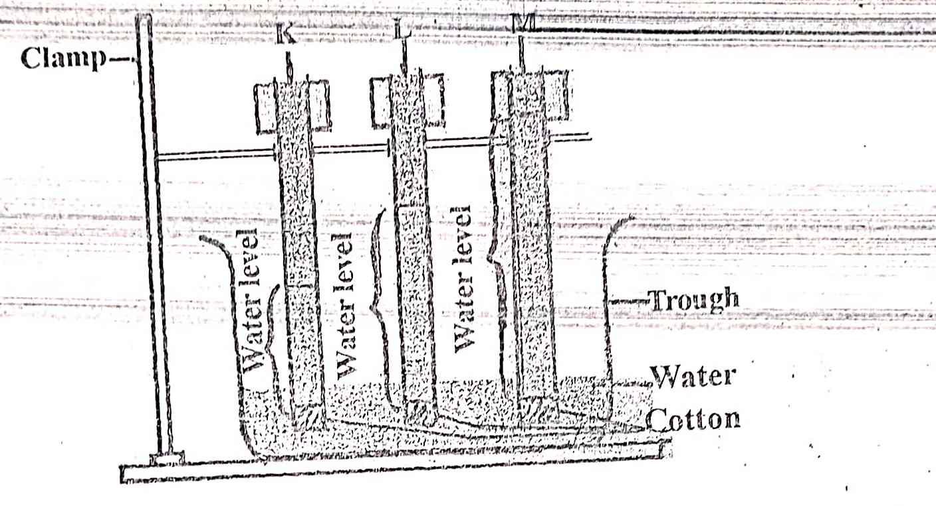

- Name the type of soil in capillary tube K, L, M. (3mks)
K
L
M
- Name the type of soil with the highest capillary action. (1mk)

- State the type of soil with the lowest capillary action. (1mk)
- List five constituents of the soil. (5mks)

- Give two ways of lowering soil pH. (2mks)

- State five categories of farm tools and equipment. (5mks)

- The diagrams below represent types of spanner.

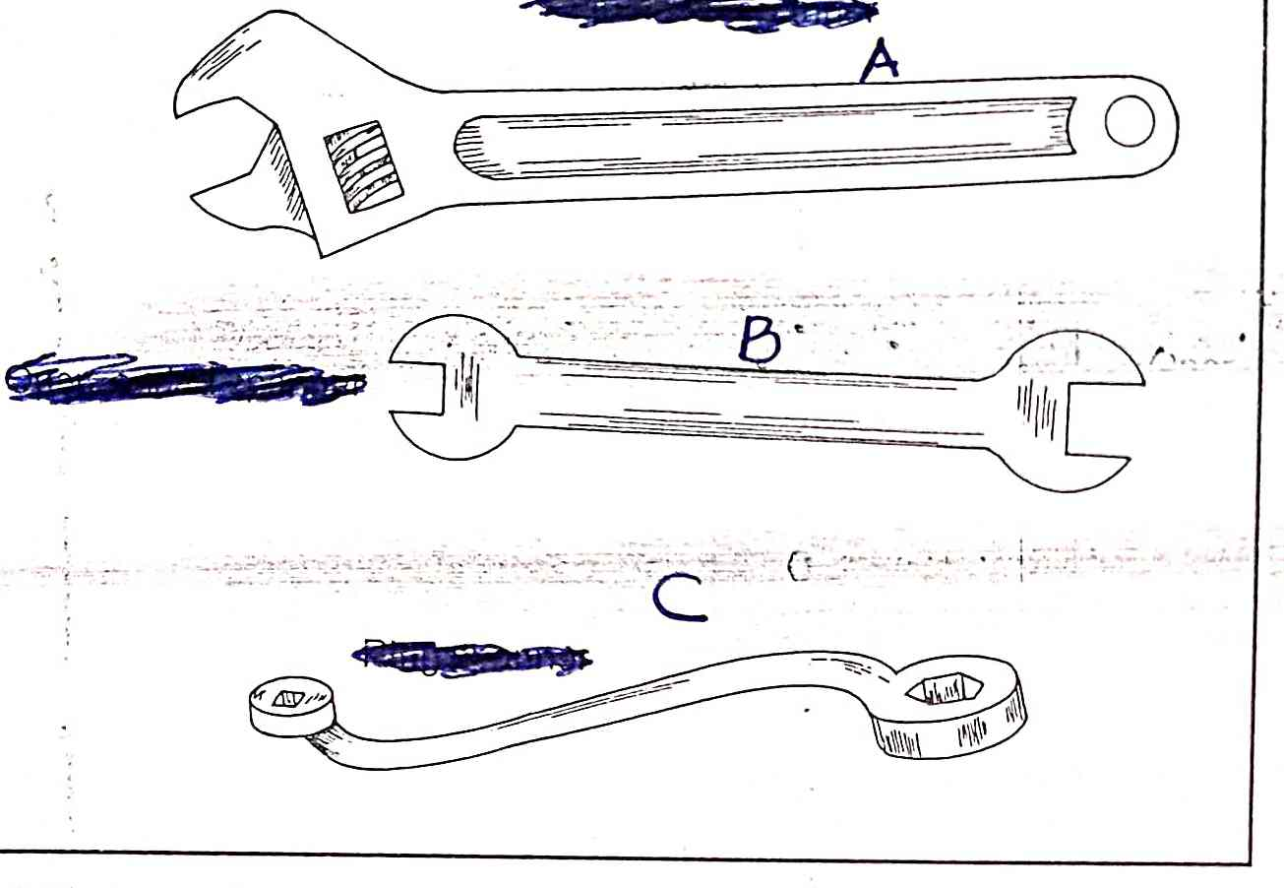

- Name tools (3mks)
A

B

C

- State one advantage of tool A over C. (1mk)

- State five reasons for maintaining farm tools and equipments. (5mks)

- Define land preparation. (1mk)

b) List five importance of land preparation. (5mks)

- Give four methods of clearing the land. (4mks)

- State one maintenance practices carried out on saws. (1mk)

