AGRICULTURE FORM 2
END OF TERM
TERM 1 2021
TIME: 1HR 30MINUTES
NAME ……………………………………………….. ADM …………….. CLASS………….

Instructions:
Answer all the questions in the spaces provided

- State four biotic factors that influence Agriculture. (4mks)

- The diagram below illustrates a method used to prepare compost manure. Study it carefully and use it to answer the questions that follow.

- Name the method used to prepare this type of compost. (1mk)

- Label the parts X and Z in the diagram. (2mks)

- By use of arrows show how each material in pits X would be moved to pit Y to pit Z. (2mks)

- Give three practices that may help in achieving minimum tillage. (3mks)

- List four characteristics which enables goats to live successfully in marginal areas.(4mks)

- Name two products obtained from a camel. (2mks)

- List three maintenance practices done on saws. (3mks)

- State four reasons why farmers should keep farm records. (4mks)

- Differentiate between macro and micro- nutrients. (2mks)

b. Give three examples of macro-nutrients used by plants. (3mks)

- Name three examples of phosphatic fertilizers used by farmers in crop production. (3mks)

- Give two method of fertilizer application. (2mks)

- A farmer was advised to apply 150kg of C.A.N/ha while top dressing the maize crop. C.A.N contains 21% N. calculate the amount of Nitrogen applied per ha. (3mks)
- The diagrams below represent soil sampling methods study them and use them to answer the questions that follow.

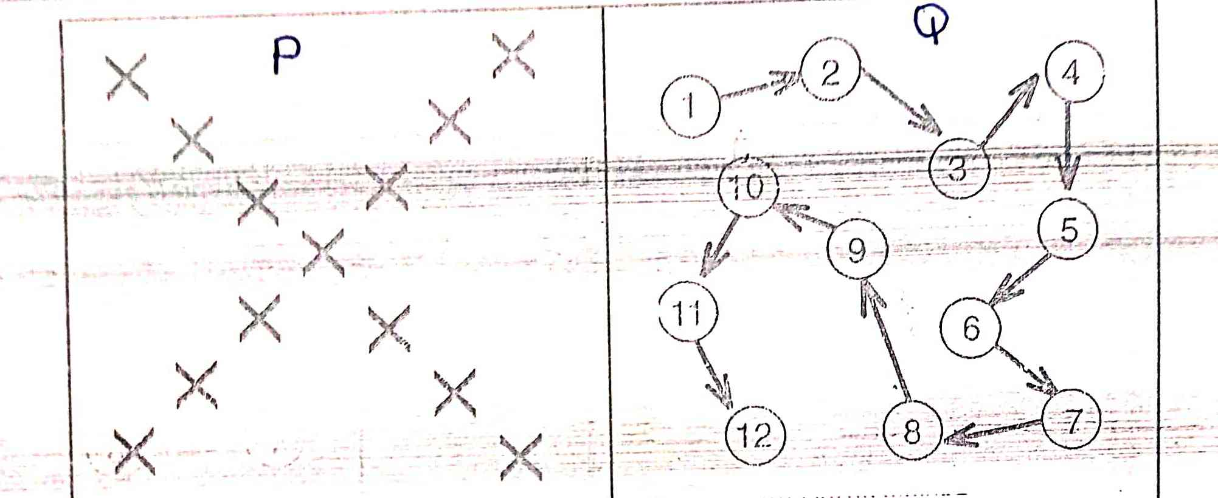

- Name sampling method P and Q. (2mks)

- Give three areas to avoid during sampling. (3mks)

- State three methods used to determine soil pH. (3mks)

- List four advantages of using seeds as planting materials. (4mks)

- Give parts used in the propagation of the following crops. (5mks)
- Sweet potatoes

- Bananas

- Sisal

- Tea

- Irish potatoes

- Below is a diagram of a nursery for raising tomato seedlings. Use it to answer the questions that follow.

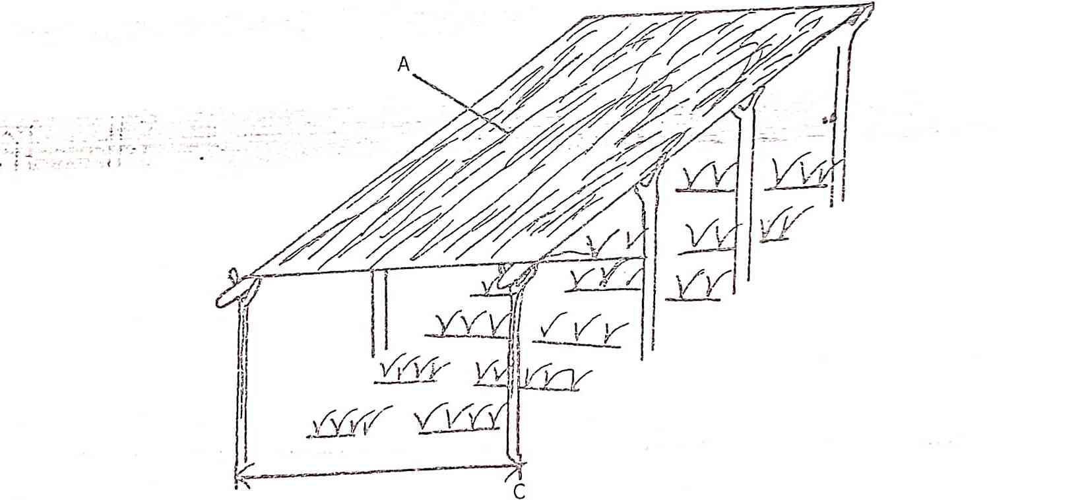

- Give two advantages of part labeled A on the diagram above. (2mks)

- State any three management practices that should be carried out on the nursery from the time seedlings emerge to the stage of transplanting. (3mks)

- Outline four importance of raising seedlings in a nursery bed. (4mks)

b) State four factors that should be considered when selecting a nursery site. (4mks)

c) Name two types of layering used in vegetative propagation. (2mks)

