END-TERM EXAM
TERM ONE FORM THREE
AGRICULTURE PAPER 1
TIME: 2 HOURS
NAME……………………………………………….. ADM……………….. CLASS……...

SECTION A: (30 MARKS)

Answer ALL questions in this section in the spaces provided.
1.Name two types of land tenure systems.(1mk)

2.State four problems associated with land fragmentation in Kenya.(2mks)

3.Give four advantages of individual owner operator tenure system as practiced in Kenya. (2mks)

4.Give four methods of breaking seed dormancy. (2mks)

5.State four disadvantages of organic mulch in crop production. (2mks)

6.Give four practices carried out in a tree nursery. (2mks)

7.State s four reasons for staking tomatoes. (2mks)

8.List four methods of treating water for use on the farm. (2 mks)

9.Give two examples for each of the following categories of water pipes.
- Metal pipes (1mk)

- Hose pipes (1mk)

10. What is organic farming? (1mk)

11. State four problems that may be brought about by hardpans in crop land. (2mks)

12.State four information contained in a land title deed. (2mks)

13. State four disadvantage of communal system of land tenure(2mks)

14. State four factors that determine the depth of planting. (2 mks)

15. List four aspects of rain.(2mks)

16.State four human factors influencing agriculture.(2mks)

SECTION B: (20 MARKS)

Answer all the questions in this section in the spaces provided.
17. The diagram below illustrates a soil profile. Study it carefully and answer the questions that follow
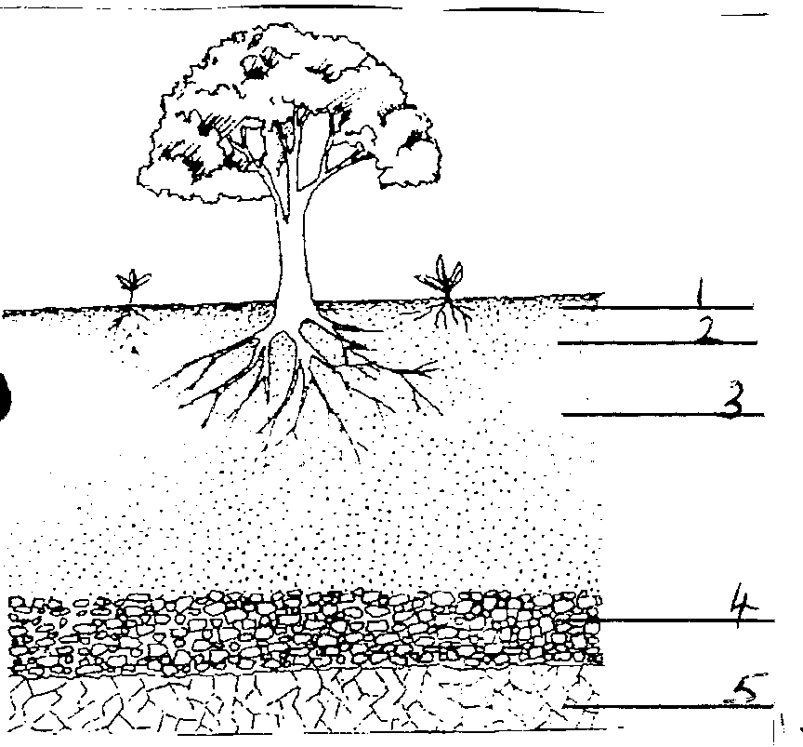

a) Name the layers represented by numbers 2,3,4, and 5.(4mks)
2……………………………………………………………………….
3………………………………………………………………………..
4………………………………………………………………………..
5…………………………………………………………………………
- State two characteristics of the layer. (2mks)

18.The diagram below illustrates a method of crop propagation.
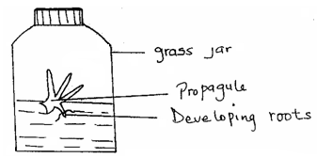

(a) Identify the method of propagation. (1 mark)

(b) Name a common crop propagated through the method. (1 mark)

(c) Name two advantages of this method. (2 marks)

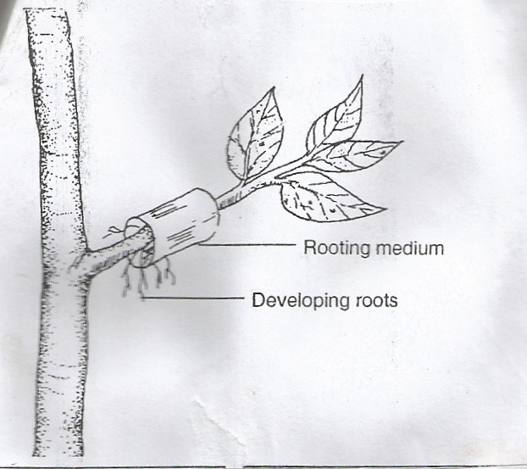
19.The diagrams below illustrate methods of crop propagation. Study them carefully and answer the questions that follow
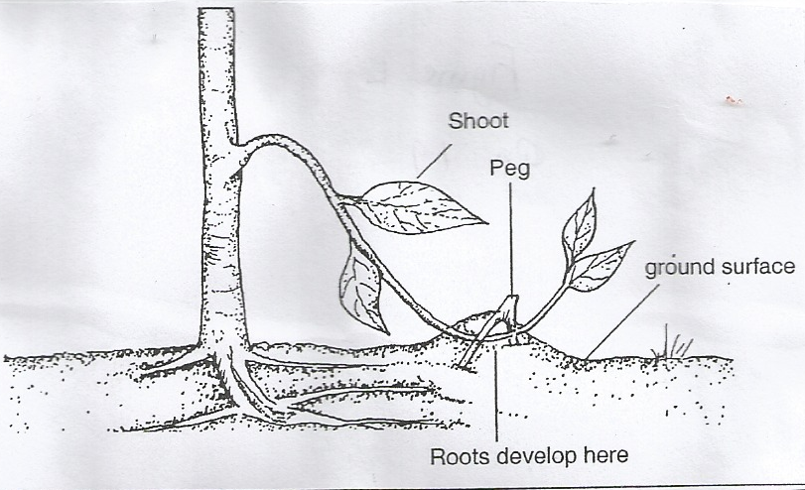

L K

- Name the types of layering shown above (1 mark)

b) State one method of budding (1mks)

20.The diagram below shows preparation of organic manure.
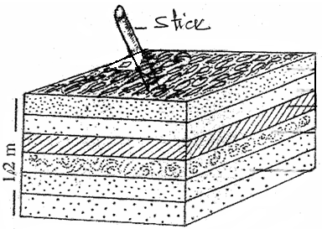
Top soil
Ash
Manure
Maize stalks
Green leaves refuse

(a) Which type of organic manure is being prepared above? (1 mark)

(b) Give the importance of inclusion of the following layers. (4 marks)

(i) Ash

- Topsoil

- Manure

- Stick

21. The diagram below shows a pest and the damaged crop. Study it and answer the questions that follow.

(a) Identify the crop pest illustrated above.( 1 mark)

(b) What damage does the pest cause to the crop?(1 mark)

(c) State two ways of controlling the pest. (1mark)

SECTION C
Answer any two questions in this section in the spaces provided
22a) State and explain five ways through which soil loses its fertility. (10 marks)
b) Describe five characteristics of Nitrogenous fertilizers. (5 marks)
c) Outline five methods used in application of inorganic fertilizers. (5 marks)
23a) Outline the factors affecting rooting of cuttings. (5 marks)
b) State and explain human factors that influence Agricultural production. (10 marks)
c) Highlight the management practices carried out in a nursery. (5 marks)
24 .) Explain the factors considered in choosing seed rates (8mks)
b) Describe the production of cabbages under the following sub headings
i) Nursery establishment and management (6 mks)
ii) Transplanting (6mks)

