END-TERM EXAM
TERM ONE FORM THREE
AGRICULTURE PAPER 2
TIME: 2 HOURS
NAME……………………………………………….. ADM……………….. CLASS……...

SECTION A: (30 MARKS)

Answer ALL questions in this section in the spaces provided.
- List four farm structures that would assist in control of livestock parasites. (2mks)

- State three desirable characteristics to be considered when a heifer for a milk production.(3mks)

- Distinguish between interbreeding and out crossing in livestock production.(2mks)

4. a) Mention four reasons why bees swarm.(2mks)

b) State two methods to stock bee hives. (2mks)

5. State four reasons for castrating male cattle.(2mks)

6. Give two reasons for steaming up in dairy cattle management. (1mk)

7. Give two reasons why honey harvesting should be discouraged at night.(1 mks)

8. a) Distinguish between inbreeding and line breeding. (1mk)

b) State any three importance of cross breeding. (1½mks)

9. State any four factors that may lower the quality of honey.(2 marks)

10. State four reasons for maintaining wheelbarrow in the farm. (2mks)

11. List one tool used in tightening barbed wire when constructing a fence. (½mk)

12. Name two types of bees.(2mks)
13. State four factors determining the quality of honey,(2mks)

14. Give two methods of castration.(2mks)

15. State four signs of parturition in a pig.(2mks)

SECTION B: (20 MARKS)

Answer all the questions in this section in the spaces provided.
16. Diagram X and Y illustrate livestock production. Study the illustration and answer the questions that follow.
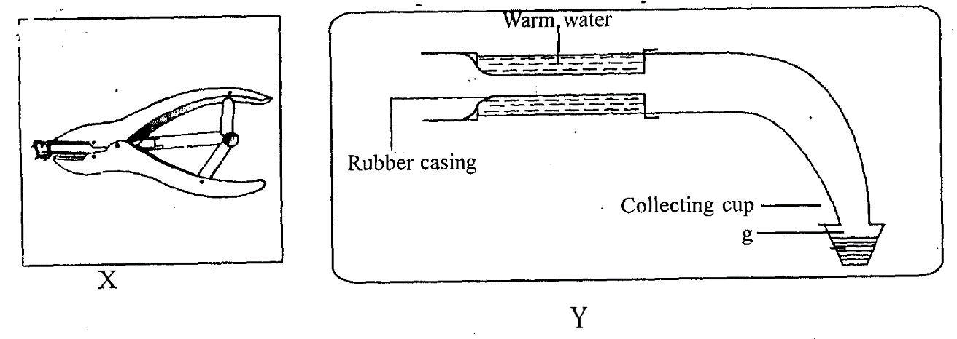
a). State one function of each tool .(2mks)
X
Y
b). What is the suitable name of the livestock production equipment Y?(1 mk)

c) State one advantage of using the substance g collected in Y above. (1mk)

17. Study the illustration of processing honey below and answer the question that follow.
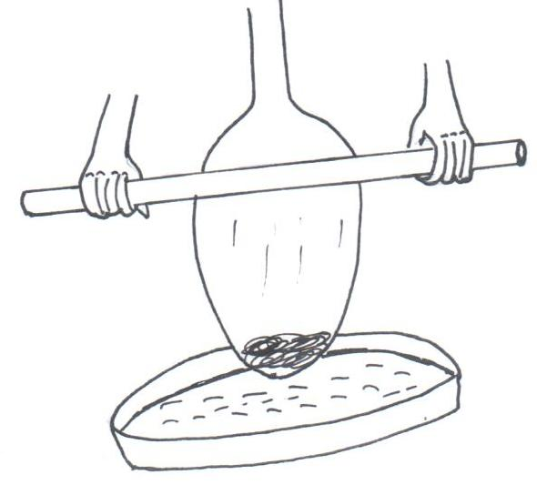

S Q

R

(a) Name the part labeled. (2 marks)

Q

R

(b) State the function of part labeled S. (1 mark)

(c) State four equipments used for harvesting honey (4 marks)

18. The diagram below represents a method of livestock nurture management practice. Study it carefully and answer the questions beneath/below.
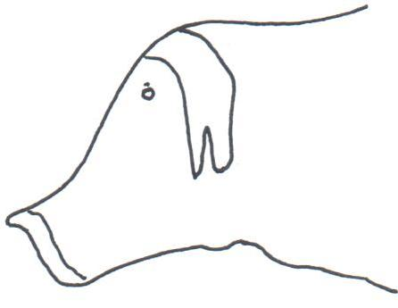

- Identify the management practice represented above.(1 mark)

(b) Name the farm tool used to carry out the management practice.(1 mark)

- State one major precautionary measure taken when carrying out the above management practice.(1 mark)

(d)Name four livestock animals which the management practice is carried out.(2 marks)

19.The diagrams M, N, P, and Q show some structure used in apiculture.
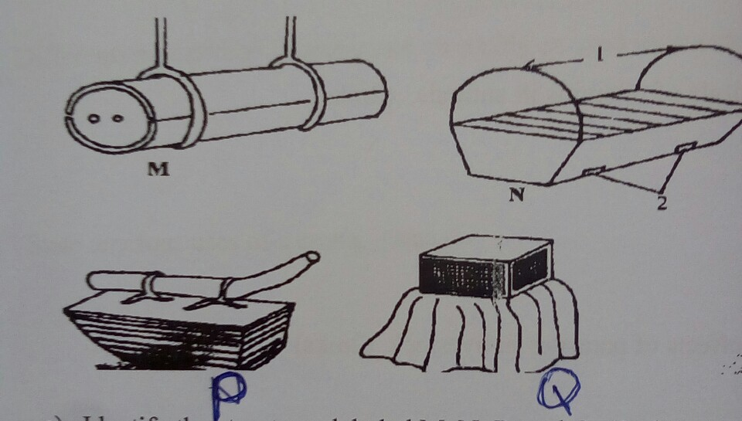

- Identify the structures labeled M, N, P, and Q. (2mks)
M –

N –

P –

Q –

- State the uses of P and Q. (2mks)
P –

Q –

SECTION C
Answer any two questions in this section in the spaces provided
20(a)Outline four factors to consider when siting a calf pen.(4 marks)
(b)Name and describe the features of an ideal calf pen.(6 marks)
(c)What factors should a farmer consider when selecting materials for
Constructing dairy cattle shed. (10 marks)

21.a)Describe the reasons why bees may abscond from a beehive. (10 marks)
b) Describe the factors considered in siting farm structures on the farm. (10 marks)
22.a)Describe the factors to consider when selecting livestock for breeding. (10 marks)
b) Describe ten signs of ill health in livestock. (10 marks)

