NAME:……………………………………………………………ADM:………………CLASS:………

AGRICULTURE PAPER I
FORM 4
END TERM 1, 2021

TIME: 2HRS

INSTRUCTIONS: the paper has 3 sections. Answer all questions in section A and B and any 2 questions in section C.

SECTION A: (30MKS)

- State four advantages of using farm yard manure. (2mks)

- State four merits of minimum tillage in crop production. (2mks)

- Mention four practices carried out to maintain grass pastures. (2mks)

- State four disadvantages of nomadic pastoralism. (2mks)

- Mention four cultural methods of used control in crop production. (2mks)

- State four ways of overcoming extremes of temperature in crop production. (2mks)

- List five precautions observed in harvesting tea to ensure high quality produce. (21/2mks)

- List three ways in which primary cultivation can be achieved. (11/2mks)

- An agriculture student was advised to apply complete fertilizer 40:30:10 in a (20x10) M plot and at
the rate of 40kg per hectare.
- Calculate the percentage of P₂O₅ in the complete fertilizer. (2mks)

- Calculate the amount of fertilizer the student would require for the plot. (2mks)

- State four divisions of livestock farming. (2mks)

- List four methods commonly used for applying nitrogenous fertilizers. (2mks)

- Name four factors influencing soil formation. (2mks)

- A farmer owns one hectare on which he can grow maize whose yield is 15 bags/hectare but has chosen to grow sorghum whose yield is 20 bags/hectare. If maize is sold at shs 1200 per bag while sorghum is sold at shs 700 per bag. Calculate the opportunity cost. (2mks)

- State four characteristics of plants used for preparation of green manure. (2mks)

SECTION B (20MKS)
- Students in an agriculture class set out to investigate the constituents of soil sample from school. They carried out a series of tests on various portions of the sample. They then prepared a table a shows below:

Description | Quantity
Mass of an empty evaporating disk  Fresh soil on evaporating disk  Mass of dried soil at 105oC on evaporating disk  Vol. of water in the tin  Vol. of water and soil after stirring  Mass of empty silica disk  Mass of silica disk and soil after ignition  Mass of silica disk and dried soil before ignition  Volume of water and soil before stirring | 10g  35g  28g  250cm³  410cm³  15g  45g  65g  500cm³

- Calculate the percentage of soil water in the sample. (1mk)

- Why was soil heated at 105ºC? (1mk)

- Calculate the percentage of soil air in the sample? (1mk)

- Calculate the percentage of soil organic matter in the sample. (1mk)

- Name one other soil constituent not tested above. (1mk)

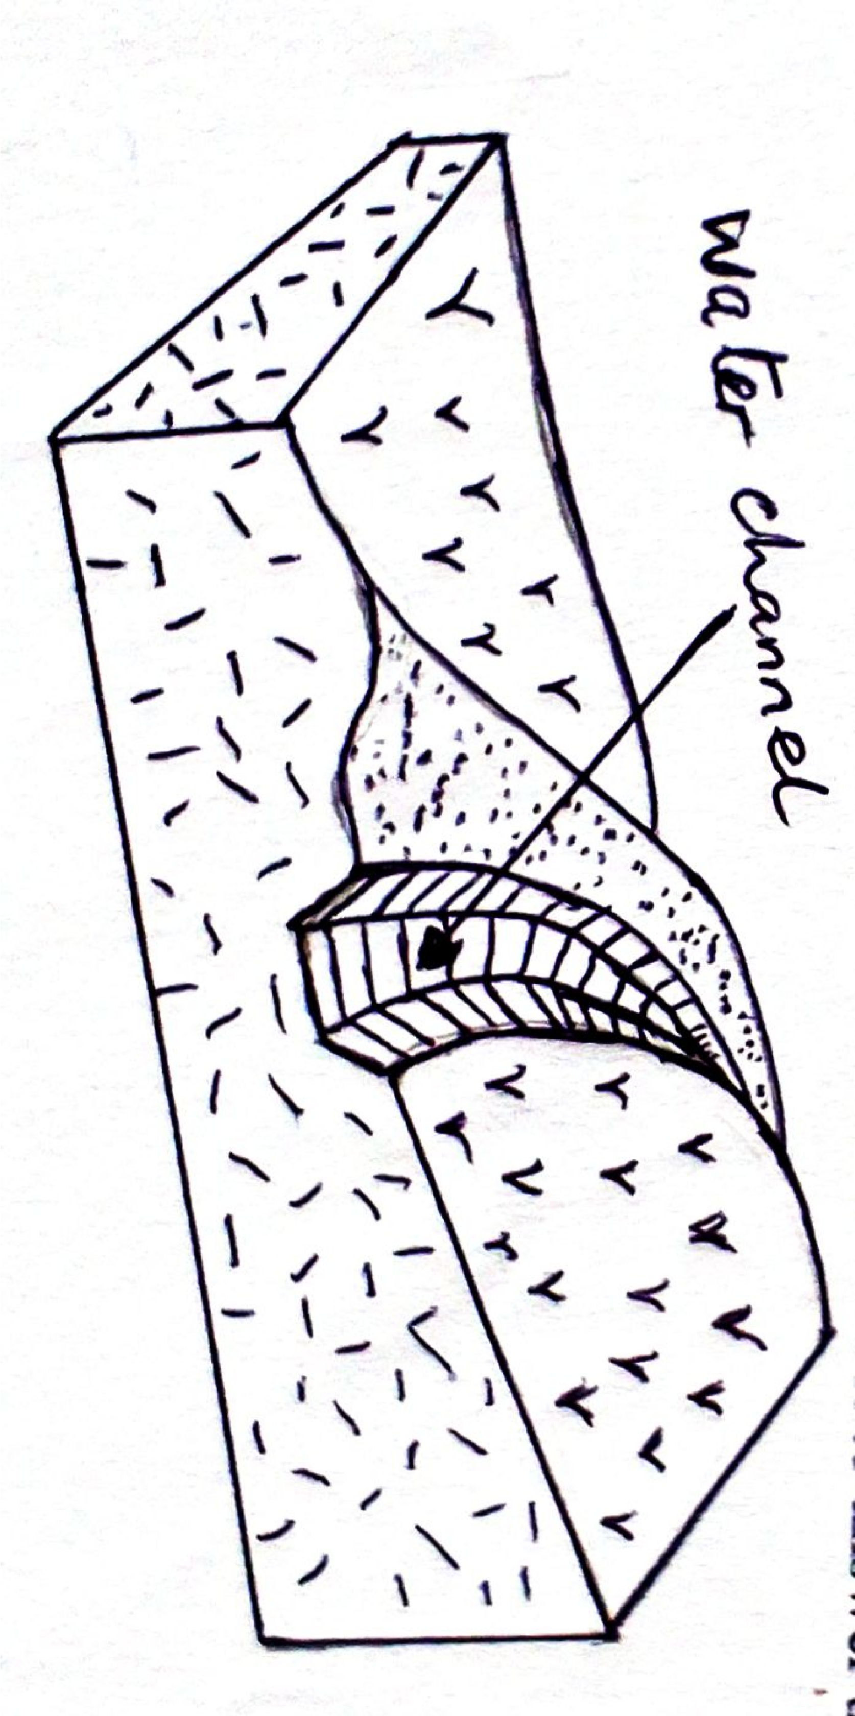
- The diagram below shows a construction on farm. Use it to answer the questions that follow.

- Identify the above structure. (1mk)

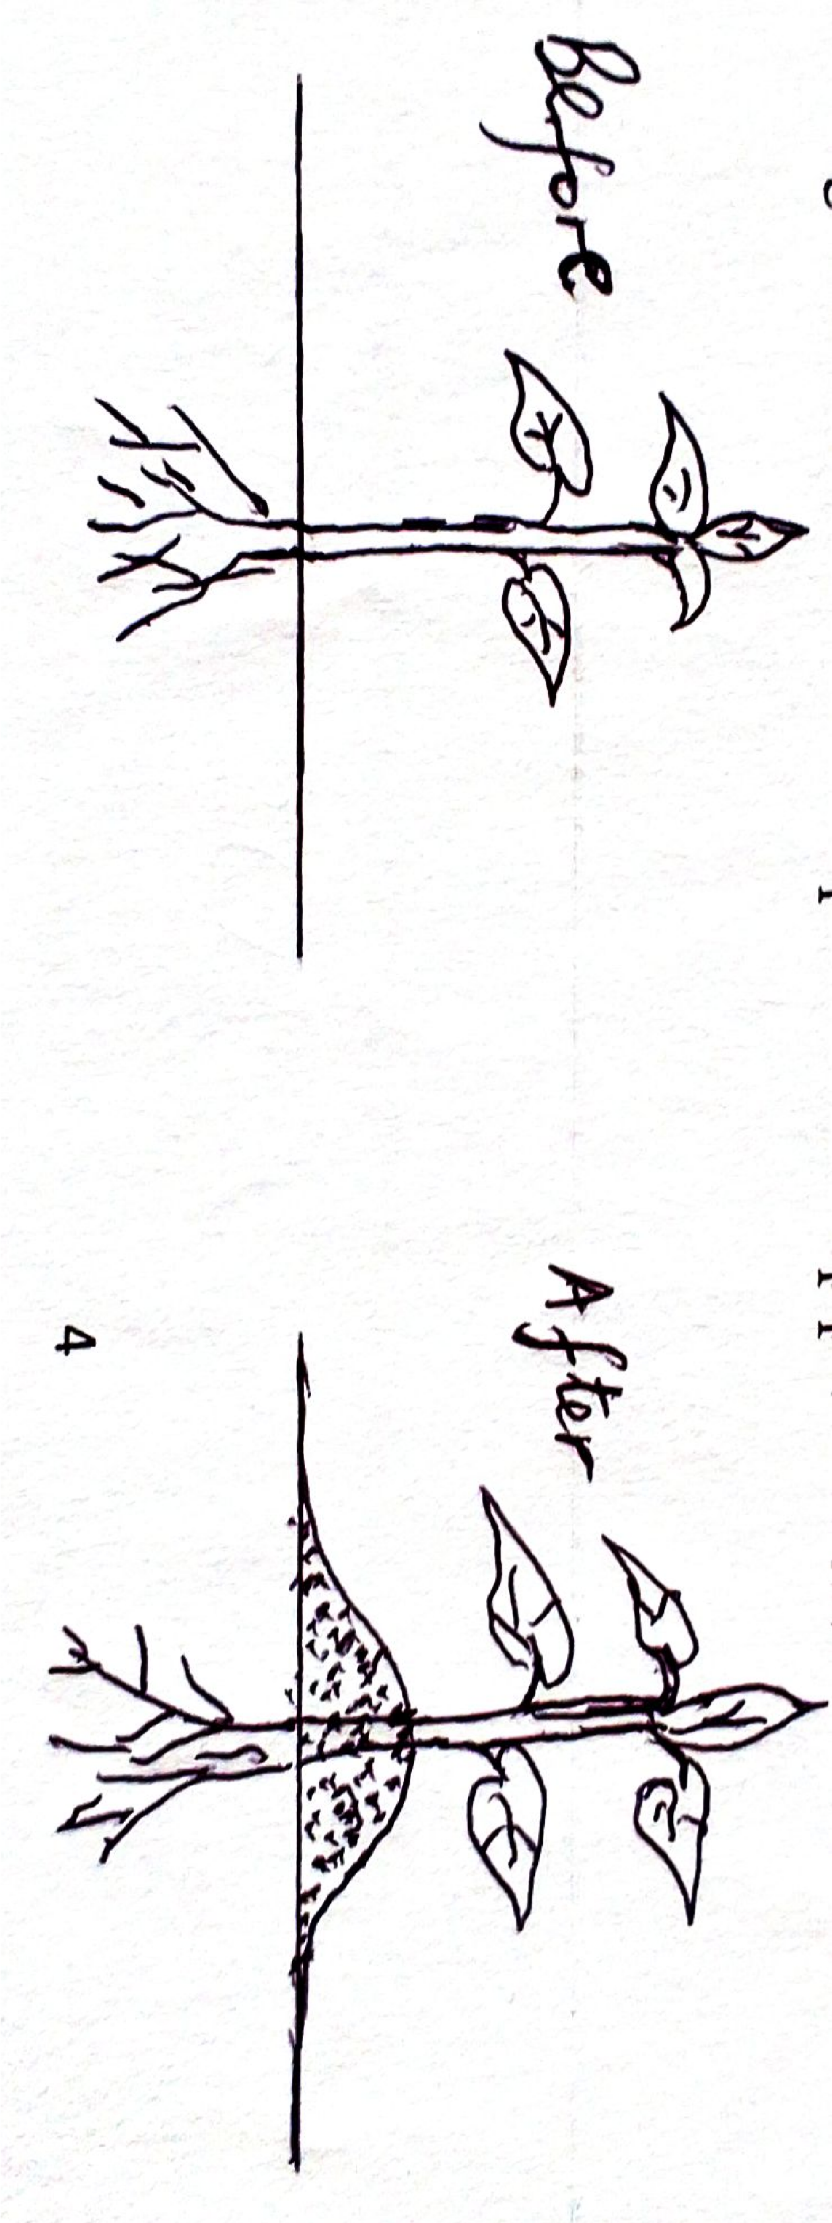

- State four areas where water in the channel is directed to: (4mks)

- The diagram below shows a field practice in crop production.

- Identify the practice. (1mk)

- State two advantages of the practice named in (a) above to Irish potatoes. (2mks)

- Name two other crops that require the above practice. (2mks)

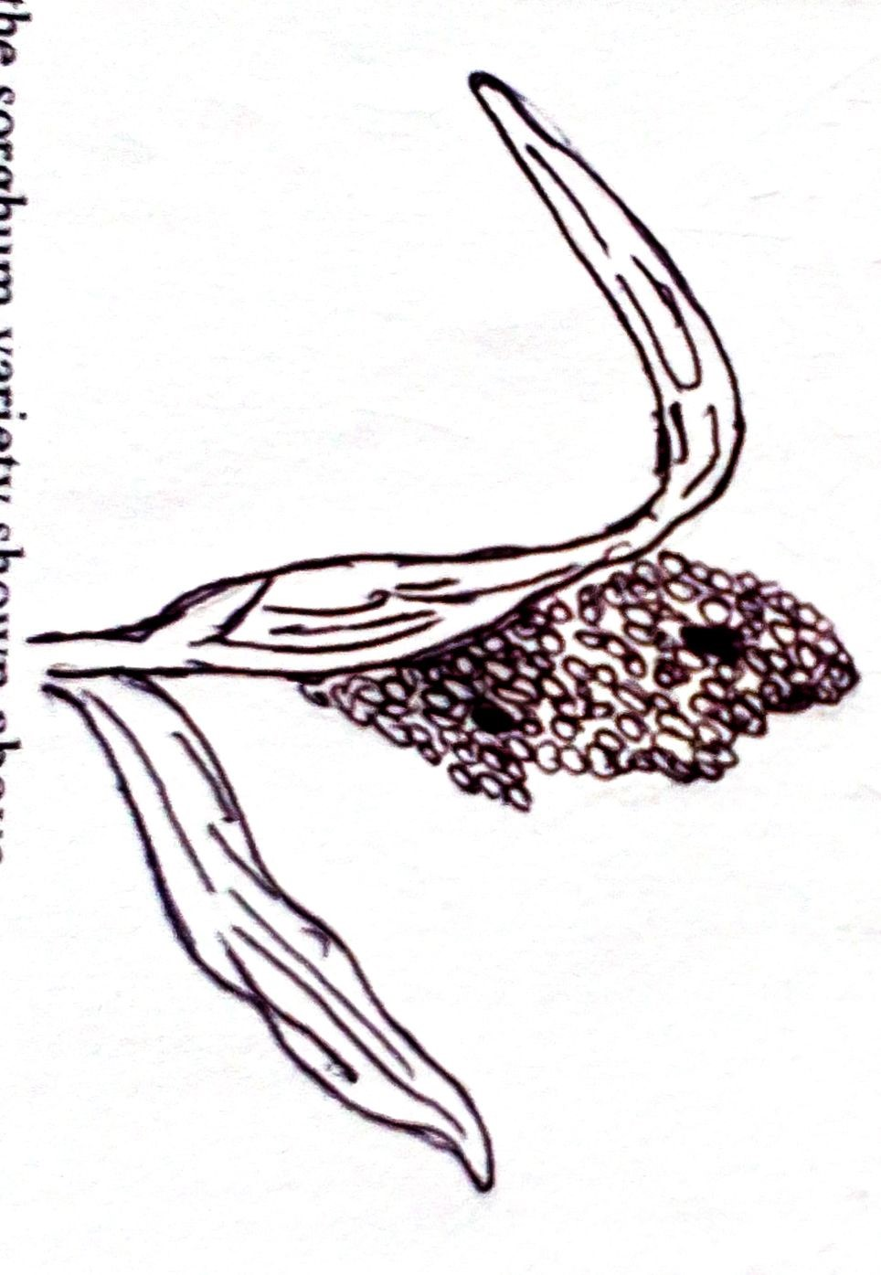
- Use the diagram below to answer the questions.

- Identify the sorghum variety shown above. (1mk)

- State two bird pests that commonly attack the crop. (2mks)

- Name two other varieties commonly grown by farmers. (2mks)

SECTION C (40MKS)
- (a) Outline the procedure for soil sampling. (8mks)
(b) Give five reasons for ridging sweet potatoes. (5mks)
© Outline seven properties of nitrogenous fertilizers. (7mks)

- (a) Discuss five benefits of weeds to the farmer. (10mks)
(b) Discuss five importance of draining a waterlogged area. (10mks)

- (a) Discuss five factors influencing crop rotation. (10mks)
(b) Discuss five government policies that regulate production, marketing and distribution of agricultural products. (10mks)

