BIOLOGY
FORM ONE
END-TERM 1 EXAM 2021
TIME:2HRS

NAME------------------------------------------------------------------------CLASS---------ADM-----------
- i)Give the meaning of biology. (1mrk).

ii) State and explain the two major branches of biology(.2mrks)

- Give three importance’s of studying biology? (3mrks)

- Name and explain the eight characteristics of living things. (8mrks)

- Motor vehicles move, use energy and produce carbon (iv) oxide and water. Similar characteristics occur in living organisms yet motor vehicles are not classified as living. EXPLAIN. (3mrks)

- Why is nutrition important in living organisms. (2mrks)

- Identify the following apparatus as used in biology and for each, give the function and an example of organism collected. (12mrks)

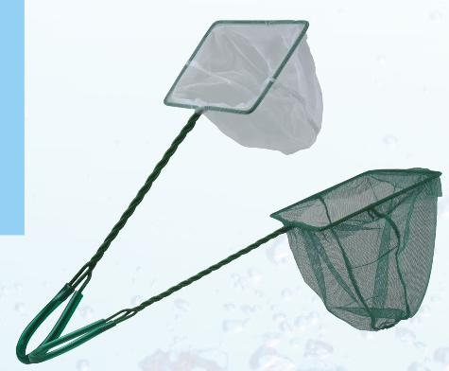

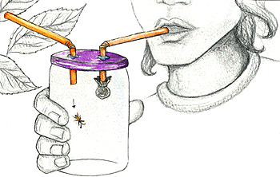
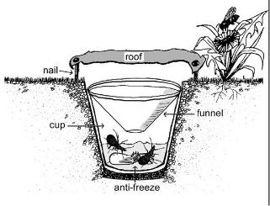
- Distinguish between the following terms.
        - Taxon and taxonomy (2mrks)

        - Genus and species(2mrks)

- Give 4 differences between plants and animals. (4mrks,)

- What do you understand by the term binomial nomenclature? (2mrks)

- A student observing a leg of an insect under a hand lens made a drawing of the leg whose length was 4cm with a magnification of X2. What was the actual length of the length.? (2mrks)

- A form one student, trying to estimate the size of onion cells observed the following on microscope’s field of view
    - 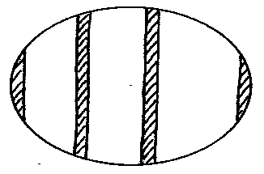
He counted 20 cells across the field of view. Calculate the size of one cell in micrometers. ( 2mks)

b) State the function of the following parts in a microscope. (5mks)
- Mirror.
- Condenser
- Body tube

- Revolving nose-piece

- Fine adjustment knob.

- Name the organelle shown in the diagram above and give its functions (2mk

- State functions of the following cell structures.
- Vacuoles, 1mk
- Nucleolus, 1mk
- In which two ways are the organelles chloroplast and mitochondria similar. 2mks

- What is meant by resolving power of a microscope. 2mks

- Give the function for the following process when preparing temporary slides. 3mks
  - Sectioning
  - fixation.
- Addition of iodine solution, to an onion epidermis on a slide while being observed on a light microscope.
- Give the meaning of the following terms, giving an example in each case. (6mrks)
  - A tissue

  - An organ

  - An organ system.

