BIOLOGY
FORM TWO
END-TERM 1 EXAM 2021
TIME:2HRS

NAME--------------------------------------------------------CLASS-------ADM-------

- Explain the following terms:
- Taxonomy (1mk)

- Species (1mk)

- State the function of the following organelles
Lysosomes(1mk)

Golgi apparatus (1mk)

- Name the form in which carbohydrates are stored in
Plant tissues
Animal tissues
(2mks)
- Name three photosynthetic cells in plants (2mks)

- State three structural differences between arteries and veins(3mrk)

- Give two reasons why clotting of blood is important (2mks)

- Name one enzyme and one metal ion that are required in the blood clotting process 2mks)

- The following diagram of a leaf shows what happens in a pant leaf during photosynthesis: -

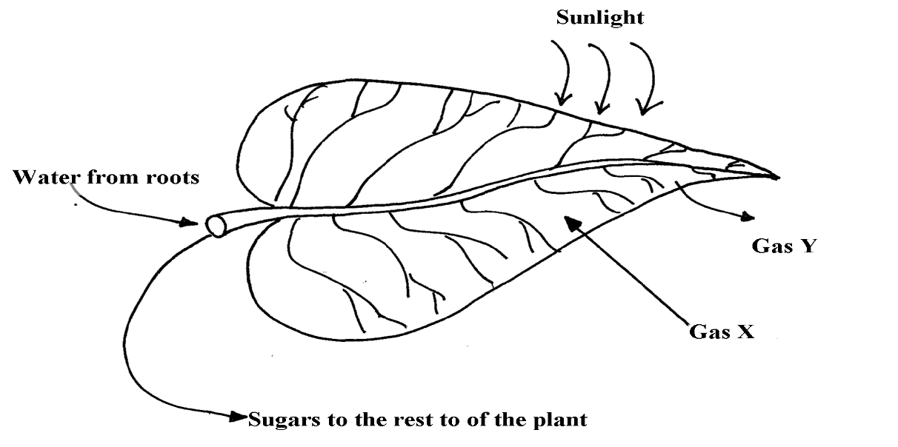

- Give two ways in which leaves are adapted to absorb light(2mrks)

- Name the gases labelled X and Y(2mrks)

- Name the tissue that transports water into the leaf and sugars out of the leaf (2mrks)

- Explain why it’s an advantage for the plant to store carbohydrates as starch rather than as sugars(2mrks)

- The diagram below represents a cell organelle

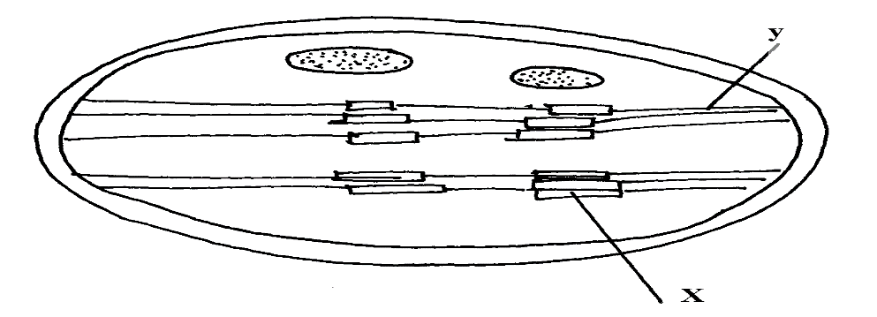

- Name the part labelled Y (1mrk)

- State the function of the part labelled X (1mrk)

- State the role of emulsification in the digestion of fats in the alimentary canal (1mrk)

- What is the function of hydrochloric acid in the alimentary canal? (2MRKS)

- What is meant by the term gaseous exchange (1mrks.

- Name and explain the characteristics of gaseous exchange surfaces. (4mrks)

- State three ways in which leaves of plants are adapted to gaseous exchange(3mrks)

- Explain stomatal distribution in plants of different habitats (6 mks)

- The diagram below represents a transverse section of a young stem.

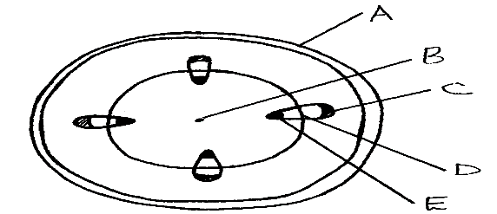

- Name the parts labelled A, B and D (3mrks)

- State the functions of the parts labelled C and E (2mrks)

- List three differences between the section above and the one that would be obtained from roots of the same plant. (3mrks)

- Distinguish between guttation and transpiration (2mrks)

- Other than transport, state one other function of xylem tissue in plants (1mrk)

- Identify the part of the heart that initiates the heart beat (1mrk)

- Give a reason why the left ventricle muscles are thicker than the right ventricles muscles (2mrks)

- State the forms in which carbon (IV) oxide is transported in the blood

- Explain how the following adaptation reduce transpiration in xerophytes
(a) Sunken stomata (2mrks)

(b) Thick waxy cuticle (1mrk)

  - Name the:
- (a) Material that strengthens xylem tissue (1mrk);

(b) Tissue that is removed when the bark of a dicotyledonous plant is ringed (1mrk)

- Why is it dangerous to sleep in an enclosed room with a burning jiko(3mrks)?

- Why do plants not take in oxygen during the day although they need it for respiration (2mrks)

- Draw and label the structure of a gill. (5mrks)

