GEOGRAPHY
FORM 1 END TERM 1 2021
TIME; 1HR 45 MINS
NAME…………………………..………………..………..CLASS…...…...ADM….....…
INSTRUCTIONS;
Attempt all the questions.

1. Define the term environment. (2mks)
……………………………………………………………………………………………………………………………………………………………………………………………………………………………………………………………………………………………………………………………………………...
2. State three sub-branches of physical Geography. (3mks)
………………………………………………………………………………………………………………………………………………………………………………………………………………………………………………………………………………………………………………………………………………
3. Give four reasons why it is important to study Geography. (4mks)
………………………………………………………………………………………………………………………………………………………………………………………………………………………………………………………………………………………………………………………………………………………………………………………………………………………………………………………………………………………………………………………………………………………………………………
4. Identify three components of the solar system. (3mks)
………………………………………………………………………………………………………………………………………………………………………………………………………………………………………………………………………………………………………………………………………………
5. Describe the passing star theory. (4 marks)
………………………………………………………………………………………………………………………………………………………………………………………………………………………………………………………………………………………………………………………………………………………………………………………………………………………………………………………………………………………………………………………………………………………………………………………………………………………………………………………………………………………………………………………………………………………………………………………………………………
6. State four effects of rotation of the earth. (4mks)
………………………………………………………………………………………………………………………………………………………………………………………………………………………………………………………………………………………………………………………………………………………………………………………………………………………………………………………………
7. The local time in New York(20⁰W) IS 8.00 a.m. what is the local time at Kitale (10⁰E). (3mks)

8. Define the following terms;
(i) Equinox (2mks)
………………………………………………………………………………………………………………………………………………………………………………………………………………………………
(ii) Solstice (2mks)
………………………………………………………………………………………………………………………………………………………………………………………………………………………………
9. The following diagram represents a solar eclipse. Name the parts A, B and C. (3mks)

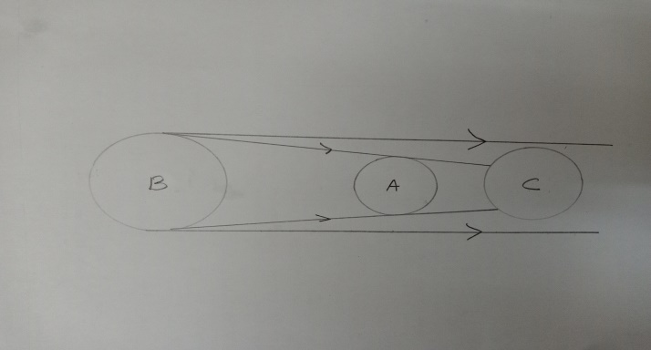
A_________________________
B_________________________
C_________________________
10. Define the term weather. (2mks)
………………………………………………………………………………………………………………………………………………………………………………………………………………………………
11. Name the instrument used to measure the following elements of weather: (4mks)
Rainfall______________________________________
Wind direction___________________________________
Humidity_____________________________________
Sunshine______________________________________
12. Anestar school wants to establish a weather station. Which four conditions should they consider while siting the station? (4mks)
………………………………………………………………………………………………………………………………………………………………………………………………………………………………………………………………………………………………………………………………………………………………………………………………………………………………………………………………………………………………………………………………………………………………………………
13. State three ways the atmosphere is heated. (3mks)
………………………………………………………………………………………………………………………………………………………………………………………………………………………………………………………………………………………………………………………………………………
14. (a) Highlight four qualities of a good Stevenson screen. (4mks)
………………………………………………………………………………………………………………………………………………………………………………………………………………………………………………………………………………………………………………………………………………………………………………………………………………………………………………………………………………………………………………………………………………………………………………
15. Explain three reasons why the interior of the earth is very hot. (6mks)
………………………………………………………………………………………………………………………………………………………………………………………………………………………………………………………………………………………………………………………………………………………………………………………………………………………………………………………………………………………………………………………………………………………………………………………………………………………………………………………………………………………………
16. Describe four characteristics of the mantle. (4mks)
………………………………………………………………………………………………………………………………………………………………………………………………………………………………………………………………………………………………………………………………………………………………………………………………………………………………………………………………
17. Name the four layers of the atmosphere. (4mks)
………………………………………………………………………………………………………………………………………………………………………………………………………………………………………………………………………………………………………………………………………………………………………………………………………………………………………………………………
18. State four factors that influence temperature of a place. (4mks)
………………………………………………………………………………………………………………………………………………………………………………………………………………………………………………………………………………………………………………………………………………………………………………………………………………………………………………………………
19. What is weather forecasting? (2mks)
………………………………………………………………………………………………………………………………………………………………………………………………………………………………
20. (a) Name any two methods of weather forecasting (2mks)
………………………………………………………………………………………………………………………………………………………………………………………………………………………………
(b) Identify three importance of weather forecasting. (3mks)
………………………………………………………………………………………………………………………………………………………………………………………………………………………………………………………………………………………………………………………………………………………………………………………………………………………………………………………………
21. Identify two types of rainfall. (2mks)
………………………………………………………………………………………………………………………………………………………………………………………………………………………………………………………………………………………………………………………………………………

