COMPUTER STUDIES
FORM 2
END TERM -TERM ONE
NAME________________________________ CL_________ ADM___________

Section A-Answer all questions in this section ( 40mks)
1.(a) What is a Word processor? (1 mark)

(b) State 4 purposes of word processing. (2 marks)

(c)State four editing and 4 formatting features of any good word processor. (8mks)

2. (a) Distinguish between Copying and Moving text. (2 marks)

3. A computer user may interact with a computer either through Graphical User Interface (GUI)
or through typed commands.
- State two features of a graphical user interface. (2 marks)

- Give two advantages of using GUI based operating system over a Command line
interface. (2mark)

(c) Some computer systems still use Command line interfaces. State two advantages of
command line interface. (2 marks)

4. Define an operating system (2mks)

5. State two advantages of electronic spreadsheets over manual worksheets. (2mks)

6a) Match the computer generation with the technology used to make the
(4mks)
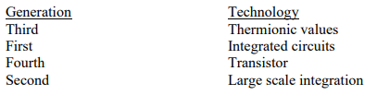
c) i) List three types of secondary storage media (3mks)

ii) State one advantage and one disadvantage of a laser printer (2mks

7.State two methods of minimizing dust in a computer laboratory. (2mks)

8.Differentiate between primary memory and secondary memory (2mks

9.State what is meant by each of the following and give an example of where each
is used
a) Magnetic Ink character Recognition (MICR) (2 mks)
b) Optical Mark Read (OMR) (2mks

Section B-30(Mks)answer all questions in this section

10. a) What are computer viruses? (2mks)

b) i) State two ways through which computer viruses may be controlled
(2mks)

ii) Explain how each of the two ways stated in b (i) above assist in
controlling computer viruses. (2mks)

11. a) The diagram below represents the essential features o a computer system .
Study the diagram and answer the questions that follow:
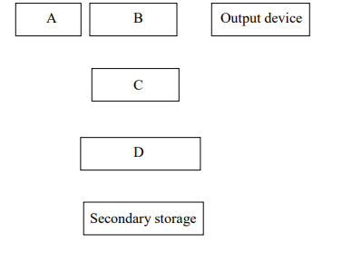
i) Name the components (4mks)
A
B
C
D
ii) On the diagram above, indicate the direction of data flow using
arrows. (3mks)
b) Name the three types of buses in a computer system
(3mks)

c) Explain how CPU registers may be used to carry out a basic calculation
such as
2 + 7 = 9 ( 4mks)

d) Name two computers output devices. (2Mark)

12. 18. a) i) What is a computer keyboard? (2mk)

ii) List four types of keys found on a computer keyboard. Give an
example of each(4mks)

(iii)Distinguish between a line printer and a page printer (2mks)

