GEOGRAPHY FORM 2
END OF TERM
TERM 1 2021
TIME: 45 MINUTES
NAME ……………………………………………….. ADM …………….. CLASS………….
Instructions:
Answer all the questions in the spaces provided

- Give two layers of discontinuity found in the internal layers of the earth. (2mks)

b. State three characteristics of the mantle. (3mks)

- Name two forms of precipitation. (2mks)

b. Study the diagram below and answer the questions that follow.

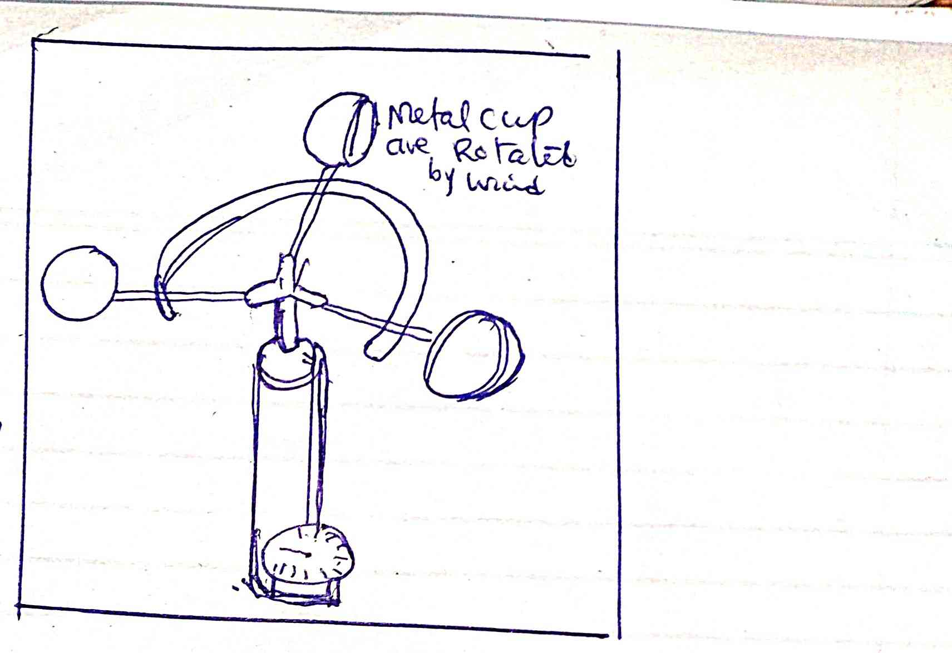
i. Identify the diagram above. (1mk)

ii. Describe how the instrument is used in the weather station. (4mks)

- Define the term mineral. (2mks)

b. Explain three forms of metamorphism. (6mks)

- Name three causes of earth movement. (3mks)

b. Give three features formed as a result of horizontal earth movements. (3mks)

- Study the diagram below and answer the questions that follow.

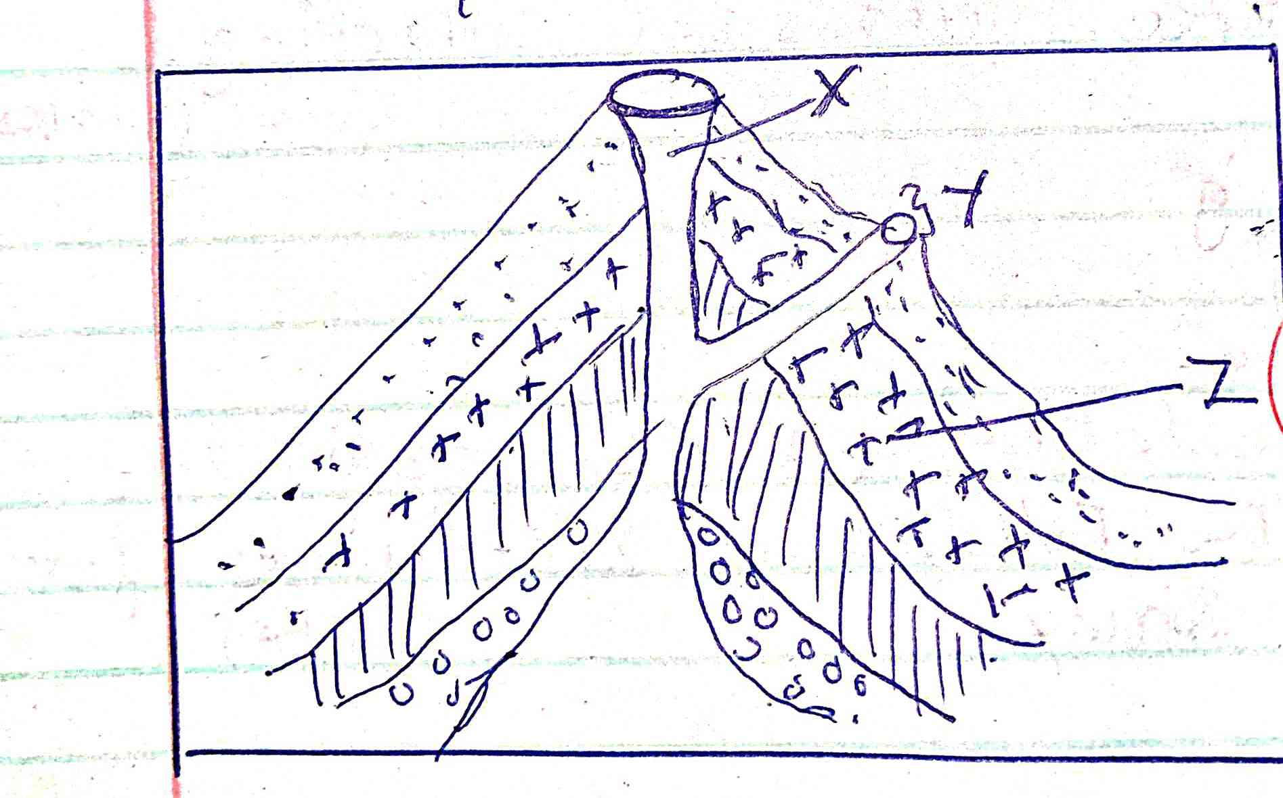

i. Identify the features represented by the above diagrams. (1mk)

ii. Name parts marked X, Y, Z. (3mks)

iii. Describe how the feature named above is formed. (3mks)

b. You are to carry out field study on volcanicity on Mt. Longonot in Kenya.
i. Give three methods of collecting data. (3mks)

ii. State the follow-up activities for the field. (3mks)

- Explain constructive consequences of vulcanicity to human activities. (6mks)

b. Give three human activities that causes earthquakes. (3mks)

c. State two modern methods of showing direction on maps. (2mks)

ii. State four ways of locating places on a map. (4mks)

iii. Name three methods of representing relief on topographical maps. (3mks)

- What is a photograph? (2mks)

b. Explain three parts of a photograph. (6mks)

- The table below shows temperature distribution of Nakuru town in the year 2020.
Month | J | F | M | A | M | J | J | A | S | O | N | D
Temp ^{O}C | 26 | 25 | 24 | 23 | 20 | 22 | 24 | 25 | 25 | 23 | 25 | 26
- Calculate the annual range of temperature from above data. (2mks)

- Using scale 1cm rep 5^{O}C. Draw a simple line graph to present the information in the table above. (5mks)

