END OF TERM 1 EXAMS 2021
FORM 2
PHYSICS
TIME: 2HRS
NAME:_____________________________ ADM NO:______________ CLASS:________

SECTION A;30MKS
- Explain why repulsion between magnets is the surest way of confirming the polarity of a magnet. (2mks).

2. In an experiment, a student obtained the thickness of an object as 6.40mm.
(i). state the accuracy of the instrument used.(1mk)

(ii). Write the measurement in SI Units (1mk).

(iii). If the measuring instrument had a zero error of +0.02mm, determine the actual thickness of the object. (2mks).

3.A bus that carries goods in the under seats carrier is more stable than one that carries goods in the carrier at the top. Explain this observation. (2mks).

4)The figure below shows a uniform wooden plank which weighs 10N. The plank is balanced at 0.8m from one end by a mass of 2.5kg.
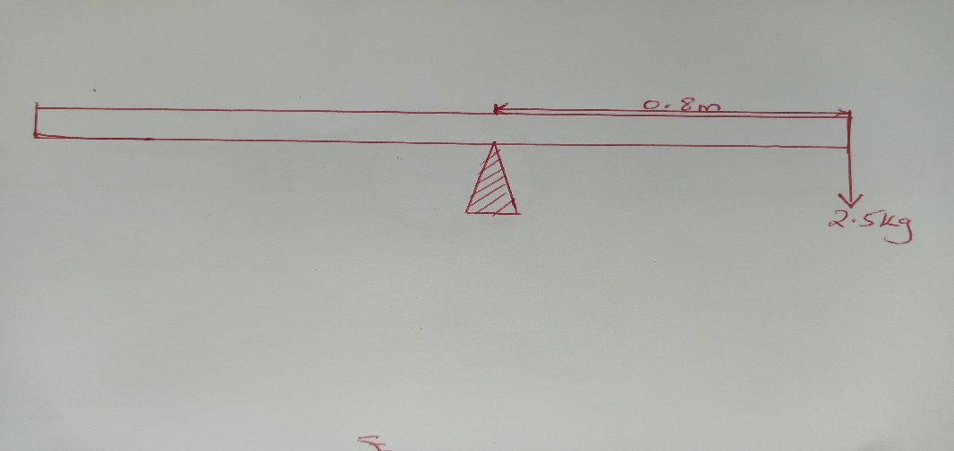

Determine the length of the wooden plank in metres. (4mks).

5(i). Complete the diagram below to show the position of the image. (3mks).

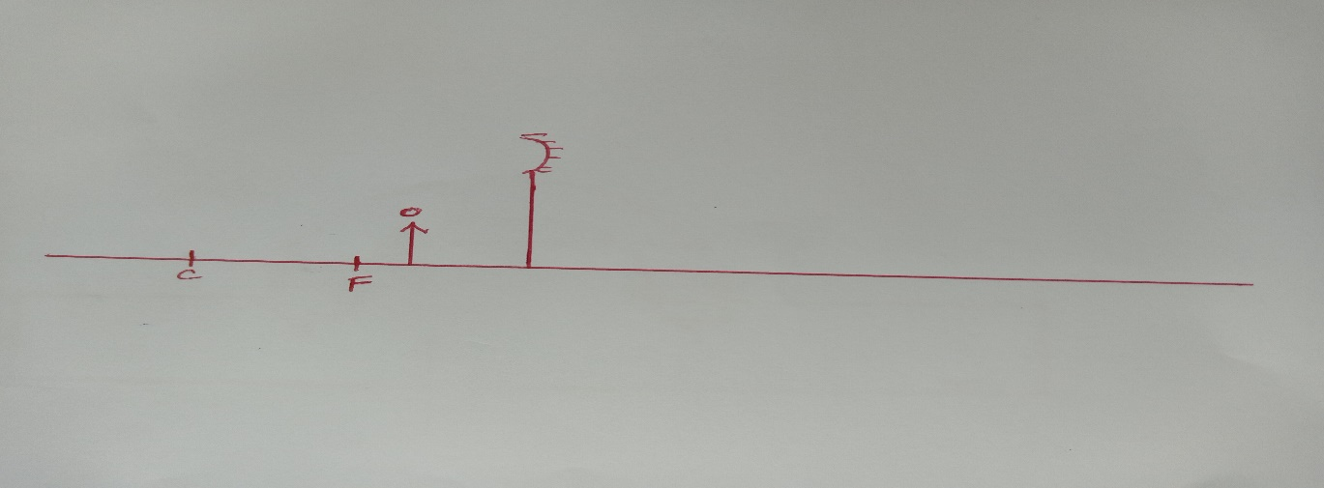

(ii). Give TWO applications of the set-up shown above. (2mks).

6.Give a reason why heat transfer by Radiation is faster than heat transfer by Conduction. (2mks).

7.State THREE factors on which the rate of heat flow depends on. (3mks).

8.Liquids expand when heated and contract when cooled. However this is not always true for water.
(i). what name is given to the behavior of water? (1mk).

(ii). State TWO importance of this behavior of water. (2mks).

(iii). State any TWO disadvantages of this behavior. (2mks).

9.The figure below shows poles of two bar magnets placed close to one another. Complete the diagrams to show the magnetic field patterns between the two magnets.(2mks).

10.State why convex mirrors are used for rear view mirror in vehicles.(1mk).

SECTION B;40MKS
11.In an oil-drop experiment, an olive oil drop of diameter 0.7mm was carefully put on lycopodium powder which had been sprinkled on a calm water surface. The oil drop spread out into a roughly circular patch of diameter 73.5cm on the water surface.
(a). Describe how the oil drop spreads out to form an oil patch. (2mks).

(b). What is the role of the Lycopodium powder. (1mk).

( c). Calculate the volume of the oil drop in mm³. (3mks).

(d). Determine the expression for the area of the oil patch in mm³. (2mks).

(e). Determine the thickness of the olive oil molecule and express your answer in standard form. (3mks).

(f). State TWO assumptions that you have made in this expt. (2mks).

12(a). State TWO methods of magnetization. (2mks).

(b). Complete the diagram below to show the magnetic field patterns. (2mks).
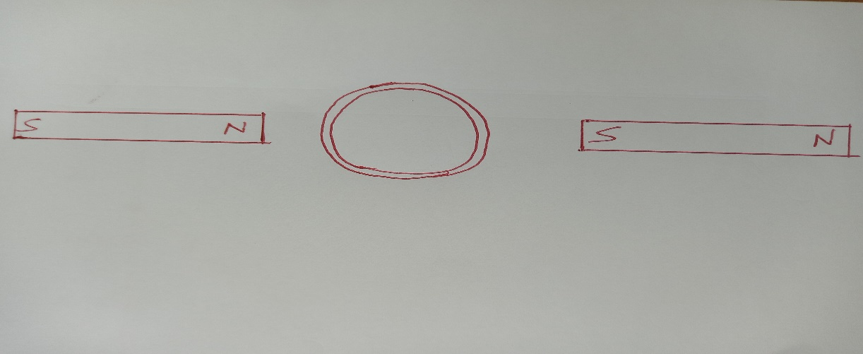

( c). (i). The figure below shows a U-shaped iron core. Indicate the polarity marked X and Y.
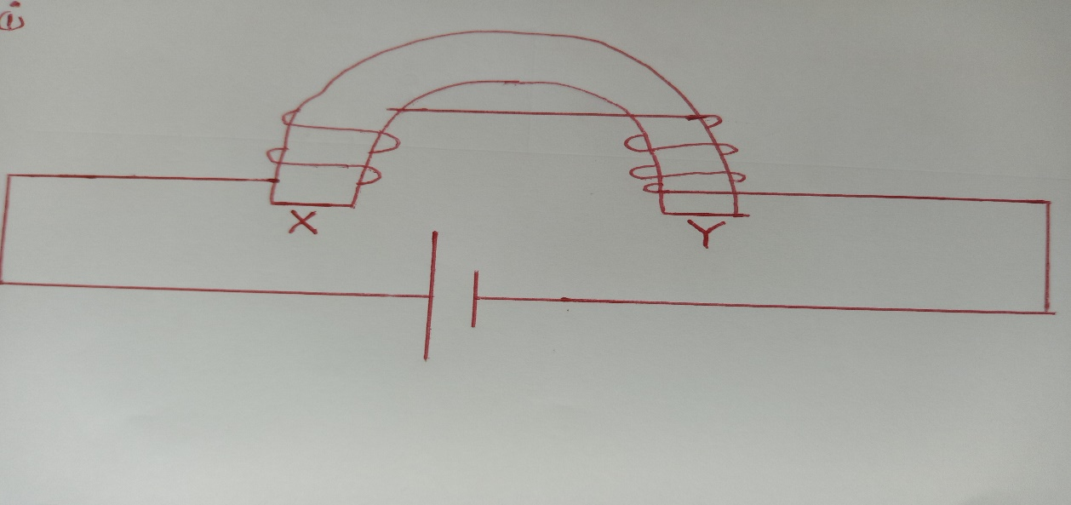

X- Y-

(ii). State TWO applications of such an electro-magnet. (2mks).

(iii). State two modifications that can be made to the set up above in order to demagnetize the iron core (2mks)

13a) The figure below shows a graph of 1/V against 1/U for a concave mirror. Use the graph to determine the focal length of the mirror. (3mks)
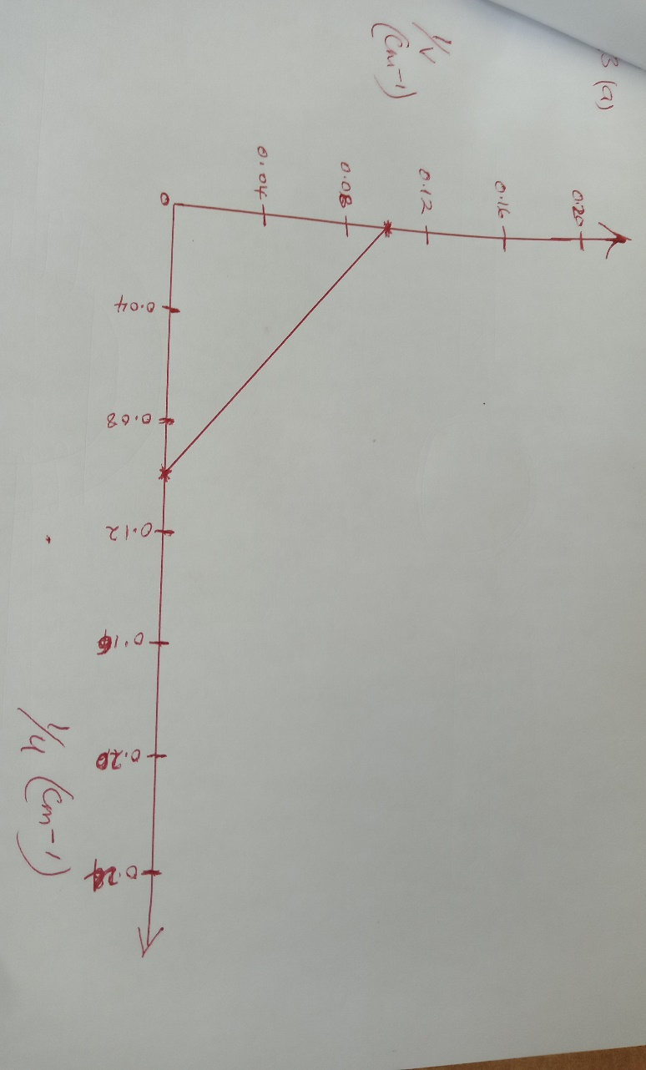

b)Determine the image distance V when the magnification m=2 for the concave mirror above. (3mks)

c.i)A small object is placed 15cm in front of a convex mirror of focal length 10cm. Determine the position of the image. (3mks)

ii)Give TWO characteristics of the image formed in part c(i) above. (2mks)

14. The table below shows the two major defects of the simple cell. Complete the table by stating the effects and remedies of these defects. (4mks)
DEFECT | EFFECT | REMEDY
Polarisation

Local action

15) Define the following terms;
a) Centre of gravity (C.O.G) (1mk)

b)Stable equilibrium. (1mk)

