NAME………………………………………………………………CLASS…… ADM.NO………...

BIOLOGY PP1
FORM THREE
END OF FIRST TERM
TIME 2 HOURS
Answer all questions in the space provided.
1.Name the organelle that performs the following functions in a cell. (4marks)
a )Transport of cell secretions

b)Proteins synthesis.

c) Formation of ATP.

d) Fixation of carbon (IV) oxide.

2. a. Distinguish between taxonomy and taxon (2marks)

b. Arachnids and crustaceans belong to the same phylum. Name the phylum (1mark)

- State three characteristics that makes them to be classified in the phylum you stated in (b)above (3marks)

- Give one structural feature that can be used to differentiate crustaceans and arachnids (1mark)

3.In a certain experiment the field of view of the microscope was determined as 4 MM.If 16 cells were found to span across the diameter of the field of view of the microscope….
a. Calculate the size of one cell in micrometers (3marks)

b) If 100 epidermalcells were viewed under magnification * 150,how many cells will be observed at magnification * 450 using the same slide? (2marks)

4.Guard cells are specialized epidermal cells.
a. State two structural features which suit them to their functions (2marks)

b.Apart from gaseous exchange;give one other function of the stomata (1mark)

5. State three ways by which a baby may acquire immunity (3marks)

6. Distinguish between residual capacity and vital capacity (2marks)

7. Suggest the most suitable biological tool for collecting
a. Ants from a tree trunk (1mark)

b.Grasshoppers from grassland (1mark)

8. a.State the functions of the condenser in a light microscope. (1mark)

b.Why is it not likely to use an electron microscope in a school laboratory? (3marks)

9. Explain why plant cells do not burst when immersed in distilled water. (2marks)

10. An experiment shown below was a set up to investigate a certain physiological processes in plants.
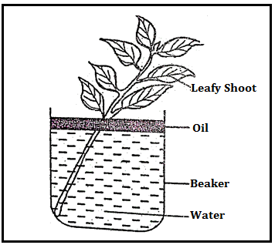
a.What process was been investigated? (1mark)

b.What effect will the following have on the observation made in (a) above?
Í)Fanning the shoot (1mark)

Íí)Removing all the leaves from the shoot (1mark)

Ííí) Placing the set up in the dark. (1mark)

11.a) State the role of light in the process of photosynthesis (2marks)

b) Name the product of the dark stage in photosynthesis (1mark)

c) State two minerals elements that are necessary in synthesis of the chlorophyll (2marks)

12. a)In an investigation, the pancreatic duct of a mammals was blocked, it was found that blood sugar regulation remains normal while food digestion was impaired. Explain these observations (3marks)

b) State the functions of the bile juice in digestion (3marks)

c) State the role of the tongue in mammalian digestion (2marks)

d) The action of ptyalin stops at the mouth. Explain (2marks)

13. Give reasons for each of the following ;
a) Constant body temperature maintained in mammals (2marks)

b) Effects of low blood sugar in the body (2marks)

14.People can die when they inhale gases from burning charcoal in a poorly ventilated room. Explain (3marks)

15. a) Name the compound found in the root nodule of the leguminous plants(1mark)

b) State the association of the bacteria named in (a) above (1mark)

16.Name the features that increases the surface area of the mammalian small intestine (3marks)

17.The diagram below represents a transverse section of a plant organ
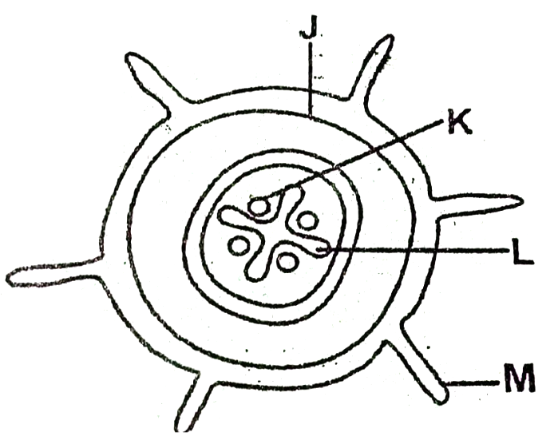

a) From which plant organ was the section obtained ? (1mark)

b) Give reason for your answers in (a) above (2marks)

c) Name the part labelled J, K and L (3marks)

d) State the functions of the part labelled M (4marks)

18. State two ways of preventing malaria (3marks)

19. Name the stage in meiosis where chromosome number is reduced by a half. (1mark)

20. Name;
a) The protein secreted by the blood platelets necessary for blood clotting (1mark)

b) The vitamin involved in blood clotting (1mark)

21. State two ways in which the tracheal system in an insect is adapted for gaseous exchange (2marks)

22. What are the importance of reproduction? (2marks)

