NAME:……………………………………………………………………ADM:………………..CLASS:….

GEOGRAPHY PAPER 2
FORM 3
TIME: 2³/₄HOURS
- This paper has TWO Sections A and B
- Answer All the questions in section A
- Answer questions 6 and any other Two questions from Section B.
- Answer must be written in the spaces provided.
- Students should check the questions paper and ascertain that all the pages are printed as indicated and that no questions is missing,
- Students should answer the questions in English.

SECTION A
- (a) What is practical Geography? (2mks)
(b) State THREE practical aspects we study in Geography. (3mks)
- Identify FIVE activities that may be undertaken in your school to conserve trees. (5mks)
- Outline the advantages of using photographs in learning geography. (5mks)
- (a) Name THREE major categories of minerals (3mks)
(b) Give TWO examples of fossil fuels. (2mks)
- (a) What is Agro-forestry? (2mks)
(b) State THREE reasons for encouraging agro-forestry in Kenya. (3mks)

SECTION B
ANSWER Question 6 and any other two questions in the section.

- (a) The table below shows land use in Nairobi area in 2003. Use it to answer questions that follow.
Land use | Area in ‘000’ km² | Length of portions in cm
Settlement  Grass  Horticulture  forest | 110  30  50  10
TOTAL | 200

- Calculate the length of each portion in the divided bar graph. (4mks)
(c ) (i) Name the TWO types of statistical data (2mks)
(ii) Give FOUR characteristics of statistical data. (4mks)
- a(i) What is mining? (2mks)
(ii) Why is mining termed as a ‘robber’ industry? (2mks)
b) Identify THREE factors that influence the exploitation of minerals. (3mks)
c) Explain how the following factors influence the exploitation of minerals. (3mks)
(ii) level of technology or skills, (5mks)
(d) (i) Explain THREE problems associated with the shaft method of mining. (6mks)
(ii) Apart from shaft method of mining, name other methods of underground mining. (3mks)
- (a) Distinguish between:
- Forestry and a forest. (2mks)
- Afforestation and re-afforestation. (2mks)
(b) Apart from coniferous forests, name FIVE other types of natural forests. (5mks)
© List FIVE factors that influence the distribution of forests in Kenya. (5mks)
d)(i) Explain THREE factors that favour the growth of natural forests on the slopes of Mt. Kenya. (6mks)
(ii) Outline the steps taken in forest exploitation (5mks)
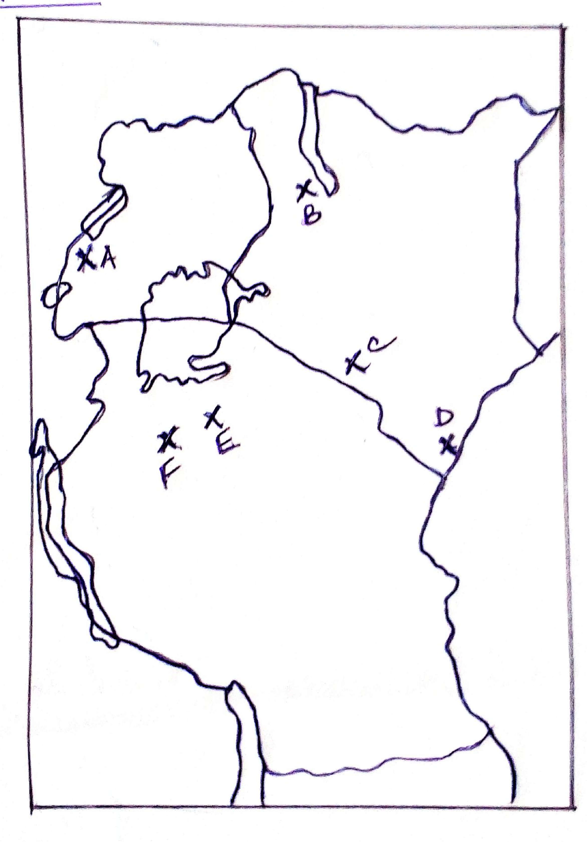
- (a) Use the map of East Africa below showing the distribution of major minerals to answer the question that follows.

Name the major minerals mined in the areas marked A- F. (6mks)
(b) Give reasons why coal in Tanzania is underexploited. (5mks)
(c) Explain THREE negative effects of mining to the environment. (6mks)
(d) (i) Give THREE uses of Soda ash. (3mks)
(ii) Name FIVE major Oil producing countries in Africa. (5mks)
- (a) The map of Kenya below shows some forested areas. Name the forest reserves marked a-h. (8mks)
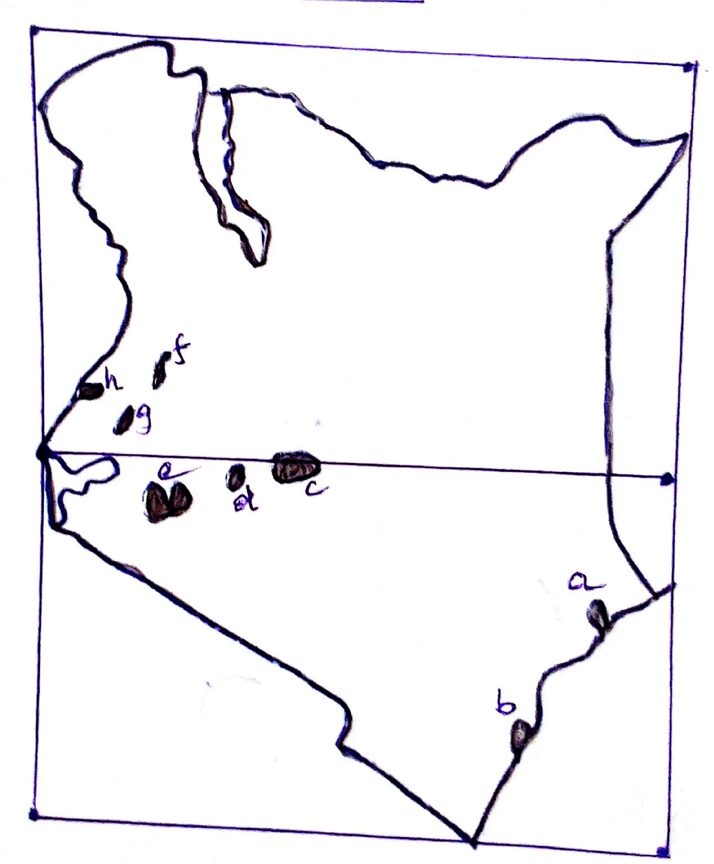

(b) State FIVE ways in which clearing of forests has affected the natural environment in Kenya. (5mks)
© 9i) Name THREE softwood tree species grown in forests of Canada. (3mks)
- Give FIVE characteristics of softwood forests of Canada. (5mks)
(d) Give the differences between softwood forests in Kenya and Canada under the following sub- headings:
(i) Period of harvesting. (2mks)
(ii) Period of growth (2mks)

